George Mitchell School Primary
Behaviour Protocols



Reviewed by Bridgit Edge – January 2021

POLICY TO PROMOTE POSITIVE RELATIONSHIPS AND EXCELLENT BEHAVIOUR IN THE PRIMARY PHASE

We believe that positive relationships are the foundation of any behaviour policy. We also believe that excellent behaviour is far deeper and stronger than quiet compliance: we aim to guide young people towards an adulthood where they continue to be kind, strong, thoughtful and brave enough to stand up for what is right, whatever the circumstance.

1. Values and Expectations
Our Values and Expectations are displayed across the school and frequently referred to in class, assemblies and as part of interactions with both adults and children at our school. These values and expectations apply to adults and children alike.

PERSERVERANCE – Enjoy the challenge
RESPECT – Be kind, be safe
INDEPENDENCE – Think for yourself
DIVERSITY – Include everybody
EXCELLENCE – Go above and beyond

2. School Culture
We are a school where every member of our community puts deliberate effort into recognising, celebrating and improving positive relationships and developing individuals.
We have a restorative approach managed by the adults in each classroom and throughout the school. The aim of this approach is to avoid the instinct to ‘win’ or to punish, and instead focus on the best possible outcomes for all, with the aim to restore calm and positive relationships. Our systems are predictable, calm, have a level of certainty about them and ensure both children and adults know and understand what is expected. We value each other at every level. This is evident in all our actions, particularly:

- We treat all adults and children with respect in all circumstances
- We listen to each other
- We use thoughtful, constructive and inclusive language when talking to or about others. Our words are positive and aim to build others up. We do not shout or use negative language about others, including in private, and we remind others of this part of our school culture when necessary.
- We treat children as individuals, showing an interest in their lives and making a daily effort to make every child feel valued
- We greet every child with pleasure and by name
- We encourage deliberate acts of kindness
- We look out for others, going out of our way in particular for visitors, those new to our school and those who are in particular need
- We stand up for what is right, even when it is difficult to do so

3. Certainty
The route to exceptional behaviour comes not from a toolkit of strategies but instead lies in the behaviour of every adult and their ability to create a culture of certainty. Certainty around expectations for behaviour needs to be expected, respected and unquestioned. Staff are expected to ‘pick up their own tab’ rather than pass students up the hierarchy, and to refer to this policy and its appendices in each situation.
The expectations need to be clear to all adults and children. Children need to be able to explain the expectations when asked and adults need to ensure the expectations and procedures are upheld. When there is a ‘grey area’, adults should use scripts to delay the conversation until the procedures can be checked and certainty can be offered to the child.

4. Celebrating Excellence
The attention needs to be on those who exhibit excellence and effort towards excellence. We have very high expectations of others and we find frequent opportunities to celebrate excellent behaviour. These include:
- A Recognition Board is displayed in each classroom, which displays each value and expectation. Children’s names are written against each value on this board each week if they have displayed excellence in that particular area.
- Children who consistently demonstrate excellence in all 5 values will be granted special privileges which give them status within the school. They will be celebrated publicly and held up as role models for others.
- The Star of the Week Assembly will celebrate those who have made a particular effort towards excellence in the value highlighted that half term
- Families are informed both informally and formally when their child has shown impressive behaviour or impressive effort.

5. No Token Economy
We do not use points, tokens or earned rewards to encourage good behaviour as we do not believe that these are effective in guiding hearts and minds.
There are some exceptions: we use house points for house competitions and some token rewards may be used for those on care plans; otherwise, we do not encourage the use of points anywhere in the school.

6. Classroom Routines
Preparation is a cornerstone of excellent classroom behaviour, enabling adults and children to be settled, feel far lower levels of stress, and be sure of what is expected of them. Interesting, effective lessons reduce both low level disruption and more serious incidents. Teachers are expected to plan effectively for the needs of the children in their classroom, to prepare suitable and stimulating resources in advance and to consider the particular needs of individuals within the space.

Teachers are expected to engage students in high quality lessons and to focus on learning within them. Attention is reserved for learning and positive behaviours; low level behaviour is dealt with privately and swiftly.

Teachers and support staff have a range of classroom management skills and the school may update and revise its expectations of classroom routines. Please see appendix.

7. Training
We are committed to constantly refreshing our training and understanding. This is built formally into our CPD regularly at all levels and informally in the way we guide and seek advice from each other as we work.

8. Restorative Steps
We have a restorative approach to dealing with negative behaviour which is not in keeping with our school values. Our aim is always to restore the child to the classroom/playground and to restore positive relationships and patterns of behaviour. Our restorative steps are outlined below.

PREVENTION
•
Positive relationships
•
Well prepared, well delivered lessons
•
Seating plans
•
Anticipation and preparation for any challenging circumstances
REDIRECTION
•
30
second interaction
•
Reminder of Values and Expectations
•
Ask: "What are you supposed to be doing?"
•
Think: "What is the child trying to do or achieve?"
•
Be certain: be clear about the expectation
•
Redirect towards the task
FORMAL
REDIRECTION
•
This step may be skipped in more serious circumstances. See "serious incidents" for complete information
•
Talk privately and quietly with child
•
Be calm and use the scripts
•
Give child a clear warning and record it privately
•
Give child a second clear warning and record it privately
REFLECTION
•
First reflection: 10 minutes in an area of own classroom to calm down and become ready for learning
•
Second reflection: 10 minutes in a designated classroom to calm down and become ready for learning
•
A reflection may take place with a senior leader
•
A reflection form should be completed during reflection time. This can then be used to scaffold the
restorative conversation.
•
All reflections should be recorded in SIMS
RESTORATIVE
CONVERSTATION
•
Conversation takes place betwen teacher / LSA and child in private
•
Use scripts and "incident form" to guide the conversation
•
SLG may guide and advise but would not lead the converstation
•
The converstaion must take place when all parties are calm
•
Natural consequences may be applied. The flowchart should guide on this.
•
The aim is discuss the incident and what lead to it, to apply consequences and to return to learning
RESTORE
RELATIONSHIP
•
The adult should reconnect with child later in same day, restoring positive relationship

9. Flow Chart for Specific Incidents
Follow up action may be applied as a result of some behaviours. These actions should be natural results of the behaviour and are reflective, with the aim to restore the child to the classroom and to normal excellent practice. No follow up action should be applied in the emotion of the moment, and adults should use scripts and delay conversations until all are calm. Adults should use the flowchart (see page 22) to guide their response.

10. Serious Incidents

Serious incidents include:
- aggression towards other children or adults
- bullying
- running away or leaving the area child is expected to remain in
- bringing a weapon into school
- non-compliance which affects the safety of themselves or others

Serious incidents and discriminatory behaviour will be referred straight to a member of SLG who will use the flowchart to inform their next steps. All serious incidents will be logged on SIMS.

11. Safer Handling

Adults must prioritise de-escalation and prevention of harm. They should look out for signs that the child has lost control and respond in a manner which reduces risk and enables the child to regain control, for example by adopting a calm, non-threatening stance and using a slow, controlled voice, clear verbal directions spaced 7 seconds apart, using ‘change of face’, and giving the child space and time.

In rare circumstances, a child may need to be handled or physically guided in order to keep him/herself or someone else safe.

Handling must be extremely rare and will only occur:
- when there is no alternative
- when someone’s safety is at direct risk and/or when the child is experiencing extreme loss of control
- using approved safe holds
- for the minimum time possible
- by someone who is Team Teach trained, where at all possible
If a child has been physically guided or otherwise handled, this must be recorded on SIMS and reported to both the SENCO and Head of Primary. The incident will be analysed carefully to identify triggers and how well procedures were followed, with the aim to improve things for all in the future.

12. Care Plans
We believe that almost all individuals are capable of making their own choices and having responsibility for their own actions. However, we do recognise that some children with ASD, ADHD, pattern of significant negative behaviour, or other special need may need a tailored plan. Care plans will be created where needed, with input from the child, family, the class teacher, SENCO, and other specialists where appropriate, and will be overseen by the Head of Primary.

These care plans will always:
- consider the individuality of each child
- take sensory, timetabling or other specific needs into account
- aim to identify and reduce triggers
- aim to directly teach children self-management in small, achievable steps
- may use a token economy for brief periods
- have positive relationships at their core
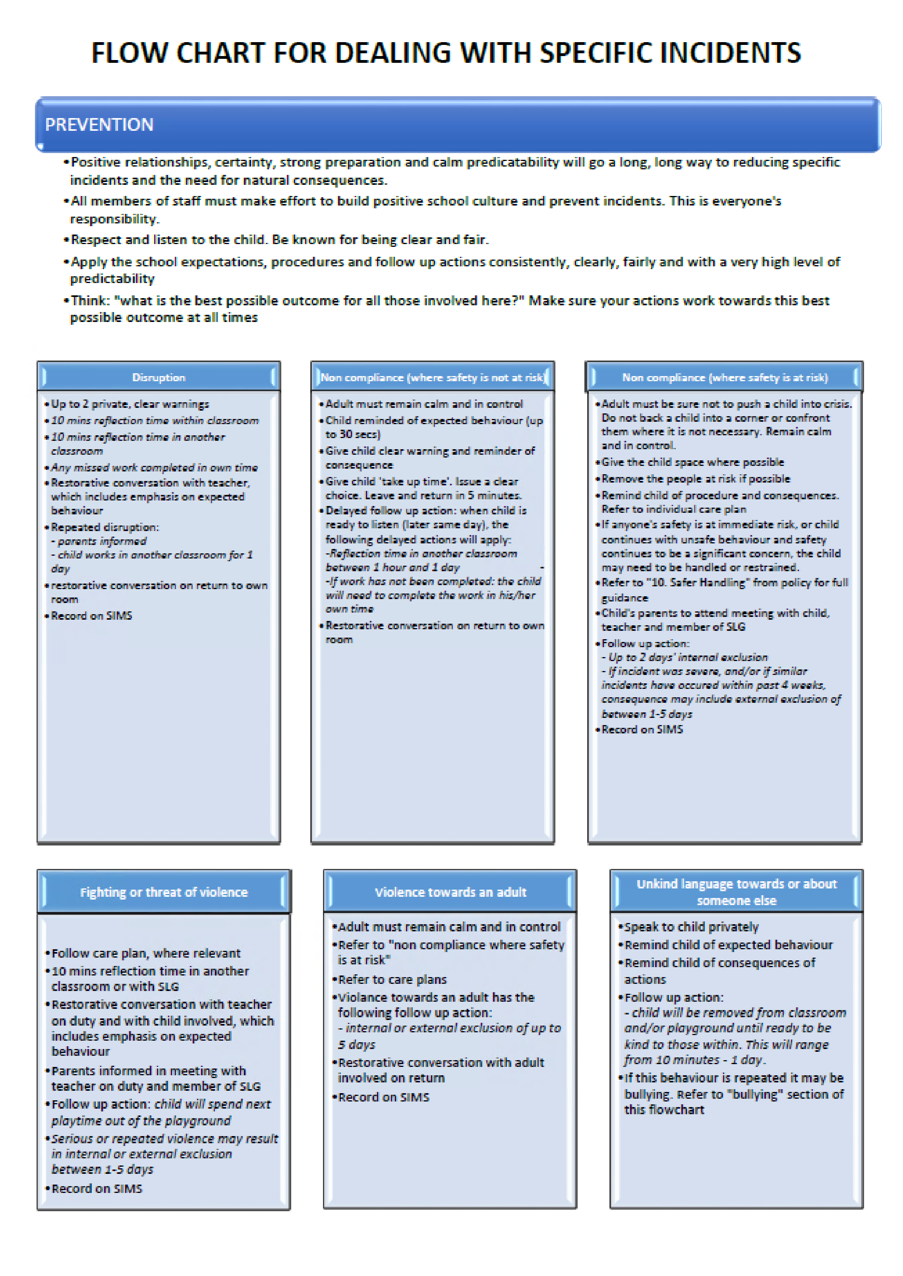

Appendix 3

George Mitchell School

Secondary Behaviour Management
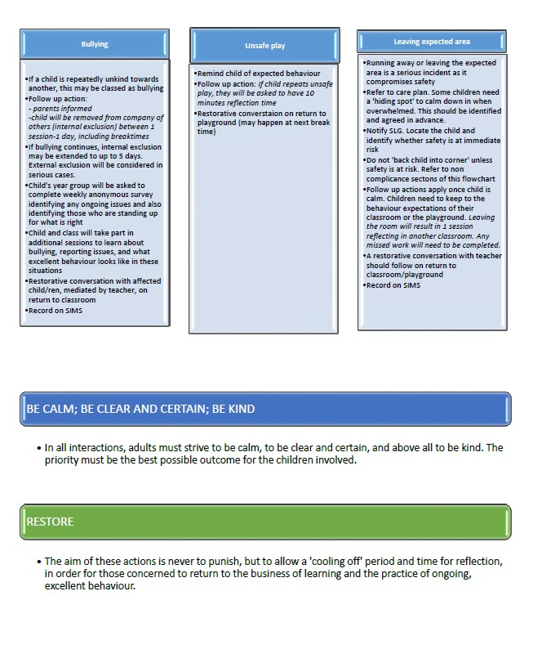

George Mitchell School
Suspension & Exclusions Policy

(This policy should be read in conjunction with the policies for Behaviour, Safeguarding & Teaching and Learning)

Definitions

Excluded from break and lunch times
Student spends break and lunch times for a determinant period of time supervised by a pastoral leader separated from the main student cohort

Excluded from lesson(s)
Student is removed from individual lessons or curriculum areas for a determinant period of time working under the supervision of the Student Support Area (SSA) staff
Internal Suspension
Student is removed from all lessons and school activities for a determinant period of time but remains in school working under the supervision of the Student Support Area (SSA) staff

Suspension
Student is suspended from school and all school activities for a determinant period of time Permanent exclusion
Student removed from the school on a permanent basis

Rationale

- All students attending George Mitchell School (GMS) have the right to a quality education without disruption or negativity;
- All students have a right to be safe and be protected from bullying or anti-social behaviour;
- All staff working at GMS have the right to work in an environment free from menace or abuse;
- All parents/carers have the right to know that their children will be protected from harm;
- The local community have the right to live peacefully with GMS at its hub.

For offences at odds with the above, the Headteacher and Senior Leadership Group (SLG), reserve the right to exclude students from aspects of their education.

Aims and Objectives

- To provide clarity to all stakeholders as to the procedures and protocols surrounding all aspects of suspension & exclusion;
- To support the SLG in making decisions as to the need and severity of a suspension or exclusion, thereby achieving consistency in the application of the Suspension & Exclusions Policy;
- Alongside the Behaviour, Attendance and Punctuality and Teaching and Learning Policies improving behaviour within lessons, around the school and in the local community;

Triggers for all types of suspension & exclusion are identified in the Serious Incidents Behaviour Guidelines (Appendix 5)

The decision to suspend (permanent or fixed term - external) can only be taken by the
Headteacher or, in their absence, the Deputy Headteacher acting in that role. All other suspension (internal) can only be authorised by a member of the SLG.

When establishing the facts, in relation to a suspension or exclusion decision, the Headteacher and members of SLG must apply the civil standard of proof, i.e. ‘on the balance of probability’ it is more likely than not a fact is true, rather than the criminal standard of ‘beyond reasonable doubt’.

Although an incremental approach to the severity of punishments will be in the mind of those making the decisions around suspensions & exclusions, each individual case will be treated on its evidence; following an incremental scale of punishment might not always be appropriate.

The decision as to whether a suspension or exclusion is appropriate will take a number of factors into consideration:

- The nature and severity of the incident;
- Student’s previous behaviour record;
- Vulnerability of the student;
- Background information provided by pastoral and inclusion teams; • Statements from student, witnesses and staff;
- Suspension tariff.

Suspended from break and lunch times

Suspended from break and lunch times may be used following:

- One-off incident of anti-social behaviour, fighting not deemed serious enough to warrant internal suspension or suspension from school.
- Series of minor misdemeanours committed during break or lunch time;
- Truancy from school or part of the school day;

Procedures for lunch and break time suspension;

- Member of SLG (or Pastoral Leader) ensures that sufficient evidence leading to break and lunch time suspension is placed on SIMS;
- An appropriate, suitable, supervised place will be identified for the student to spend their break and lunch times separated from the main student cohort.

Excluded from lesson(s)

Overall management and decisions regarding suspension from lessons is the responsibility of a member of SLG only.

Suspension from lesson(s) may be used following:

- A one-off incident allowing breathing space for student, teacher and/or class;
- A period of disruption to lessons, after a range of interventions have been evidenced involving the class teacher, Curriculum Leader and SLG Line Manager;

Procedures for lesson Suspension

- Member of SLG (or Curriculum Leader) ensures that sufficient evidence leading to internal suspension is placed on SIMS.
- Letter will be sent home to parent/carer.
- Work will be provided by the class teacher for completion in the Student Support SSA (SSA).
- Student records and SIMS will be updated by a member of the SSA (‘withdrawn from
curriculum area’).

Following a suspension from a lesson(s)

- A meeting will be held between SLG, the Curriculum Leader, the class teacher and the student. Following this meeting the student will go back into lessons;
- There may be occasions when a parent/carer is also invited to this meeting if there have been several issues within a curriculum area or parental intervention is required;
- A record of the meeting will be recorded by the member of SLG (or Curriculum Leader) and
filed as an intervention on the school’s Management Information System – SIMS.

A number of interventions will be considered to support the student with their reintegration:

- Weekly behaviour report to a member of SLG or the Pastoral team;
- Mentoring;
- Peer mediation or support;
- Time out from a curriculum area or lessons;
- Mediation meeting with staff;

Internal Suspension

Overall management and decisions regarding internal suspension is the responsibility of a member of SLG only.

Internal suspension at George Mitchell means full-time attendance in the Student Support Area (SSA). The SLG and staff working within the SSA believe in enabling students to work and be supported in a nurturing environment. Whilst serving an internal suspension, students receive individualised support and mentoring designed to help them modify their behaviour.

NB: Internal suspension is not an appropriate sanction for truancy.

Procedures for Internal Suspension

- Member of SLG informs the SSA in order for work to be arranged via curriculum/subject areas;
- Member of SLG (or pastoral leader) ensures that sufficient evidence regarding internal suspension is placed on SIMS;
- SSA Manager will update SIMS with actions;
- Member of SLG explains to the student the reasons for and the duration of the internal suspension and expectations;
- A letter detailing the terms and length of the internal suspension will be posted home and placed on the student’s file by the Headteacher’s PA.
- Student remains under the supervision of the SSA for all lessons and break times;
- The SSA Curriculum will be appropriate to the year group, and wherever possible, the work being undertaken in class;
- Isolation should only be used for disruptive behaviour in the SSA (removed from main body of the SSA to independent work space);
- Students will have break and lunch times supervised by SSA staff;
- Member of SLG will be responsible for monitoring behaviour of internally excluded student.

Following an Internal Suspension

- A meeting will be held between the member of SLG (or pastoral leader) and the student will, following this meeting, then go back into lessons;
- There may be occasions when a parent/carer is also invited to this meeting if there have been several internal suspensions or it is felt that parental intervention is required;
- A record of the meeting will be recorded by the member of SLG (or pastoral leader) and filed as an intervention on the school’s Management Information System – SIMS.

A number of interventions will be considered to support the student with their reintegration:

- Weekly behaviour report to a member of SLG or the Pastoral team;
- Mentoring;
- Peer mediation or support;
- Time out from a curriculum area or lessons;
- Mediation meeting with staff.

Suspensions

Before deciding whether to issue a suspension, the Headteacher will ensure that:

- Appropriate investigations have been carried out;
- All evidence available to support the allegations has been collated;
- The student has been allowed to give their version of events via a written statement;
- Advice is taken from the Pastoral and Inclusion teams as to any background information relevant to the suspension decision.

The length of the suspension will depend on previous history and the severity of the incident.

Although an incremental approach to the severity of a suspension will be considered, each case/incident will be judged on the evidence, therefore an incremental approach may not always be appropriate.

NB: A suspension is not an appropriate sanction for truancy.

Procedures for Suspension

- The parent/carer is notified by telephone;
- If the parent/carer sanctions student to be sent home immediately, this will constitute Day 1 of the suspension
- If the student cannot be sent home immediately, they will remain in school until the end of the day and the following day will constitute Day 1 of the suspension;
- A letter detailing the terms and length of the suspension will be sent home with the student, posted home and placed on the student’s file by the headteacher’s PA. The letter will contain details of the parent/carer’s right to appeal, a ‘return from suspension’ meeting time with a member of SLG and instructions that the student must not be in the immediate vicinity of the school for the duration of the suspension;
- A copy of the letter is sent to the Local Authority;
- The student will be sent home with work appropriate to their ability and for the length of the suspension;
- The Headteacher’s PA will update SIMS to show action taken – suspension.

Following a Suspension

- A ‘return from suspension’ meeting must be held between a member of SLG, parent(s)/carer(s) and the student before they are able to return to lessons;
- Until a successful ‘return from suspension’ meeting is held, the student will remain under the supervision of the SSU staff for both lessons and break times;
- A record of the meeting will be recorded by the member of SLG and filed as an intervention on the school’s Management Information System – SIMS.

A number of interventions will be considered to support the student with their reintegration:

- Weekly behaviour report to a member of SLG or the Pastoral team;
- Mentoring;
- Peer mediation or support;
- Time out from a curriculum area or lessons;
- Mediation meeting with staff.

Permanent Exclusion

The decision to exclude a student permanently is a serious one and will never be taken lightly. In so doing, the Headteacher recognises that a permanent exclusion may have a serious impact on a student’s life chances.

Permanent exclusion may be used at any time following:

- Actions that could have repercussions for the orderly running of the school;
- Actions that pose a threat to another student or member of staff or member of the public, or serious actual or threatened violence against another student, member of staff or member of the public;
- Actions that could adversely affect the reputation of the school
- Sexual abuse or assault
- Supplying drugs
- Carrying an offensive weapon

The behaviour of students outside of school can be considered grounds for exclusion. The school’s Behaviour, Punctuality and Attendance Policy sets out what the school will do in response to all non-criminal bad behaviour and bullying which occurs anywhere off the school premises. The Headteacher could exclude a student for any misbehaviour while the student is:

- Taking part in any school-organised or school-related activity;
- Travelling to/from school; or
- Wearing the school uniform or in some other way is identifiable as a student at the school.

The school will consider police involvement for any of the above offences.

Before deciding whether to exclude a student permanently the Headteacher will ensure that:

- Appropriate investigations have been carried out;
- All evidence available to support the allegations has been collated;
- The student has been allowed to give their version of events via a written statement;
- Advice is taken from the Pastoral and Inclusion teams as to any background information relevant to the exclusion decision.

Procedures for Permanent Exclusion

- The school will inform parents/carers immediately by telephone;
- A letter in which the terms of the exclusion and their right to appeal will also be sent.
- The Chair of Governors and the Local Authority will be notified straightaway.


Serious Behaviour Incidents
Guidelines

Factors to be considered when deciding on the nature and duration of a suspension/exclusion:

- Severity of incident
- Any provocation
- Age/experience of student
- Immediate impact on other students
- Longer term impact on behaviour within the school
- Impact on staff
- Previous conduct history of students
- Other mitigating or aggravating factors
- Particular circumstances pertaining to the student
- Student’s response, including honesty, contrition, responsibility for action
- Combinations of offences are likely to lead to suspension longer than for a single offence
- Previous history of different sorts of offences may still lead to longer suspension than for a first
- Offence
In making decisions as to the nature and severity of punishments for serious behaviour incidents, the Headteacher and Senior Team will refer to the following guidelines.
It must be noted however that the Headteacher has the authority and the duty to decide on punishments and the severity of punishments based on the evidence provided.

Nature of Behaviour | First Offence | Repeated Offence
DISRUPTION
Refusal to follow uniform code | SSA/removal of free time | SSA/removal of free time
Consistent refusal to work acceptably in class | SSA | - DS 1st suspension  - DS 2nd suspension  + DS each offence
Consistent disruption of others learning | SSA | - DS 1st suspension  - DS 2nd suspension  + DS each offence
Persistent disruption to the smooth running of the school, including unwarranted demands on staff time | SSA to 2DS | 1DS to 5DS  + DS each offence  Could lead to Permanent
Refusal to follow  instructions or to cooperate with a member  of staff  If in state of violent rage putting safety of others in danger. | SSA to 1DS  1DS to 3DS | 1DS  + DS each offence  3DS to 5DS  Could lead to permanent
Possession of a phone in school | Phone removed and returned  to parent at teachers’ convenience. | Phone removed and returned  to parent at teachers’ convenience. SSA – 1 DS
Lesson truancy | Department Detention 1-2 hrs | Department Detention 2-5 hrs Suspension from break and lunchtime1-5 days
School truancy | SSA (Only vulnerable cases) Suspension from break and lunchtime1-5 days | SSA (Only vulnerable cases) Suspension from break and lunchtime3-10 days
BULLYING
Single incident of low level bullying | SSA to 1DS | 1DS to 5DS
Persistent serious bullying | 2 DS to 5DS | Min 3DS; could lead to P
Racist, homophobic, cultural, religious, disability, gender abuse (protected characteristics) | SSA to 1DS | 1DS to 5DS
Inappropriate sexual behaviour (comments) | SSA to 1DS | 1DS to 5DS
Online bullying using social media or virtual group platform | SSA to 2DS | 2DS to 5DS

SUBSTANCES
Suspected under the influence of alcohol or drugs | SSA to 5DS | 5DS to 15DS  Could lead to permanent
Possessing or Dealing in illegal drugs | 5DS to 15DS;  Could lead to Permanent | P
Possession of alcohol | 5DS to 15DS  Could lead to permanent | P
Possession of vape | SSA to 1DS | 2DS to 5DS
ENVIRONMENT and POSSESSIONS
Graffiti | SSA to 2DS (Depending on nature of graffiti) | 2DS to 5DS  + DS each offence
Vandalism/Deliberate Damage | SSA to 3DS | 5DS to 15DS
Theft | SSA to 3DS if admitted and returned undamaged  1DS to 5DS if damaged/unreturned  P if exceptional | 3DS to 5DS  3DS to 5 DS
Robbing another student of possessions using intimidation or violence | 2DS to 5DS | 5DS to 15DS  Could lead to permanent
ABUSE
Serious verbal assault against another student | SSA to 1DS | 1DS to 2DS  + DS each offence
Any serious abuse including reference to any of the protected characteristics | SSA to 2DS | 2DS to 5DS
Using a phone in school to record, photograph or video any member of the school community without permission. | Phone removed and returned  to parent at teachers’ convenience. SSA – 2DS | Phone removed and returned  to parent at teachers’  convenience 2DS to 5DS
Harmful sexual behaviour: Harmful sexualised language,  Inappropriate touching, Demanding sexual activity or sexual images, Sending or receiving inappropriate images. | SSA to 2DS  Could lead to permanent | 2DS to 5DS
Offensive or insulting language directed at staff | SSA to 2DS | 2DS to 5DS
Threatening staff with violence | 1DS to 3DS | 3 DS to 5DS
If minor. In heat of moment and apologised immediately. If serious and with continued intent. | 5DS to 10DS | 10DS to 15DS;  Could lead to permanent
VIOLENCE
Threatening behaviour causing anyone real fear of violence | SSA to 1DS | 1DS to 2DS  + DS each offence
Physical assault committed under the guise of ‘banter’ or ‘jokes’ that emotionally or physically hurt another student. | SSA to 2DS | 2DS to 5DS
Minor fight in the heat of the moment. | SSA to 1DS | 1DS to 3DS  + DS each offence
More serious violence towards other student or students (Assault) | 2DS to 5DS  In extreme cases could lead to permanent | 5DS to 10DS  Could lead to permanent
Group attack/assault on other student | 3DS to 5DS | 5DS to 15DS  Could lead to permanent
Violence towards staff | Likely to be permanent.  5DS to 15DS for minor incidents or if mitigating circumstances  are accepted | P
Sexual assault | SSA to 5DS  In extreme cases could lead to permanent | 3DS to 15DS  Could lead to P
Possession of weapon | Permanent
OUTSIDE SCHOOL
Bringing the name of the  school into disrepute  Including ‘any form’ of bullying, abuse, violence or criminal activity | SSA to 15DS  Could lead to permanent | SSA to 15DS  Could lead to permanent

