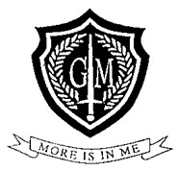

George Mitchell School

Uniform Policy

Date to be reviewed | June 2027
Produced by | Matthew Farrow

George Mitchell School Primary Uniform Guidance

Required Uniform | Example | Unacceptable
Plain, white polo shirt  (with or without school logo, does not need to be tucked in)  Any outlet or ‘Victoria 2’ School Uniform Shop | 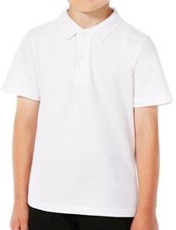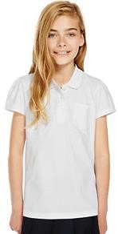 | Branded polo shirts  Sports logos or coloured detailing  Coloured t-shirts worn beneath Long-sleeved t-shirts worn beneath
Plain, formal white school shirt, long or short sleeved – worn with tie  (to be worn tucked in)  Any outlet | 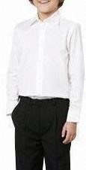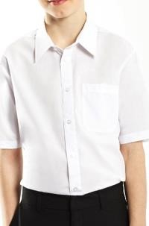 | Branded shirts  Patterns or logos  Coloured t-shirts worn beneath shirt
Black sweatshirt or v-neck jumper (MUST have school logo)  Branded  ‘Victoria 2’ School Uniform Shop | 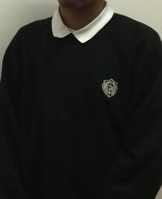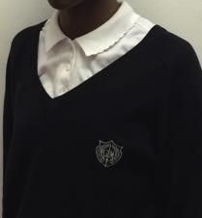 | Jumpers without school logo  Sweatshirts without school logo  Branded sweatshirts
Smart, black trousers  (plain black belt optional)  Non Branded  Any outlet | 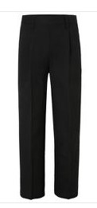 | Jeans or Chinos  Rivets  Shorts or rolled up trousers  Tracksuit bottoms  Trousers worn as ‘drop downs’  Leggings/ jeggings / Flares  Super-skinny styles  Stretch fabrics (lycra/ jersey/ stretch denim)
Smart, black, school skirt  (any length but NOT SHORTER THAN KNEE-LENGTH):  Non Branded  Any outlet | 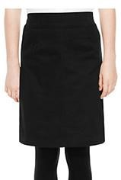 | Culottes  Shorts  Tube skirts  Jersey/ Stretch/ Lycra skirts/ Skirts with belts or any kind of detail (rivets/ lace/ pattern)
Plain, black tights  Non branded  Any outlet | 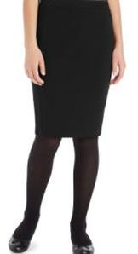 | Footless tights  Leggings  Trousers worn under skirts  Knee-high tights  Patterned tights
Plain, black or white socks with a skirt  Plain, dark socks (if worn with trousers)  Non branded  Any outlet | 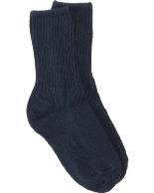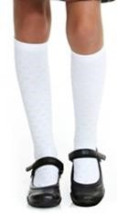 | Socks with a visible sports logo

Entirely black, LEATHER, school shoes:  Business-like  Lace-up, Velcro or slip-on Kickers are accepted but not the  training shoe style Smart ankle boots | 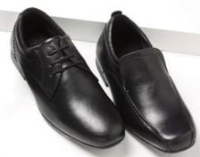 | 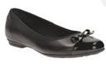  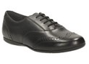 | Black trainers  Shoes with any kind of sports or designer logo e.g. Nike/ Adidas/  Reebok/ Prada/ Lonsdale  High boots or UGG boots  Heels
Simple, black, white or hair-coloured hair accessories:  Hair bands  Clips  Small, simple headbands | 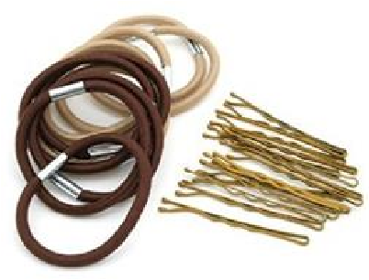 |  | Hairbands with bows and jewels  Excessive accessories  ‘Over-dressed’ hair
Plain, dark (sensible) school coat | 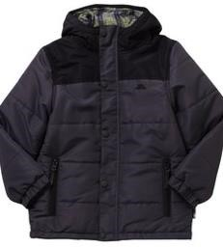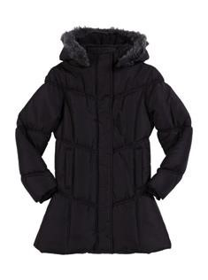 |  | Hoodies  Sports/ leisure tracksuit tops  (branded or unbranded)  Cardigans  Leather/ denim jackets (full or in part)  Camouflage  High fashion coats/ jackets
Plain black or white Headscarf | 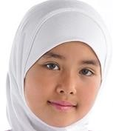 |  | Patterned fabric  Black and white patterned scarves (one colour or the other- not both)  Jewelled fasteners or pins.
Girls are not permitted to wear a Kameez- alternative modesty options include long-sleeve blouses, sweatshirt and either trousers or an ankle-length skirt.

We encourage students to present themselves well by taking pride in their appearance. Our aim is that students look business like. This is part of the home-school agreement made when accepting a place at the school. Students should not accessorize the uniform with jewellery, boots, scarves and cardigans, but should stick to the items specified on the uniform list. Uniform and sportswear with the school logo can be purchased from ‘Victoria 2’ School Uniform Shop, 246 Hoe Street, Walthamstow, E17 3AX.

Hairstyle

Inappropriate and extreme hairstyles are not acceptable at school. Hair colours should be natural tones (not blue/ pink/ green etc) and this includes coloured and artificial weaves in braids. Excessively beaded braids are also discouraged. Students are not allowed to wear noticeable make-up, nail varnish or false nails at school. Children can and will be removed from lessons if they ignore these school rules.

Jewellery

Students can wear a plain watch and one pair of small stud earrings in the ear-lobe only. No other piercings are permitted in school; this includes nose, tongue, lip, facial and upper ear-piercings. Students should not wear rubber/ leather/ cotton wrist bands or any other such accessories.

George Mitchell School Secondary Uniform Guidance

Required Uniform | Example |  | Unacceptable
George Mitchell blazer  (branded)  ‘Victoria 2’ School Uniform Shop, | 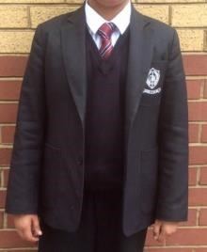 | 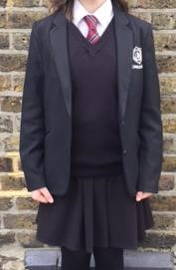 | Blazers without school logo
Plain, formal white school shirt, long or short sleeved – worn with tie  (to be worn tucked in)  Any outlet |  |  | Branded shirts  Patterns or logos  Coloured t-shirts worn beneath shirt
George Mitchell tie  (branded)  ‘Victoria 2’ School Uniform Shop, | 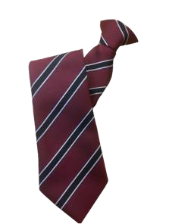
Black V-neck jumper (MUST have school logo)  (branded)  ‘Victoria 2’ School Uniform Shop |  |  | Jumpers without school logo
Smart, black trousers  (plain black belt optional)  Non branded  Any outlet |  |  | Jeans or Chinos  Rivets  Shorts or rolled up trousers  Tracksuit bottoms or visible under trousers  Trousers worn as ‘drop downs’  Leggings/ jeggings / Flares  Super-skinny styles  Stretch fabrics (lycra/ jersey/ stretch denim)
Smart, black, school skirt  (any length but NOT SHORTER THAN KNEE-LENGTH):  Non Branded  Any outlet |  |  | Culottes  Shorts  Tube skirts  Jersey/ Stretch/ Lycra skirts/ Skirts with belts or any kind of detail (rivets/ lace/ pattern)
Plain, black tights  Non branded  Any outlet |  |  | Footless tights  Leggings  Trousers worn under skirts  Knee-high tights  Patterned tights
Plain, black or white socks with a skirt  Plain, dark socks (if worn with trousers)  Non branded  Any outlet | 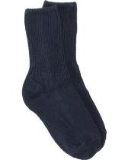 |  | Socks with a visible sports logo  White socks over black socks
Entirely black, LEATHER, school shoes:  Business-like  Lace-up, Velcro or slip-on Kickers are accepted but not the  training shoe style Smart ankle boots  Non branded  Any outlet |  |  | Black trainers  Shoes with any kind of sports or designer logo e.g. Nike/ Adidas/  Reebok/ Prada/ Lonsdale  High boots or UGG boots  Heels
Simple, black, white or hair-coloured hair accessories:  Hair bands  Clips  Small, simple headbands  Non branded  Any outlet | 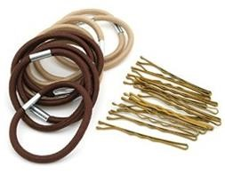 |  | Hairbands with bows and jewels  Excessive accessories  ‘Over-dressed’ hair
Plain, dark (sensible) school coat  Non Branded  Any outlet |  |  | Hoodies  Sports/ leisure tracksuit tops  (branded or unbranded)  Cardigans  Leather/ denim jackets (full or in part)  Camouflage  High fashion coats/ jackets
Plain black or white Headscarf  Non branded  Any outlet |  |  | Patterned fabric  Black and white patterned scarves (one colour or the other- not both)  Jewelled fasteners or pins.
Girls are not permitted to wear a Kameez- alternative modesty options include long-sleeve blouses, sweatshirt and either trousers or an ankle-length skirt.

We encourage students to present themselves well by taking pride in their appearance. Our aim is that students look business like. This is part of the home-school agreement made when accepting a place at the school. Students should not accessorize the uniform with jewellery, boots, scarves and cardigans, but should stick to the items specified on the uniform list. Sweatshirts and jumpers with the school logo can be purchased from ‘Victoria 2’ School Uniform Shop, 246 Hoe Street, Walthamstow, E17 3AX and sportswear is available to buy from ‘Fashion Stop School Wear’, 138 High Street North, East Ham, E6 2HT.

Hairstyle

Inappropriate and extreme hairstyles are not acceptable at school. Hair colours should be natural tones (not blue/ pink/ green etc) and this includes coloured and artificial weaves in braids. Excessively beaded braids are also discouraged. Students are not allowed to wear noticeable make-up, nail varnish or false nails at school. Children can and will be removed from lessons if they ignore these school rules.

Jewellery

Students can wear a plain watch and one pair of small stud earrings in the ear-lobe only. No other piercings are permitted in school; this includes nose, tongue, lip, facial and upper ear-piercings. Students should not wear rubber/ leather/ cotton wrist bands or any other such accessories.

PE Uniform
PE Kit essentials
Maroon PE polo shirt with school logo Required ‘Victoria 2’ School Uniform Shop | 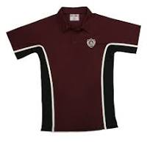
Maroon GM PE shorts optional  ‘Victoria 2’ School Uniform Shop  Plain Black shorts are an alternative | 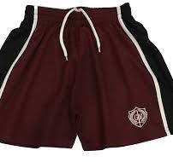
Trainers suitable for sport | 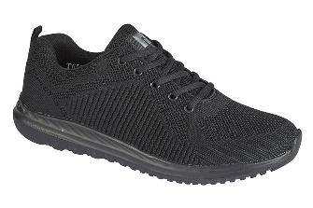
*Students are permitted to wear leggings under their PE shorts for religious reasons or during colder weather conditions.

Optional extras (Cold weather only) – These should not act as a replacement for any of the items above
Tracksuit bottoms  ‘Victoria 2’ School Uniform Shop | 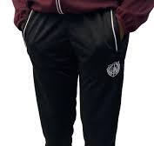
Track suit jacket  ‘Victoria 2’ School Uniform Shop | 