

2026-2027
*including realtionships and sex education
Lancashire County Council

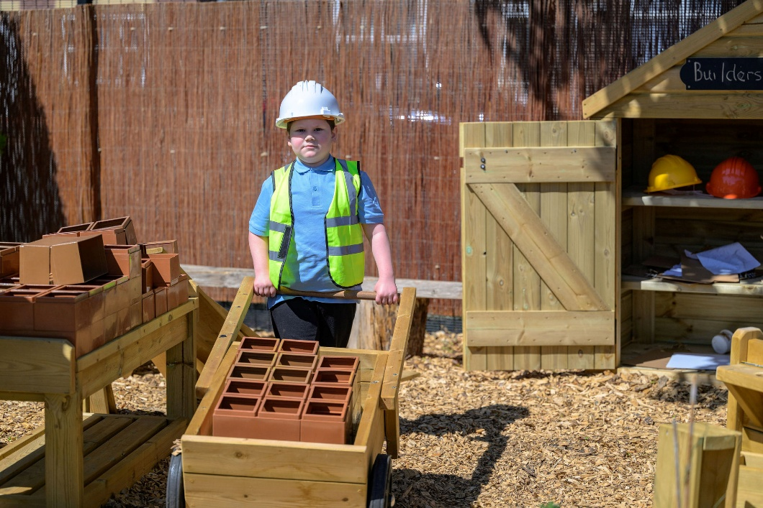
Primary PSHE* and values Policy
September 2026

Golden Hill Short Stay School Primary PSHE
(including Relationships and Sex Education (RSE)) and Values Policy 2026

Purpose:

This policy outlines the importance of primary Personal, Social, Health and economic education (PSHE), the subject through which we teach the statutory RSHE guidance from the Department for Education (DfE). This policy outlines how we deliver the subject and how the 'Values' curriculum extends the learning of the children we teach, further supplementing the personal development programme. This policy is in-line with the updated DfE guidance from July 2025 for implementation in September 2026. Relationships Education, Relationships and Sex Education and Health Education guidance
At Golden Hill Short Stay School, PSHE and Values are central to our curriculum and underpins all aspects of school life.
Our PSHE provision supports pupils’ emotional, social, moral and physical development and enables them to become safe, resilient, respectful and responsible members of society. The Values curriculum works nicely alongside PSHE to support the core skills pupils will learn and help them to practise embedding this into their real lives.
As a primary pupil referral unit, we recognise that many of our pupils have experienced disrupted education, adverse experiences, and social, emotional and mental health difficulties. Our PSHE curriculum is therefore flexible and responsive.
Our curriculum aims to:
- Support emotional regulation and wellbeing
- Develop positive relationships
- Promote self-esteem and resilience
- Teach safety and healthy choices
- Equip pupils for reintegration
- Promote equality and British values
At Golden Hill (Short stay) School we develop the potential of each and every child, empowering them and giving them the confidence to play a positive role in society as responsible citizens. We aim high and believe we can succeed. We work as a Team to ensure the very best outcomes for our children.

Subject Content
R(S)HE is taught within the subject of PSHE at Golden Hill and that this is taught inline with the statutory guidance. PSHE is:
'PSHE education is the school subject through which children and young people acquire the knowledge, understanding and skills they need to manage their lives, now and in the future.
PSHE education develops the qualities and attributes pupils need to thrive as individuals, family members and members of society'

(PSHE Association, 2024)
As part of PSHE, we build a bespoke curriculum programme using a range of high-quality resources which align with the statutory obligations set out by the DfE.
The statutory elements of relationships and health education are included within the curriculum content. These topics are taught throughout the PSHE curriculum and revisited at an age-appropriate level as the children journey through school.
There are elements of the topics and objectives within these topics that will also overlap and be taught or revisited in wider areas of the curriculum or through events such as assemblies, topic and themed days or celebration days.
The new guidance for RHE (2025) focuses on teaching the fundamental building blocks and characteristics of positive relationships and staying healthy through teaching about the following topics :
- Families and people who care for me
- Caring friendships
- Respectful and kind relationships
- Online safety and awareness
- Being safe
- General well-being
- Well-being online
- Physical health and fitness
- Healthy eating
- Drugs, alcohol, tobacco and vaping
- Health protection and prevention
- Personal safety
- Basic first aid
- Developing bodies
All of these topics sit within the statutory RHE objectives and therefore, content from these lessons cannot be withdrawn from.
As part of Health Education, pupils are taught the correct scientific vocabulary for body parts (including the names of external genitalia), as well as the physical and emotional changes that occur during puberty. This content is carefully mapped within the curriculum and delivered at appropriate stages throughout pupils’ primary education.

In addition, as a school, we have chosen to include the non-statutory element of Sex Education (conception), which extends beyond the statutory requirements of the National Curriculum for Science. This includes teaching about how babies are conceived which will be delivered to pupils in Year 6. Parents and carers have the right to withdraw their child from this element of the curriculum, should they wish.

In addition, we further complement our programme of PSHE with a regularly timetabled Values lesson which supports a whole school theme.
We promote values by:
- Delivering weekly values lessons, linked to a whole school theme of the week (discussed twice weekly.) Our whole school Values are: Co-operation, Responsibility, Respect, Happiness, Friendship and Trust.
- Providing as many wider learning opportunities as we can, such as: Live Music experiences, School trips (climbing, outdoor adventure activities, farm visits, experience trips e.g. shopping for ingredients to bake cakes for a sale), visitors in school linked to different curriculum areas, emergency services educational visits.
- Encouraging our pupils to be independent and to seek support if / when they need it.
- Providing opportunities for reflection during Daily Points Time and Social Breakfast sessions. This includes a restorative justice approach to dealing with any grievances the children may have.
We are keen to ensure that parents and carers have adequate access to the materials that we use to deliver the curriculum for this subject and therefore, we encourage them to make a request with the school office to find a mutually convenient time to view these or gain access to them.

How the subject is taught
While promoting the values above, we will ensure the pupils are offered a balanced programme by delivering a weekly PSHE lesson in addition to covering some objectives within our daily activities (points time, zoned playtimes, social lunch and breakfast)
We understand that, being a PRU, the needs of our children change throughout the academic year as classes expand, change and develop with little notice and that our curriculum may be subject to change to accommodate this. We endeavour to deliver the statutory content in a broad and balanced way, although it may be necessary to repeat some objectives to accommodate the social, emotional, behavioural and academic abilities of our children at different times throughout the year. We also aim to cover some non-statutory objectives which we believe to be the most beneficial and important for our pupils, creating a broad and well balanced PSHE curriculum.
However, we recognised that the children at Golden Hill do not attend here from R-Y6 and that they will receive some teaching of PSHE in the schools that they attend before and after being at Golden Hill. This should ensure a broad coverage of all statutory objectives in addition to a broader PSHE curriculum by the end of Primary Education.
Our PSHE curriculum will be responsive to current affairs or incidents, which are relevant to our children in one or more cohort. For example, teaching one off lessons or sequences of lessons to respond to local need or to respond to PSHE needs within a class, which may include peer-peer issues, bullying, instances of violence or aggression, friendship issues, smoking or alcohol related problems and lifestyle choices.
This subject will be part of the taught curriculum and delivered through regularly timetabled lessons taught by the class teacher. They will be taught ensuring that the individual needs of the cohorts are taken into account and that the children will feel confident to engage in their learning without prejudice.
We will further supplement the curriculum and life skills opportunities through the teaching of the character education programme in place.
In order to add to the effectiveness of this curriculum we also invite specialists and volunteers into school to support the delivery of messages and we regularly have the following agencies who visit some pupils within school:
- Dan Worsley - Author
- EpicKidz or RNLI – Water Safety
- Little Barn Mobile Farm
- Dementia Friends / Dementia awareness
There may be occasions when additional visitors would further supplement the curriculum and may visit our school. When this happens, parents and carers will be informed by way of a message to let them know who is attending and what the purpose of the visit is.

Responsibilities

PSHE at Golden Hill is a whole-school responsibility, ensuring that pupils are as well prepared as possible for life beyond their time at school. All staff play a vital role in the effective delivery and implementation of the curriculum. These roles are outlined below:

Headteacher: Responsible for ensuring that the PSHE policy and curriculum are shared with and approved by the Governing Body prior to implementation. The Headteacher also works alongside senior leaders and the PSHE lead to ensure appropriate opportunities for staff continuing professional development (CPD) are in place to support effective curriculum delivery.

PSHE Lead: Responsible for the development of the PSHE curriculum and for monitoring its implementation and impact, in collaboration with senior leaders and the Headteacher. The PSHE Lead also supports the effective delivery of staff CPD by engaging in relevant training and disseminating updates and guidance as appropriate.

Class Teachers: Responsible for the effective delivery of the PSHE curriculum, recording relevant evidence of learning, and using assessment information to inform future planning that is appropriate to the age and stage of pupils within their class.

Teachers delivering PSHE: All staff delivering any aspect of the PSHE curriculum are expected to do so in line with the agreed curriculum overview and approved school resources. They must adhere to school policies and procedures and ensure that any sensitive or challenging questions are addressed appropriately, in line with safeguarding guidance and this policy.

Support Staff: Responsible for supporting pupils in their learning and assisting the class teacher in the delivery of sensitive or potentially challenging content where appropriate.

Pastoral Staff: Responsible for identifying pupils who may require additional support in specific PSHE topics, including through pre-teaching of content or targeted follow-up intervention where necessary.

Governors (Members): Responsible for approving the PSHE policy and working with school leaders to ensure effective implementation and delivery of the curriculum.

External Visitors: Responsible for familiarising themselves with this policy, delivering only pre-approved content, and adhering to the school’s safeguarding procedures at all times.

Right to Withdraw
At Golden Hill, we believe it is important to teach Sex Education as part of a broad and balanced PSHE curriculum. Due to the nature of a PRU, it is not always clear what prior teaching and learning the children have experienced and it is not always possible to include all children in each lesson from the start of a unit to the end. With this is mind, our Sex Education lessons will be thoroughly planned and resourced in consultation with SLT, teachers and parents and delivered during a series of lessons in the latter part of Summer Term.
The content of the lessons will differ year upon year to reflect the emotional and social maturity, SMSC and individual circumstances of the present cohort of children. A series of lessons will be planned, resourced and agreed before any teaching takes place. Parents will be informed prior to the lessons and will be able to discuss the teaching and learning with their child’s class teacher should they wish to.
Should a parent wish for their child to be withdrawn from Sex Education lessons, they may request this by contacting the head teacher. However, children cannot be withdrawn from lessons on Relationships and Health because these areas are statutory. Please ask school for further guidance on this if you require it.

Accessibility for All Pupils
We recognise the right for all pupils to have access to PSHE education learning which meets their needs.
We will ensure that pupils with SEND receive access to PSHE through linking teaching and learning to appropriate to their prior knowledge and adapting lessons accordingly. Teaching and learning is further adapted as appropriate to suit the needs of individuals. The PSHE Association SEND objectives may be used to support teaching if appropriate for individual children or classes.
Teaching will take into account the ability, age, development and cultural backgrounds of our young people and those with English as a second language to ensure that all can fully access HRE and PSHE education provision.
We promote social learning and expect our pupils to show a high regard for the needs of others by using good manners, checking with adults before doing something if they are unsure and acting within the boundaries of the positive behaviour management system in place at our school.
We will use PSHE as a vehicle to address diversity issues and to ensure equality for all.
At Golden Hill School, we are committed to ensuring that the needs of the children are put first. This includes identifying and addressing any vulnerabilities that may get in the way of a child's success and overcoming these barriers alongside them. PSHE can be used as a subject to support our young people in being prepared for the world. As such, each topic is taught with sensitivity and care for any of the vulnerabilities that our young people may be facing.

Monitoring and Evaluation
PSHE provision and coverage will be monitored though lesson observations, learning walks and gathering pupil voice, in liaison with teachers and SLT. Teachers will use Seesaw or a class ‘Big Book’ to record evidence of learning.
PSHE is reported on through termly Position Statements provided by the subject leader.
PSHE will be monitored by SLT and the subject leader and changes can be made where necessary.
The contribution of external visitors will be evaluated through a simple standard proforma.
The School Council will be given the opportunity to discuss their learning and raise any points to discuss in classes or with the appropriate adults.

Parental Access to Curriculum Materials
Should parents or carers wish to view any materials used to deliver lessons within the PSHE curriculum, they are welcome to do so. Arrangements should be made in advance through the school office to agree a mutually convenient time for the PSHE Lead and class teacher to share these resources.

As many lessons are delivered through resources kept on an online subscription platform, there may be limited physical materials readily available to send home straight away. Parents and carers are therefore encouraged to visit the school to view the lessons and materials in school where possible.

The school operates an open-door policy and is committed to full transparency. Parents and carers are welcome to review curriculum materials and discuss them with staff should they wish to do so.

Answering Questions
Pupils’ questions are answered by staff in a supportive, age-appropriate, and informative manner. Pupils are given opportunities to raise anonymous questions through the use of question boxes in classrooms during sensitive topics covered within the PSHE curriculum. Recording devices such as a talking tin can also be used where appropriate to help children record their question should writing not be their preferred/most appropriate method of recording.

Where a question is posed or asked and a member of staff requires additional time to provide an appropriate response, the pupil will be informed that an answer will be provided at a later time outside of the lesson. Pupils will also be reminded not to use search engines to independently seek answers to sensitive questions.

Where pupils ask questions that fall outside the planned curriculum content (for example, in younger year groups, questions about how a baby is made), staff will respond positively and appropriately, acknowledging the question while redirecting it.

Such questions will be shared with the PSHE Lead and/or senior leadership team, who will consider the most appropriate response. Where necessary, parents and carers will be informed of the question and the proposed approach, and will be supported in addressing the topic at home if appropriate.

Responses provided by staff will be factual and will use accurate scientific vocabulary where appropriate. If any safeguarding concern is raised during a lesson or through an anonymous question, staff will follow the school’s Safeguarding and Child Protection Policy and take appropriate action immediately.

Policy Development and Review
This policy has been written by the PSHE Lead in line with Department for Education (DfE) guidance and has been shared with staff alongside the curriculum overviews. It has also been presented to the Governing Body for approval and shared with parents and carers through a consultation process to ensure transparency. This ensures that all stakeholders are informed of the policy and how it aligns with statutory guidance for implementation in 2026.
This policy will be reviewed on a bi-annual basis, or sooner should there be any significant changes to the delivery or content of the curriculum. In the event of such changes, further consultation will take place to communicate updates to all stakeholders.
The policy is approved by the Governing Body and the Headteacher and will come into effect from September 2026, in line with the implementation of updated statutory guidance.

Appendices
- Statutory guidance references: Relationships Education, Relationships and Sex Education and Health Education guidance

- Sample parental withdrawal form.

RSE Withdrawal Request
(to be completed by parents)
Student's Name: |  | Form
Name of Parent |  | Date
Reasons for withdrawing student from sex education:
Any further information you would like school to consider:
Parent Signature:
Agreed Actions
(to be completed school)
Staff Name |  | Date
Agreed actions from the discussions:
Staff Signature:

- curriculum overview

