Year 4: Spring Term (First Half)
English  - discuss words & phrases that capture the imagination  - participate in discussion about both books that are read to them and those they can read for themselves, taking turns and listening to what others say  - recognise a variety of forms of poetry  - identify & summarise ideas  - use VIPERS to ask and answer questions about texts  - plan writing based on familiar forms  - organise writing into paragraphs  - evaluate own and others’ writing  - write narratives with a clear beginning, middle and end with a clear plot  - create detailed settings, characters and plot  - use a variety of sentence types (taught as ‘blue sentences’ to add interest and detail  - use inverted commas to punctuate direct speech  - choose pronouns or nouns appropriately within a sentence to avoid ambiguity (verb, person sentences)  - spelling – prefix au-, suffixes –sion, -ssion, -cian, adverbs of manner, challenge words | PSHE / Jigsaw  “Dreams and Goals”  - accept that hopes and dreams don’t always come true  - know how to make a new plan and set new goals even when I have been disappointed  - identify what resilience is  - identify the feeling of disappointment and suggest ways to cope with it  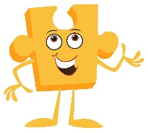 | Art  Painting:  - understand the term ‘still life’  - observe, analyse and comment on still life paintings from different time periods, expressing preferences using art terminology  - know that using lighter and darker tints and shades of a colour can create a 3D effect  - observe colour and suggest why it has been used  - explore different brush strokes and why / when they might be used  - use a range of brushes to create different effects.  - create all the colours needed to create mood in still life painting.  - know how to create texture.  - know and can explain: Colour mix/ colour match/ warm and cool colours/ hue/ tertiary colours  - discuss how they are influenced by the work of other artists
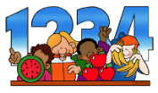  Maths  - multiply 2 and 3 digit  numbers by a 1 digit number using  the formal written method  - multiply 3 numbers  - multiply by 1 and 0  - know and use division facts linked to times tables  - apply multiplication and division facts to problem solving | RE  Salvation: Why do Christians call the day that Jesus died “Good Friday”?  • know that Christians see Holy Week as the culmination of Jesus’ earthly life, leading to his death and resurrection.  • say what each event of Holy week means for Christians today including Palm Sunday, the Last Supper, Judas’ betrayal, Peter’s denial, the Crucifixion and the Resurrection.  • know that most Christians believe that Jesus rose from the dead and so is alive today.  • know that for some Christians today, standing up for your faith can risk ridicule and even persecution.  • use knowledge built through this and previous units as well as collective worship to explain why Christians call this Good Friday. | Design Technology
Science (Living Things)  - recognise that living things can be grouped in a variety of ways  - explore and use classification keys to help group, identify and name a variety of living things in their local and wider environment  - construct and interpret a variety of food chains, naming producers, predators and prey  - recognise that environments can change and that this can sometimes pose dangers to living things. | Geography: How is the USA similar to/ different from the UK?  - explain what places are like using maps, offering reasons for some of my observations and judgements  - use a variety of maps of different scale to locate places  - identify the position and significance of Equator, Northern and Southern hemisphere, Tropics of Cancer and Capricorn, Arctic and Antarctic circle  - use maps and atlases to locate North America and the countries within it  - locate the USA and know that it is formed of states, naming some of these  - know the significance of the Prime Greenwich meridian and that there are different time zones across the USA/World  - make more detailed comparisons of human and physical geography between the USA and the UK, including climate zones and biomes | Music (Kapow – Rock’n’Roll)  • perform the hand jive hand actions in sequence and in time with the music  • sing in tune and perform their actions in time.  • play the notes of the walking bass in the correct sequence  • independently play their part with some awareness of the other performers
Computing (Programming)  - develop the use of count-controlled loops in a different programming environment  - explain that in programming there are infinite loops and count controlled loops  - develop a design which includes two or more loops which run at the same time  - modify an infinite loop in a given program  - design a project that includes repetition  - create a project that includes repetition  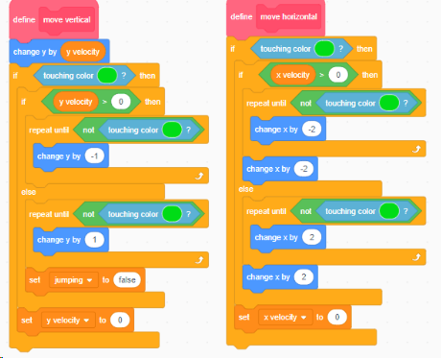 | History | 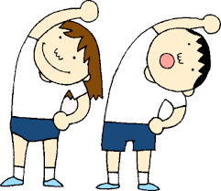  PE  Netball  - defend one on one, and know when to win the ball.  - move to a space to help the team to keep possession and score goals.  - pass, receive and shoot the ball with increasing control.  - use simple tactics to help the team score or gain possession.  - communicate with teammates to apply simple tactics.  Fitness  • explain what happens to the body with exercise  • provide feedback using key terminology  • I can show balance when sprinting, and changing direction at speed
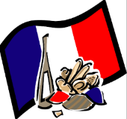
French

- further develop knowledge of Paris and its large parks and gardens.
- understand that in French, nouns can be either masculine or feminine and that this is known as the gender. Determiners in French must match the gender.
- know a range of common animal nouns, both masculine and feminine, such as un canard, un renard, une abeille and une baleine
- know an increasing range of sentence starters (fronted adverbials), such as dans la mer, dans le jardin, dans les bois, à Paris, à Londres.

Year 4: Spring Term (Second Half)
English  - Discuss words & phrases that capture the imagination  - Participate in discussion about both books that are read to them and those they can read for themselves, taking turns and listening to what others say  - Recognise a variety of forms of poetry  - Identify & summarise ideas  - Use VIPERS to ask and answer questions about texts  - Plan writing based on familiar forms  - Organise writing into paragraphs  - Use simple organisational devices  - Vary sentence openers  - Use fronted adverbials with commas  - Evaluate own and others’ writing  - Spelling – The /s/ sound spelled /c/, the sol, real , phon and sign word families, Prefixes: super-, anti-, auto-, bi | PSHE / Jigsaw  Healthy Me  - know some ways to resist if people are putting pressure on  - explain the facts about smoking and its effects on health  - explain the facts about alcohol and its effects on health  - identify the feelings of anxiety and fear associated with peer pressure | Art
Maths  - Recognise and show, using diagrams, families of common equivalent fractions.  - Count up and down in hundredths; recognise that hundredths arise when dividing an object by 100 and dividing tenths by ten.  - Solve problem involving increasingly harder fractions to calculate quantities, and fractions to divide quantities, including non-unit fractions where the answer is a whole number.  - Add and subtract fractions with the same denominator.  - Recognise and write decimal equivalents of any number of tenths or hundredths.  - Recognise and write decimal equivalents to ½ ¼ ¾  - Find the effect of dividing a one or two digit number by ten and one hundred identifying the value of the digits in the answer as ones, tenths and hundredths.  - Round decimals with one decimal place to the nearest whole number.  - Compare numbers with the same number of decimal places up to two decimal places.  - Solve simple measure and money problems involving fractions and decimals to two decimal places. | RE  Islam: What do Muslims believe?  • explain that Islam is a world religion and recognise the symbol of Islam.  • know the people who follow Islam are called Muslims.  • know that Allah is the Islamic name for God, and that in the Islamic religion he has 99 names.  • recall some key facts about Muhammed and how the Qu’ran was created and should be treated.  • identify the 5 pillars of Islam and how they affect the daily life of Muslims, comparing this to own experience. | Design Technology (Soup Making)  - explain what ACCESS FM stands for  - explain the importance of washing hands before food preparation  - explain the importance of using a sharp knife carefully  - explain the importance of using a chopping board when cutting.  - explain the importance of safety when using a hob.  - explain what a blender is used for and the importance of safety when using it.  - create a list of ingredients for my soup as well as a list of instructions to follow.  - write an evaluation using the agreed elements Cost, Customer & safety when judging the success of the soup.
Science (Animals including humans)  - describe the simple functions of the basic parts of the digestive system in humans  - identify the different types of teeth in humans and what they do  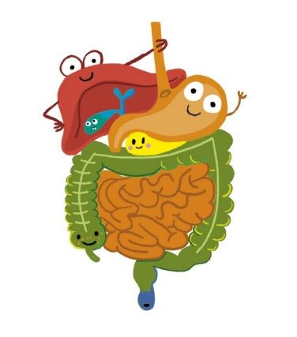 | Geography | Music (Production – SuperStan!)  - sing in tune and perform their actions in time  - play and perform in solo and ensemble contexts, using their voices with increasing accuracy, fluency, control and expression
French
- use the verb je vois to answer questions about what animals can be seen.
- use speaking frames to create simple spoken sentences using several word types.
- use writing frames to create simple written sentences using several word types.
- recognise and spell colour adjectives accurately.
- recognise the grapheme ‘oi’, and know how to pronounce it in English – as in oil, boil and soil, and in French – as in poisson, bois, trois and étoile
- know that a cognate is a word in one language that is related in origin to a word in another language.
Computing (Photo Editing)  - explain that digital images can be changed  - change the composition of an image  - describe how images can be changed for different uses  - make good choices when selecting different tools  - recognise that not all images are real  - evaluate how changes can improve an image | History – Anglo-Saxon England  Children know that:  - Britain was made up of a number of independent kingdoms.  - Movement of tribes – Angles, Jutes and Saxons first raiding, then settling.  - Tribes came because they wanted farm land that didn’t flood.  - The Tribes living/settling in England after the Romans left in 476CE: Anglo-Saxons, Celts and Scots  - Anglo-Saxons arrived Pagan but converted to Christianity.  - People mainly lived in small farming settlements/communities.  - Place names gave an indication of who had invaded different areas.  - There are differences in the language used during the medieval period and that used in modern Britain.  - There are differences between Romano-British and Anglo-Saxon houses, which impacted on the daily life of the people living in them. | PE  Tennis:  - return to the ready position to defend the court.  - sometimes play a continuous game.  - use a range of basic racket skills.  OAA:  • accurately follow and give instructions.  • confidently communicate ideas and listen to others.  • identify key symbols on a map and use a key to navigate around a grid.

