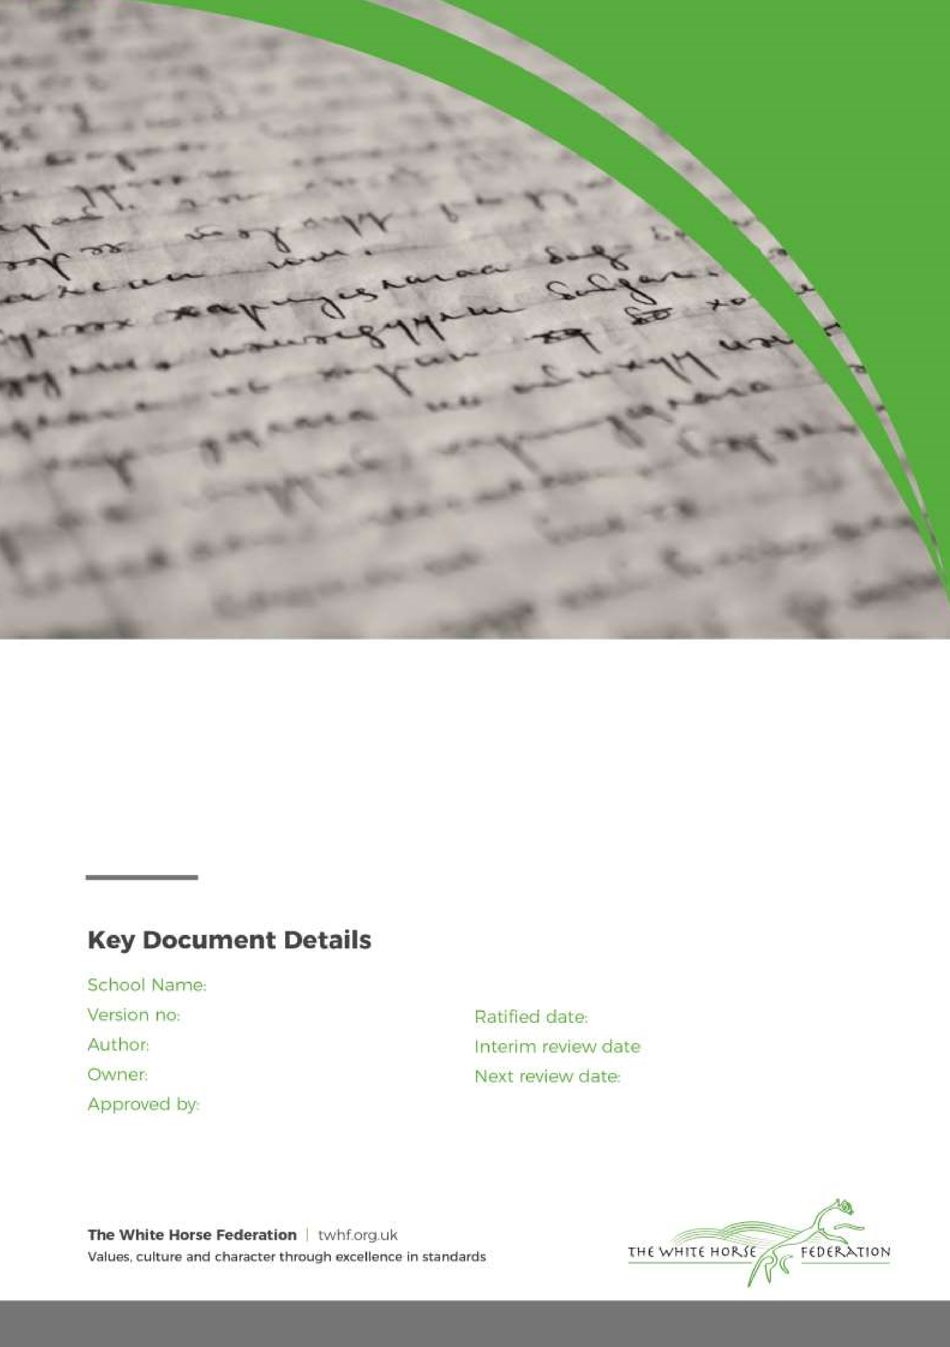

Behaviour Statement of Procedures and Anti-Bullying Procedures

a

6

Candida Hutchinson

Principal

July 2023

September 2026

Gorse Hill School

September 2025

|  |  |
| --- | --- |
| **Page 2** | **Part One – Behaviour Statement of Procedures** |
| **Page 12** | **Part Two – Anti -Bullying Procedures** |

**Part One**

**Behaviour Statement of Procedures**

**1. Aims and Expectations:**

As part of The White Horse Federation, Gorse Hill Primary School implements TWHF Behaviour and Discipline Policy. To ensure that it is effectively implemented across the whole school, this document identifies the localised procedures and expectations to ensure that there is a consistent approach to behaviour management and in celebrating positive behaviours and the achievements of individuals.

It is our primary aim at Gorse Hill School that every member of the school community feels valued and respected and that each person is treated fairly. We are a caring community and we encourage all of our stake holders to be the best version of themselves, all of the time.

Our approach is a means of promoting good relationships so that all members of our school community can work together with the common purpose of helping everyone to learn. This policy supports the school community in aiming to allow everyone to work together in an effective and considerate way.

At Gorse Hill School, we recognise that behaviour is a form of communication and it is the intention of this policy to outline how, as a school, we consistently reward positive behaviour and manage instances of behaviour that does not meet our expected standard, ensuring that appropriate support is put in place, where necessary.

This policy aims to help children to grow in a safe and secure environment and to become positive, responsible and increasingly independent members of the school community who can take care of themselves, each other and the world they live in.

**2. Our school CARE Values:**

All members of our school community are encouraged to be the best version of themselves, all of the time, and this ethos is underpinned by our CARE values: Courage, Appreciation, Respect, Responsibility and Excellence. Our CARE values enable our pupils to grow into responsible, independent and considerate citizens.

**C** - We show **courage** when faced with a challenge;

**A** - We show **appreciation** for the rights, faiths and beliefs of others;

**R** - We **respect** and take **responsibility** for ourselves, each other and our environment;

**E** - We aim for **excellence** through having high expectations.

**2. Expectations:**

At Gorse Hill School, we have high expectations for children’s behaviour, attitudes to learning and personal conduct, and we advocate that all children at Gorse Hill School have the right to:

* Learn
* Be safe
* Be respected
* Be valued and appreciated

Children and staff are expected to demonstrate our CARE Values through their own personal conduct, which included, but are not limited to:

* Holding doors for others
* Listening to others
* Showing good manners (using ‘please’ and ‘thank you’)
* Entering a classroom ready to learn
* Transitioning around the building quietly, sensibly and safely
* Wearing the correct school uniform and wearing it smartly

**2. Rewarding Positive Behaviour and Learning Attitudes:**

**House Teams and House Points:**

At Gorse Hill School, each pupil (and staff member) is assigned to a House Team to which they belong as a valued member of during their time at Gorse Hill. Our House Teams are named after **‘the elements’** and are:

* Red Fire
* Yellow Air
* Green Earth
* Blue Water

As a school, we use House Points to reward pupils for their positive behaviour and attitudes to learning. The use of House Points does not only reward pupils for their individual efforts, but also encourages a sense of team reward, with House Points being added to a communal tally for each House Team. We have three types of House Point, each with different values and a criteria for reward:

* White House Point (Value of 1 HP) – *awarded to pupils who exemplify a value or learning behaviour (this will often link to the use of Recognition Boards, explained below)* White HPs can be awarded by all members of staff. These are commonly awarded in classes.

* Black House Point (Value of 5 HP) – *awarded to pupils who have 100% attendance in one term; represent the school in a special way; other examples as appropriate.*
* Gold House Point (Value of 10 HP) – *this is a very special award and is awarded by the Head Teacher for pupils who have deserved recognition for a particularly special achievement.* Gold HPs can be awarded by the Head Teacher or a member of the SLT. Usually, these will only be awarded in assembly for public recognition.

Within classrooms, each child’s name is added to a ‘House Point Tally Chart’ and class teachers use this to track the House Points achieved by individual pupils.

When a child earns a particular number of House Points, they are awarded with a badge which they can proudly wear on their school uniform:

* Bronze Badge = 50 HPs
* Silver Badge = 100 HPs
* Gold Badge = 150 HPs

As a school, we do not use any other form of reward (e.g. Class Dojo/Marbles in a Jar) – this is to ensure a consistent approach to rewarding positive behaviour and attitudes to learning across the school.

**Recognition Boards:**

As a school, we use Recognition Boards to publicly praise and celebrate the positive behaviour and learning attitudes of our pupils. Our use of Recognition Boards was inspired by the behaviour expert, Paul Dix. Each classroom has their own Recognition Board that includes our CARE Values, learning behaviours that are an agreed focus between the class teacher and their pupils, and pupil names. All children start on ‘It’s good to be green’ and their names will be moved to a value or learning behaviour when these are demonstrated by the individual pupil. In turn, they are awarded with a House Point.

As a school, we do not publicly display any warnings that the children may receive should they behaviour fall below our expected standard. Instead, this is dealt with privately between the supervising adult and the individual child. The minor exception to this principle is evident in the Early Years and Key Stage 1 where ‘sun and cloud’ behaviour barometers *may* be used to visually reinforce the use of ‘good’ choices and ‘poor’ choices with younger children, as they learn to develop their self-regulation.

**Headteacher Values & Dazzlers Certificates:**

Each week, a child in each class is chosen by their class teacher to receive a certificate for demonstrating one of the CARE Values. A pupil is also chosen as a ‘Dazzler’ in recognition of their positive work. These pupils are publicly recognised and their achievement celebrated in our weekly celebration assembly. Pupils who are awarded a values certificate receive two House Points.

**Positive notes home:**

We value the contribution that parents and carers make to our school and their child’s development. We also value the positive impact that sharing a child’s achievements can have. As a result, positive notes home are sent home in recognition of achievements. Children will receive five HPs if they receive a positive note home.

3. **Consequences for behaviour that is not in line with our expectations and CARE Values:**

Examples of behaviour that does not meet our expected standards include, but are not limited to the following. The following behaviours are for staff to consider the consequence to in relation to the child’s needs, although additional needs will not be an excuse for negative behaviour.

|  |  |  |  |
| --- | --- | --- | --- |
|  | Learning environment (in school or off-site) | | |
|  | Low-Level | Mid-Level | High-Level |
| * Behaving in an unfriendly way towards another child and excluding others * Talking out of turn, calling out * Disturbing/disrupting the learning of other children * Being off task * Not telling the truth * Inappropriate wandering around the classroom during focussed learning time * Teasing / name calling | | * Ignoring instructions * Not respecting school equipment e.g. throwing equipment in class * Speaking disrespectfully * Behaving disrespectfully * Continuing to disturb the class * Physical contact with another child (low level) * Continuing to call others unkind names * Continuing to break rules * Continual teasing * Repeatedly shouting out * Purposefully not engaging in learning | * Serious damage to school equipment * Swearing including gestures * Intentionally hurting others * Fighting * Using racist or in appropriate language * Dangerous/Threatening behaviour * Throwing furniture * Verbally abusive language towards others * Acting dangerously * Consistent bullying * Physically hurting others * Continuing to ignore instructions * Stealing resources/others possessions * Purposefully leaving classroom without permission * Continuation of behaviours on return from an exclusion * Child on child sexual abuse |

|  |  |  |  |  |  |
| --- | --- | --- | --- | --- | --- |
|  |  |  | Playground |  |  |
|  | Low-Level |  | Mid-Level |  | High-Level |
| * Behaving in an unfriendly way towards another child and excluding others * Play fighting / rough play * Messing around in the toilet * Disturbing/Disrupting other’s * games * Not telling the truth * Not following school rules * Squabbling * Unkind to others * Name calling * Not sharing * Not lining up | | * Ignoring instructions * Not respecting school equipment * Speaking disrespectfully * Behaving disrespectfully * Continuing to disturb other’s games * Deliberate physical contact with another child * Taking something that isn’t theirs * Continuing to call others * unkind names * Swearing * Back chatting (disrespectful) * to adults * Pushing (consistently) * Constantly going in and out of building * Disrespectful towards school resources | | * Serious damage to school equipment * Swearing including gestures * Intentionally hurting others * Fighting * Using racist or in appropriate * language * Dangerous/Threatening behaviour * Physically hurting others * Continuing to ignore instruction * Pushing (intending to cause harm) * Child on child sexual abuse | |

**Graduated Approach:**

At Gorse Hill School, we use a graduated system for dealing with negative behaviour that follows these steps:

* + Reminder of what constitutes good behaviour from a MDSA/TA/Class teacher
  + Explanation of the impact of the poor behaviour and the expected behaviour that is desired
  + Time Out (in or out of the classroom)
  + Time Out (in partner classroom)
  + Key Stage Leader/Phase Leader
  + Head Teacher/SLT
  + Phone home/talk to home
  + Behaviour incident logged. The class teacher must ensure they have spoken to the parent(s) of children involved in the incident on the day it has occurred.
  + If a child becomes withdrawn, or there are noticeable changes in their behaviours, the class teacher must contact the inclusion lead to discuss the behaviours and identify appropriate support to be put into place (for example, appropriate intervention strategies).
  + If changes in behaviour become a pattern, staff members should consider whether the pupil may have an unmet need, and raise this with the SENCO in the first instance.

**Use of Sanctions/Consequences:**

Children are made aware of the consequences of their actions (both positive and negative) through the school’s Behaviour Consequences Ladder (Appendix 1).

The school will sanction pupils for incidents of negative behaviour. These sanctions vary according to the severity of the behaviour, but range from:

* A verbal warning
* Time out in another classroom
* Loss of privilege (play time/part of lunch time) *NB: children will always have an opportunity to eat their lunch*
* Reasonable adjustments as determined by the Head Teacher/SLT
* Suspension
* Permanent exclusion

If there is a concern that a child is being bullied, staff members will follow the Anti-Bullying Policy. All incidents of significant negative behaviour (mid-level and high-level) will be recorded. If a child repeatedly acts in a way that disrupts or upsets others, the school will contact the child’s parents/carers to arrange a time to discuss the situation further.

**Child on Child Abuse**

We recognise that children are capable of abusing other children. We understand that the pupil/student who is perpetrating the abuse may also be at risk of harm. We will make every effort to ensure that the perpetrator is also treated as a victim and supported appropriately. Child on Child abuse can include but are not limited to sexual harassment, sexting and sexual violence.

**Sexual Harassment/Violence**

* Our school makes clear that sexual violence and sexual harassment is not acceptable, will never be tolerated and is not an inevitable part of growing up.
* All incidents of sexual harassment or violence will be recorded, reported and investigated.
* Will be reported to the safeguarding team.
* Staff will follow the safeguarding procedures set out in the safeguarding policy. (See Safeguarding Policy for further information)
* Parents will be informed.
* Additional lessons using Jigsaw and NSPCC resources relevant to the incident e.g. Use of the pants rule
* Pastoral support for the parties involved

For further information please refer to the school’s anti-bullying procedures at the end of this policy.

**Physical support and Intervention (i.e. use of Team Teach)**

There may be instances where it is appropriate to physically support or remove a child due to the risk of harm to themselves or others or serious disruption of others learning. There are members of staff that are trained in Team Teach which support both staff member and child in being safely supported or removed. However, it must be noted that all staff may use reasonable force to intervene in an emergency or to defend themselves in circumstances where they have a genuine fear of being injured or believe a child or young person or indeed any adult may be at risk. A calm and measured approach to a situation is needed and members of staff should never give the impression that they have lost their temper, or are acting out of anger or frustration, or to punish the child or young person. Use of reasonable force is always a last resort. (see Appendix 3 for more guidance around physical Intervention / reasonable force) All members of staff are aware of the regulations regarding the use of force by teachers, as set out in DfEE Circular 10/98, relating to section 550A of the Education Act 1996: The Use of Force to Control or Restrain Pupils. Teachers in our school do not hit, push or slap children. Staff only intervene physically to restrain children or to prevent injury to a child, an adult, or if a child is in danger of hurting him/herself. The actions that we take are in line with government guidelines on the restraint of children. This policy should be read in conjunction with the White Horse Federation policy on physical restraint of pupils. All incidents involving the use of force will be recorded by staff involved as soon possible no in CPOMS using the physical intervention log. Parents will always be informed if their child has been involved in an incident where physical intervention from staff has been required.

**4. Roles and Responsibilities:**

The effective behaviour management of pupils is the responsibility of all adults within the school. All adults, irrespective of role, experience or seniority, are expected to play an equal and integral part in managing pupil behaviour through:

* Modelling high standards of personal behaviour and our CARE Values;
* Referring to the CARE Values in dialogue with the children;
* Recognising and celebrating positive behaviour;
* Fairly and consistently applying our behaviour policy – use of reward and sanction;
* Challenging and dealing with negative behaviour, only escalating when the behaviour is serious; ➢ Taking professional ownership of managing pupil behaviour.

**The Role of the Class Teacher:**

It is the responsibility of the class teacher to ensure that the school rules are implemented in their class and that their class behaves in a responsible manner at all times.

The class teacher is always the first point of contact in dealing with behaviour issues – issues can be escalated if required.

The class teachers in our school have high expectations of the children regarding behaviour, and they strive to ensure that all children work to the best of their ability. Staff recognise that sometimes behaviour is a form of communication and their actions should always be to resolve the behaviour in a fair and objective way.

It is the responsibility of the class teacher to ensure that their classroom behaviour management is in line with this policy, including the use of House Points, Recognition Boards, Positive notes home and the use of the graduated approach in dealing with negative behaviour.

If a child misbehaves repeatedly in class, the class teacher keeps a record of all such incidents. In the first instance, the class teacher deals with incidents him/herself in the normal manner. However, if misbehaviour continues, the class teacher seeks help and advice from the Phase lead or a member of SLT (Appendix 1).

The school liaises with external agencies, as necessary, to support and guide the progress of each child. The class teacher may, for example, discuss the needs of a child with the SEMH outreach service after discussing their behaviour with parents/carers.

The class teacher reports to parents about the progress of each child in their class, in line with the whole– school policy. The class teacher may also contact a parent if there are concerns about the behaviour or welfare of a child.

**The Role of the Learning Mentor:**

At Gorse Hill School, we have two Learning Mentors. Our Learning Mentors have ELSA training and their role is to support vulnerable and targeted pupils who have behaviour and emotional needs.

In order to request the involvement of a Learning Mentor, the class teacher must complete a Referral Form.

Learning Mentors should not be called upon to deal with a pupils’ behaviour that should otherwise be dealt with by the supervising adult, usually the class teacher or teaching assistant.

**The Role of Phase Leaders and SLT:**

It is the responsibility of the Phase Leaders and the SLT to support class teachers in managing the behaviour of pupils and in implementing the standards expected of the policy. It is expected that class teachers (or the adult witnessing) will deal with low-level behaviour and mid-level behaviour, seeking the support of Phase Leaders when required, who are responsible for standards of behaviour within the phase. Any high-level behaviour should be immediately reported to a member of the SLT. The SLT should also be made aware of any mid-level behaviour that is frequent and persistent. It is the the role of the Phase Leader / SLT to arrange a meeting with the parent/carer, as required, to inform them of their child’s behaviour, discuss sanctions and required actions to prevent this behaviour.

**The Role of the Head Teacher:**

It is the responsibility of the Head Teacher, under the School Standards and Framework Act 1998, to ensure that all staff implement the school behaviour policy consistently throughout the school, and to report to governors, when requested, on the effectiveness of the policy. It is also the responsibility of the Head Teacher to ensure the health, safety and welfare of all children in the school.

The Head Teacher supports the staff by implementing the policy, by setting the standards of behaviour, and by supporting staff in the implementation of the policy.

The Head Teacher keeps record of all reported serious incidents of misbehaviour. These are discussed, monitored and reviewed by the Head Teacher.

The Head Teacher is the only person who has the responsibility for issuing suspensions to individual children for serious acts of misbehaviour. For repeated or very serious acts of anti-social behaviour, the Head Teacher may permanently exclude a child. Both these actions are recorded and reported to the LA, Governors and TWHF Executive Director (Primary).

**The Role of Parents & Carers:**

At Gorse Hill School, we work collaboratively with all parents/carers to enable a positive working relationship. We expect parents/carers to support their child’s learning, and to co-operate with the school, as set out in the Home–School Agreement. We aim to build a supportive dialogue between the home and the school, and we inform parents immediately if we have concerns about their child’s welfare or behaviour.

Pupils’ learning is enhanced by a positive relationship between home and school. Parents can contribute in the following ways:

* Being an ambassador and role model of our CARE Values to their child/ren
* Being interested in their child’s learning
* Understanding and supporting school procedures and rules
* Being willing to support activities related to school
* Being aware of their child’s role within the community
* By ensuring their child is ready for the school day by being punctual, in the correct uniform and ready to learn
* By communicating effectively with staff by:
* Reading and responding appropriately to school letters
* Making appointments to see staff about concerns where necessary
* Providing up to date emergency contact numbers
* Attending parents’ evenings and school meetings
* Informing the school of absence by telephoning on the first day.

**The Role of Governors:**

The Local Governing Body has the responsibility of setting down these general guidelines on standards of behaviour, and of reviewing their effectiveness.

The Head Teacher has the day-to-day authority to implement the school behaviour policy, but governors may give advice to the Trust Directors about particular disciplinary issues. The Trust Directors must take this into account when making decisions about matters of behaviour.

1. **Incidents involving children with SEN, disabilities and or medical conditions and Social, Emotional and Mental Well-being needs:**

As a school we recognise the impact of trauma and adversity on children’s mental and physical health and behaviour.

The SENCO and Inclusion team will monitor the behaviour of identified children and support staff with implementing appropriate strategies to manage behaviours that are challenging, disruptive or withdrawn to enable to child to access all aspects of school life.

Support can include:

* + ELSA (Emotional Literacy Support Assistant)
  + ABC charts (identifying behaviour patterns and triggers)
  + Drawing and talking time
  + ARC outreach support
  + Behaviour charts
  + Communication logs home
  + Learning mentor and inclusion lead support

When using reasonable force in response to risks presented by incidents involving children with SEN or disabilities or with medical conditions, at Gorse Hill School, we consider the risks carefully recognising the additional vulnerability of these groups.

As a school we consider our duties under the Equality Act 2010 in relation to making reasonable adjustments by planning positive and proactive behaviour support. This is done through the drawing up of individual behaviour plans for more vulnerable children, and agreeing them with parents/carers. We recognise by doing this as a school we reduce the occurrence of challenging behaviour and the need to use reasonable force.

1. **Suspensions and permanent exclusions:**

For information on suspensions and exclusions, please see TWHF Behaviour Policy for reference.

The school follows the process and procedures outlined in the Government’s September 2023 Suspensions and Exclusions guidance - https://assets.publishing.service.gov.uk/government/uploads/system/uploads/attachment_data/file/11624 01/Suspension_and_permanent_exclusion_guidance_May_2023.pdf

As outlined, only the Head Teacher has the power to exclude a pupil from school. The Head Teacher may suspend a pupil for one or more fixed periods, for up to 45 days in any one school year. The Head Teacher may also exclude a pupil permanently. In exceptional cases it is also possible for the Head Teacher to convert a suspension into a permanent exclusion if further evidence comes to light and the circumstances warrant this. If the Head Teacher excludes a pupil, s/he informs the parents immediately, giving reasons for the exclusion. At the same time, the Head Teacher makes it clear to the parents/carers that they can, if they wish, appeal against the decision to the governing body. The school informs the parents how to make any such appeal. The Head Teacher informs the LEA and the governing body about any permanent exclusion, and about any suspensions beyond five days in any one term. The governing body itself cannot either exclude a pupil or extend the exclusion period made by the Head Teacher. The governing body has a discipline committee which is made up of between three and five members. This committee considers any exclusion appeals on behalf of the governors. When an appeals panel meets to consider an exclusion, they consider the circumstances in which the pupil was excluded, consider any representation by parents and the LA, and consider whether the pupil should be reinstated. If the governors’ appeals panel decides that a pupil should be reinstated, the executive Head Teacher and Head Teacher of that setting must comply with this ruling.

1. **Monitoring:**

The Head Teacher monitors the effectiveness of this policy on a regular basis. The Head Teacher also reports to the governing body on the effectiveness of the policy and, if necessary, makes recommendations for further improvements.

1. **Review:**

The governing body reviews this policy every two years. The governors may, however, review the policy earlier than this, if the government introduces new regulations, or if the governing body receives recommendations on how the policy might be improved.

1. **Related Policies:**

This policy should be read in conjunction with:

* + Anti-Bully Policy
  + TWHF Behaviour Policy
  + Safeguarding and Child Protection Policy

**Part Two**

**Anti -Bullying Procedures**

**Aims and objectives**:

At Gorse Hill Primary School, bullying is unacceptable and can damage children’s individual and educational needs. We therefore do all we can to prevent it, by developing a school ethos in which bullying is not tolerated under any circumstances. This policy aims to produce a consistent school response to any bullying incidents that may occur. We aim to make all those connected with the school aware of our opposition to bullying, and we make clear each person’s responsibilities with regard to the eradication of bullying in our school.

**Our CARE Values**

At Gorse Hill School, we encourage all members of our community to *‘be the best version of themselves, all of the time.’* We do this through the teaching and living of our CARE Values which encourage our pupils to take care of themselves, others and the environment they live in.

Safeguarding and ensuring the well-being of our pupils is the most important work that we do as a school and we use our CARE Values as a vehicle to promote a sense of inclusion and support our children’s personal development, well-being and safety.

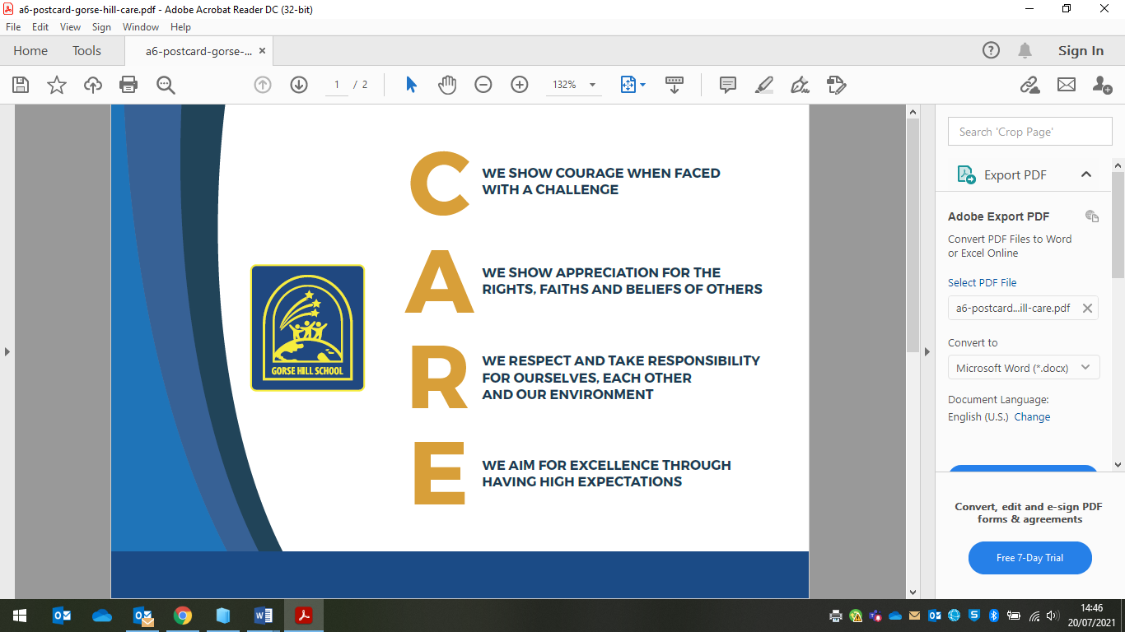

**Our School:**

* Discusses, monitors and reviews our Anti-Bullying Policy on a regular basis.
* Supports staff to promote positive relationships and identify and tackle bullying appropriately.
* Ensures that pupils are aware that all bullying concerns will be dealt with sensitively and effectively; that pupils feel safe to learn; and that pupils abide by the anti-bullying policy.
* Reports back to parents/carers regarding their concerns on bullying and deals promptly with complaints. Parents/ carers in turn work with the school to uphold the anti-bullying policy.
* Seeks to learn from good anti-bullying practice elsewhere and utilises support from the Local Authority and other relevant organisations when appropriate.

**A Definition of Bullying:**

Bullying is a subjective experience that can take many forms. Various national and international definitions of bullying exist and most of these definitions have three things in common which reflect children’s experience of bullying and evidence gained from extensive research in this area. The three common aspects in most definitions of bullying are that:

* It is deliberately hurtful behaviour
* It is usually repeated over time
* There is an imbalance of power, which makes it hard for those being bullied to defend themselves.

**Forms of Bullying**

Bullying behaviour across all types of bullying can represent itself in a number of different forms. Children and young people can be bullied in ways that are:

**Physical** – by being punched, pushed or hurt; made to give up money or belongings; having property, clothes or belongings damaged; being forced to do something they don’t want to do.

**Verbal** – by being teased in a nasty way; insulted about their race, religion or culture; called names in other ways that discriminate or having offensive comments directed at them.

**Indirect** – by having nasty stories told about them; being left out, ignored or excluded from groups.

**Electronic / ‘cyberbullying’** – via text message; via instant messenger services and social network sites; via email; and via images or videos posted on the internet or spread via mobile phones or other electronic devices.

**Specific Types of Bullying**

The school recognises that although anyone can be bullied for almost any reason or difference, some children may be more vulnerable to bullying than others. Research has identified various different types of bullying experienced by particular vulnerable groups of children. These include:

* Bullying related to race, religion or culture
* Bullying related to special educational needs (SEN) or disabilities
* Bullying related to being of higher ability
* Bullying related to appearance or health conditions
* Bullying related to sexual orientation
* Bullying of young carers or looked–after children or otherwise related to home circumstances
* Sexist, sexual or transphobic bullying.
* Derogatory language – relating to race, religion, culture, special educational needs, disability, age, gender, sexual orientation, appearance, health conditions, family/home circumstances.

The school recognises that bullying is a complex type of behaviour occurring between individuals and groups. Different roles within bullying situations can be identified and include:

* The ring-leader, who through their position of power can direct bullying activity
* Assistants/associates, who actively join in the bullying (sometimes because they are afraid of the ring-leader)
* Reinforcers, who give positive feedback to those who are bullying, perhaps by smiling or laughing
* Outsiders/bystanders, who stay back or stay silent and thereby appear to condone or collude with the bullying behaviour
* Defenders, who try and intervene to stop the bullying or comfort pupils who experience bullying.

Some children can adopt different roles simultaneously or at different times e.g. a bullied child might be bullying another child at the same time, or a ‘reinforcer’ might become a ‘defender’ when the ringleader is not around.

We positively encourage all pupils to take responsibility for their behaviour and its consequences and to make a commitment to take action to end the bullying and provide support for the bullied pupil.

**Preventing, Identifying and Responding to Bullying**

We will:

* Work with staff and outside agencies to identify all forms of prejudice driven bullying.
* Seek pupil’s views on our school and how happy and safe they feel.
* Actively provide systematic opportunities to develop pupils’ social and emotional skills, including their resilience.
* Consider all opportunities for addressing bullying and child on child sexual abuse through the curriculum, displays, peer support, inclusion team support, NSPCC Talk PANTS, PSHE and RSHE lessons, the School Council and consistent use of the school’s CARE Values.
* Train all staff to identify bullying and follow school policy and procedures on bullying.
* The work of the Learning Mentor to ensure that vulnerable children are supported and protected from bullying or becoming a bully.
* Actively create “safe spaces” for vulnerable children.

**Involvement of Pupils**

We will:

* Regularly canvass children’s views on the extent and nature of bullying.
* Ensure children know how to express worries and anxieties about bullying.
* Ensure all children are aware of the range of sanctions which may be applied against those engaging in bullying.
* Involve children in anti-bullying activities in school.
* Offer support/intervention to children who have been bullied.
* Work with children who have been bullied in order to address the concerns that they have.

**Liaison with Parents and Carers**

We will:

* Ensure that parents / carers know whom to contact if they are worried about bullying.
* Ensure parents know about our complaints procedure and how to use it effectively

**Responsibilities**

The whole school understands that bullying is not tolerated, that we have a zero-tolerance approach to bullying, and understands the steps that will be taken to both prevent and respond to bullying.

**The role of governors**

The governing body supports the Head Teacher in all attempts to eliminate bullying from our school. This policy statement makes it very clear that the governing body does not allow bullying to take place in our school, and that any incidents of bullying that do occur are taken very seriously and dealt with appropriately.

The governing body monitors any incidents of bullying reported to them and reviews the effectiveness of the school policy every 2 years. The governors require the Head Teacher to keep accurate records of all incidents of formal and recognised bullying and to report to the governors on request about the effectiveness of school anti-bullying strategies.

The governing body will respond within ten days to any request from a parent to investigate incidents of bullying. In all cases, the governing body notifies the Head Teacher and asks him/her to conduct an investigation into the case and to report back to a representative of the governing body

**The role of the Head Teacher**

1. It is the responsibility of the Head Teacher to implement the school anti-bullying strategy and to ensure that all staff (both teaching and non-teaching) are aware of the school

policy and know how to deal with incidents of bullying. The Head Teacher reports to the governing body about the effectiveness of the anti-bullying policy on request.

1. The Head Teacher ensures that all children understand the definition of bullying, know that it is wrong and that it is unacceptable behaviour in this school.
2. The Head Teacher ensures that all staff receive sufficient training to be equipped to deal with all incidents of bullying.
3. The Head Teacher sets the school climate of mutual support and praise for success to making bullying less likely. When children feel they are important and belong to a friendly and welcoming school, bullying is far less likely to be part of their behaviour.
4. The Head Teacher works collaboratively with Senior Leadership and Inclusion teams to ensure that this policy is upheld.

**The role of the teacher and teaching assistants**

1. Teachers and teaching assistants in our school take all forms of bullying seriously, and intervene to prevent incidents from taking place.
2. If teachers and teaching assistants witness an act of bullying, they do all they can to support the child who is being bullied. If a child is being bullied over a period of time, then, after consultation with the Inclusion lead, the teacher informs the child’s parents.
3. A record is kept on children’s individual records of bullying that occurs outside lesson time, either near the school or on the children’s way home or to school or online. If any adult witnesses an act of bullying, they should inform the a member of the SLT.
4. If, as teachers and teaching assistants, we become aware of any bullying taking place between members of a class, we deal with the issue immediately, in liaison with Inclusion lead. Appropriate support for the victim of the bullying will be put into place, and consequences for the child who has carried out the bullying will be implemented. We spend time talking to the child who has been bullied: we explain why the action of the child was wrong, and we endeavour to help the child change their behaviour in future. If a child is repeatedly involved in bullying other children, we inform the Senior Leadership team. We then invite the child’s parents into the school to discuss the situation. In more extreme cases, for example where these initial discussions have proven ineffective, the school may contact external support agencies.
5. Teachers support all children in their class and establish a climate of trust and respect for all. By praising, rewarding and celebrating the success of all children, we aim to prevent incidents of bullying.

**The role of parents**

Parents who are concerned that their child might be being bullied, or who suspect that their child may be the perpetrator of bullying, should contact their child’s class teacher immediately. Parents have a responsibility to support the school’s anti-bullying policy and to actively encourage their child to be a positive member of the school.