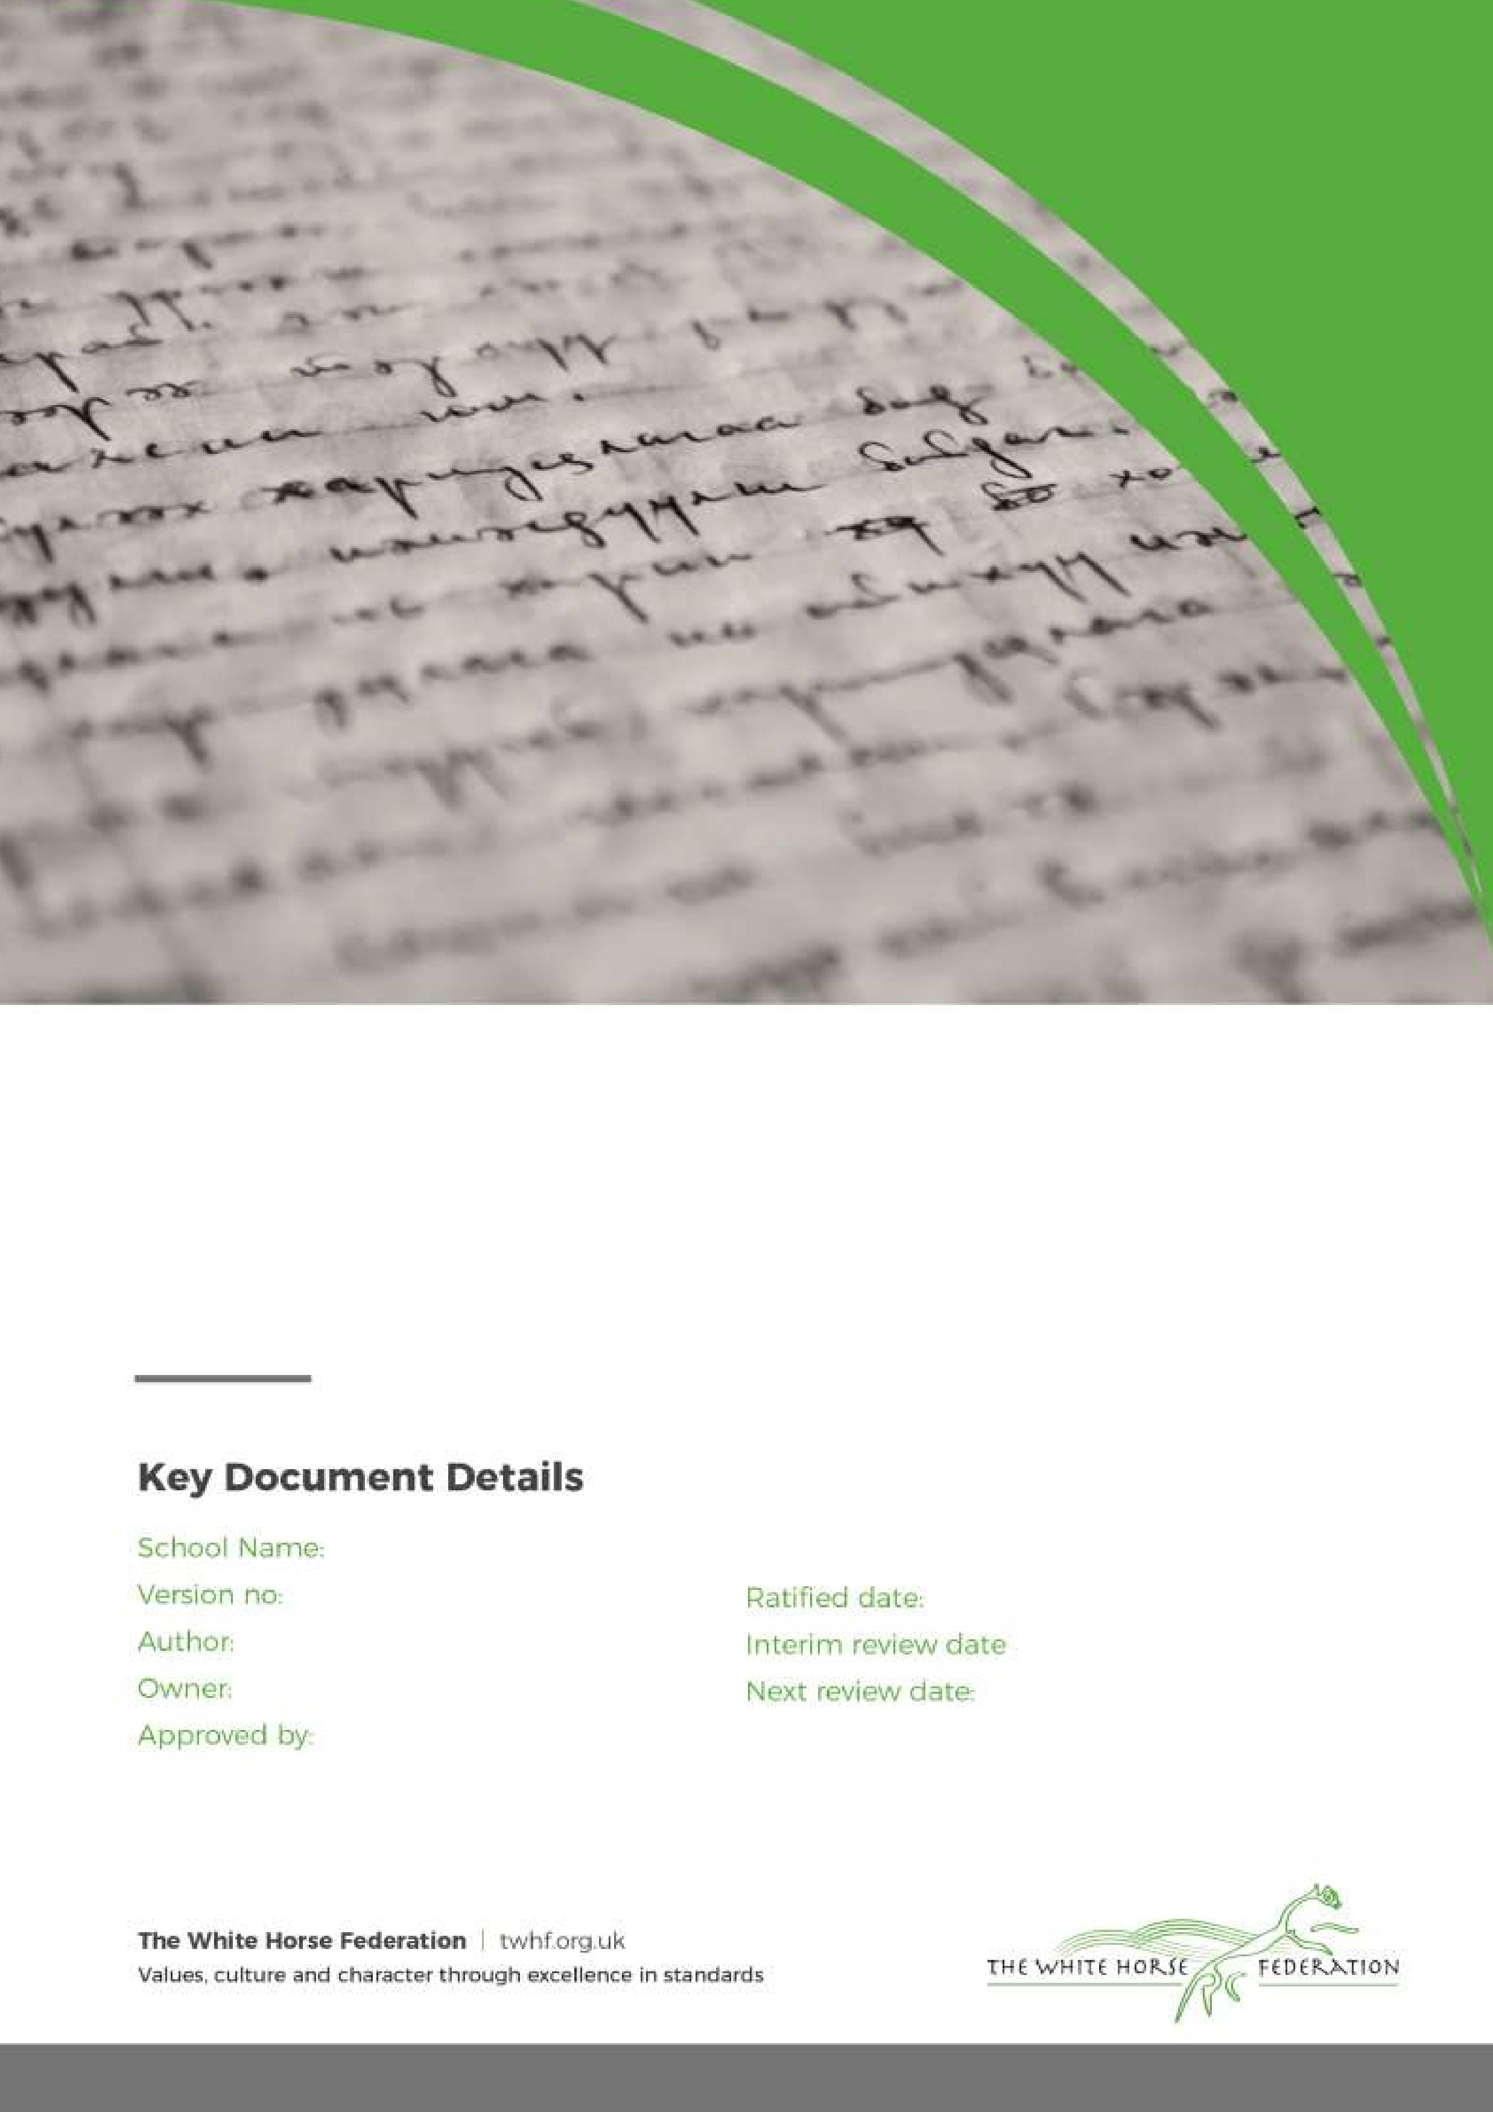

H
omework

Policy

2

L Graham

Principal

Principal

September 2023

n/a

September 2024

G
orse Hill Primary School

Introduction:
Homework is anything that children do outside the normal school day that contributes to their learning in response to guidance from the school. Homework encompasses a whole variety of activities instigated by teachers and parents to support children’s learning. For example, a parent who spends time reading a story to their child before bedtime is helping with homework.

Rationale for homework:
Homework is a very important part of a child’s education and can add much to a child’s development. We recognise the mutual support of parents and teachers in encouraging them to learn both at home and at school. We see homework as an important way of establishing a successful dialogue between teachers and parents. One of the aims of our school is for children to develop as independent learners.

One of our school’s CARE Values is ‘Responsibility’ and we see homework as one way in encouraging our pupils to take responsibility for their learning and personal growth.

We believe that homework is way in which children can acquire the skill of independent learning. Homework plays a positive role in raising a child’s level of attainment. We also acknowledge the important role of play and free time in a child’s growth and development. While homework is important, it should not prevent children from taking part in the wide range of out-of-school clubs and organisations that play an important part in the lives of many children.

Aims and objectives:
The aims and objectives of homework are:
- To encourage the extended family to engage with the child’s learning by providing experiences that are linked to the child’s culture, heritage and personal skills
- To consolidate and reinforce learning experienced in school and to allow children to practice skills taught in lessons
- To help children develop positive work habits to support their life choices in the next stage of their learning
- To help pupils develop the skills and confidence to become an independent learner and to develop
a ‘can do’ attitude
- To encourage reading
- To promote a partnership between home and school in supporting each child’s learning
- To encourage the children to perceive learning as something that happens both at school and at home

Types of homework:
Homework expectations are tailored to the age of each individual child. These expectations include the type and amount of homework that is set for children.

Phase | Amount of time to spend on Homework each week | Homework Expectations
EYFS | 10 minutes a day, which includes reading to an adult | - Daily reading each day to an adult at home  - Practising phonics
Year 1 | 10-15 minutes a day, which includes reading to an adult  Approx 1 hour per week (not including daily reading) | - Daily reading each day to an adult at home  - Practising phonics  - Spellings (linked to phonics)
Year 2, 3 & 4 | 20 minutes a day, which includes reading to an adult  1 hour per week (not including daily reading) | - Daily reading each day to an adult at home  - Times Table Rockstars  - Spellings
Year 5 & 6  To support with transition into Year 6 and then on to secondary school, Year 5 and 6 pupils have additional homework | 20 minutes a day, which includes reading to an adult  1 to 1.5 hour per week (not including daily reading) | - Daily reading each day to an adult at home  - CGP Books for English & Mathematics (x1 activity) – these books should be brought into school each week for marking.  - Times Table Rockstars  - Spellings
All Year Groups |  | On occasions, class teachers may set children project-based homework to be completed over a holiday period. This will link to a topic that the children will be studying in the next term and is often research based, encouraging children to present their work in a variety of ways (e.g. posters, models, scrapbooks, journals, use of ICT).  All children are also encouraged to take part in curriculum-based House Team competitions, sending their entries into school.

Homework resources that we use:

As a school, we set Homework using the following resources:
- ‘Times Table Rockstars’ is an online resource that encourages children to learn their times tables to develop fluency through practice. Pupils have their own account, with their own login. Practising times tables on a frequent basis is proven to support children to develop fluency and confidence in number, enabling them to recall facts quickly. Times Table Rockstars allows pupils to complete in times table games and competitions against other children in their class and children in other schools, to which they earn points for a leader board. The more practice, the more points!
- Reading books – each pupil has a reading book which is either aligned to their age or reading level.
- Spellings – each week, pupils are given a list of spellings which they are encouraged to learn and practise at home using ‘look, cover, write, check’.
- CGP Books are used in Year 5 and Year 6 to support pupils to develop their skills in core subject areas. Homework set will either recap prior learning, build fluency skills or link to current learning.

When is Homework set?

It is expected that children read on a daily basis. The school will change your child’s reading book when necessary. Parents are expected to sign their child’s Reading Record Book.

‘Times Table Rockstars’ can be accessed at any point.

Spellings will be given to your child each week, with these assessed in class the following week.

Year 5 and 6 pupils should bring their Homework books into school each Friday to be reviewed/marked.

The role of Parents & Carers:
Homework is set for children to complete independently, however we encourage parents to support their child (but not do their homework for them!) where possible. Parents and carers can support their child with homework by:
- Agreeing a time/times in the week with your child when they will complete their homework;
- Praise them for completing their homework fully and on time;
- Talking to them about how homework helps them to learn;
- Finding a quiet place for your child to complete their homework;
- Ensure that you sign your child’s Reading Record Book each time they read.

Although, as a school, we believe that homework is important to a child’s learning and development of their independence, we do not believe it to be fair to punish a child for not completing their homework. As a result, children who do not complete their homework will not face any sanctions in school.

Monitoring & Review:
It is the responsibility of our governing body to agree and then monitor the school homework policy. This is done by the committee of the governing body that deals with curriculum issues. Our governing body may, at any time, request from our Headteacher a report on the way homework is organised in our school.

Review and evaluation of the policy:
This policy was drawn up by the Principal and takes into account the workload of staff. The Policy will be reviewed on an annual basis.

