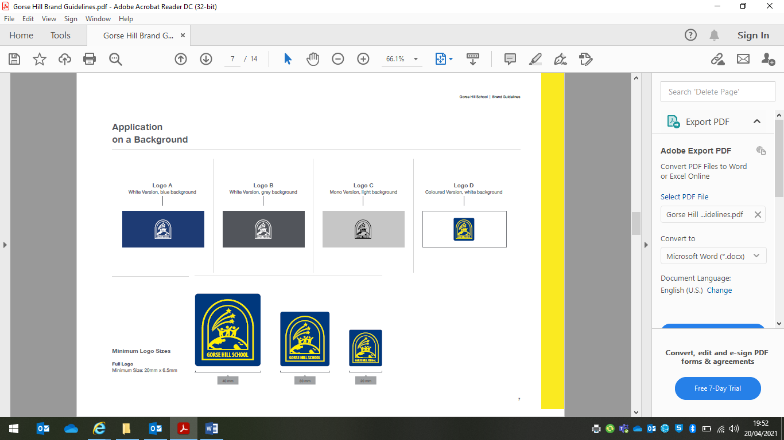

Sports Premium Plan 2025-2026
Allocated Funding 2024-2025: £0
Funding carried forward from 2022/23: £0
Key Indicators for the Primary PE and the Sports Premium:
- Increased confidence, knowledge and skills of all staff in teaching PE and sport;
- Engagement of all pupils in regular physical activity;
- The profile PE and sport is raised across the school as a tool for whole school improvement;
- Broader experience of a range of sports and activities offered to all pupils;
- Increased participation in competitive sport.

Key indicator 1: Increased confidence, knowledge and skills of all staff in teaching PE and sport
Intended impact | Actions to achieve | Funding | How will you ensure sustainable improvement? | Evidence of impact | Suggested next steps
To develop the leadership of PE so that it is more effective in overseeing the quality of education and provision, and wider sporting experiences for pupils. | Provide the PE subject leader with CPD opportunities to develop leadership through attending professional courses and network meetings with other school PE leads. | £1308 | Enabling ongoing professional development and training will enable the PE curriculum lead to be even more effective in their role, leading to sustainability of the leadership of the sports curriculum. | PE lead and Sports Coach have been able to successfully use the knowledge obtained to offer teachers relevant support for upcoming topics. | Planned coaching of ECT and less confident staff members.
Enable PE to be effectively assessed by sports coaches | Re-subscribe to Real PE’s online platform, including subscription to allow for assessment. | £678 | Assessment of children’s PE skills and progress on an on-going basis with adaptations to provision made in light of this. | Teachers have been able to confidently lead PE with a well structured platform. | Changing to Get Set for PE as teachers have expressed that they have struggled to know how to ‘question’ in PE and Get Set has planned questions on the planning.
Key indicator 2: Engagement of all pupils in regular physical activity
Intended impact | Actions to achieve | Funding | How will you ensure sustainable improvement? | Evidence of impact | Suggested next steps
Continue to offer high-quality learning experiences that promote and encourage physical education and take into account new initiatives and developments in sports evident in the school’s curriculum offer and through extra-curricular provision. | The school will purchase new equipment to ensure the resources offered to the children inspire their sporting curiosity and motivate them to take part, including through the offer of extra-curricular provision. Additionally, all resources will link closely with the school’s curriculum planning for PE and will enable children to progress in their acquisition of skills and confidence (for example, use of appropriate balls in KS1 to develop throwing and catching skills) | £794 | Reviewing the impact of the extra-curricular club provision to assess whether this leads to an increase in pupil numbers/increased engagement through improved resources.  Reviewing that pupils benefit from age-appropriate resources, and that curriculum provision and progress of skills is sustained into the future. | Children have been able to use a varied range of equipment that is in good working order and there has been a surplus of equipment which means less waiting for a turn thus increase in active minutes. | Purchase equipment from less known sports to further increase awareness of other sports that children may be interested in.
Key indicator 3: The profile of PE and sport is raised across the school as a tool for whole school improvement
Intended impact | Actions to achieve | Funding | How will you ensure sustainable improvement? | Evidence of impact | Suggested next steps
Pupils understand the importance of healthy lifestyles and the enjoyment of being active | To raise the profile of sports day and encourage participation and enjoyment.  Rental of Swindon Harriers Athletic Track to celebrate and promote a year of activity in PE. | £125 | To introduce this as a sports day for KS2 and intend to continue this for the future. This should motivate children to be active and engage in sports to allow themselves to be as successful as able next year. | Childrens enjoyment was high. They were physically active on the walk to and from the ground. They celebrated each others achievements | To extend to KS1 also.
Key indicator 4: Broader experience of a range of sports and activities offered to all pupils
Intended impact | Actions to achieve | Funding | How will you ensure sustainable improvement? | Evidence of impact | Suggested next steps
An offer of a variety of extra-curricular physical activities result in a greater number of children attending clubs and, as a result, more children will be physically active and impact positively on child obesity rates and on well-being. | To offer swimming lessons to every child from reception to year 6 the opportunity to swim by hiring a swimming pool on site for term 3. Extra curricular swimming lessons to be offered to PP children. | 14,982.24 | It is the intention that providing extra-curricular clubs that pupils in receipt of the Pupil Premium are prioritised for leads to a sustained increase in the number of disadvantaged pupils accessing free sports clubs over time. It is the intention of offering free sports clubs/swimming lessons to all that more children sustain an interest in extra-curricular sport and benefit from more physical activity. | Children improved water confidence and water safety. Some children continued to engage in swimming lessons after school. | To provide this again next year and to extend it to more after school swimming opportunities.
Key indicator 5: Increased participation in competitive sport
Intended impact | Actions to achieve | Funding | How will you ensure sustainable improvement? | Evidence of impact | Suggested next steps
Increased participation in competitive sports by pupils of all ages, by actively encouraging children to take part in school sports events and participating in local events. | Engage with local sports tournaments (local schools/sports clubs – e.g. athletics & cricket), including travel to and from events.  Membership to Fortius to take part in a range of competitions against other schools. | £840 | It is the intention that opportunities for healthy competition both in school and across partner schools is sustained, leading to increased opportunities for pupils to engage in physical activity. | Provided opportunities to children who are PP and disadvantaged. Helped promote positive behaviour in lessons as they were only able to go if they demonstrated CARE values. | To enter more competitions next year.

Swimming Data
% of current Year 6 cohort that can swim competently, confidently and proficiently over a distance of at least 25 metres | 35%
% pupils starting swimming lessons requiring a swimming aid | 50%
% of pupils requiring a swimming aid after lessons | 28%
% of cohort that can use a range of strokes effectively [for example, front crawl, backstroke and breaststroke] | 35%
% of Year 6 cohort perform safe self-rescue in different water-based situations | 53%
Schools can choose to use the Primary PE and sport premium to provide additional provision for swimming but this must be for activity over and above the national curriculum requirements. Have you used it in this way? | Yes, due to extra curricular opportunities provided with the pool and family sessions.

