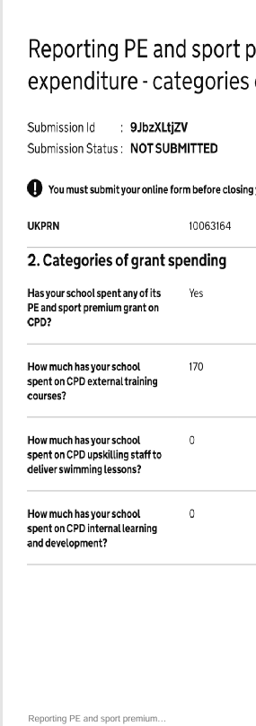

Yes

498

810

0

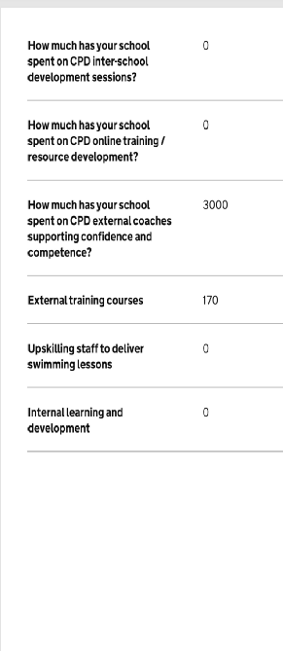
0

0

-
0

0

0

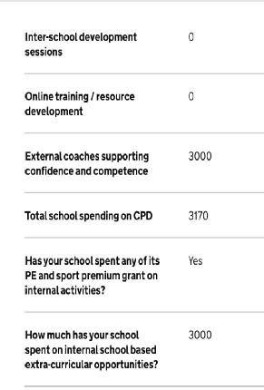
0

0

0

1308

Yes

0

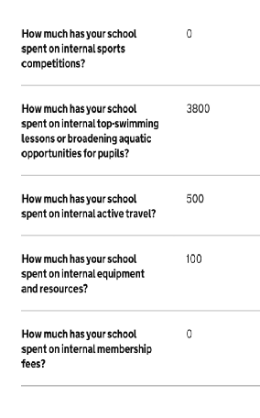
0

14,982.24

0

794

0

840

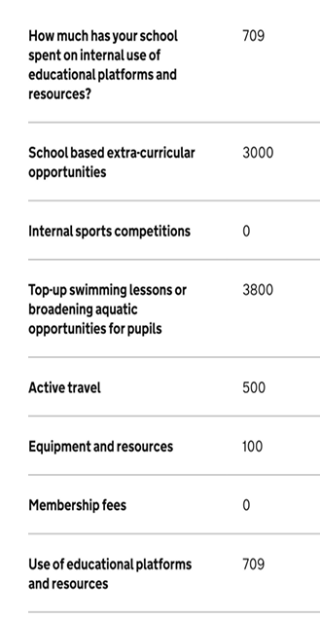
0

0

0

0

0

0

678

0

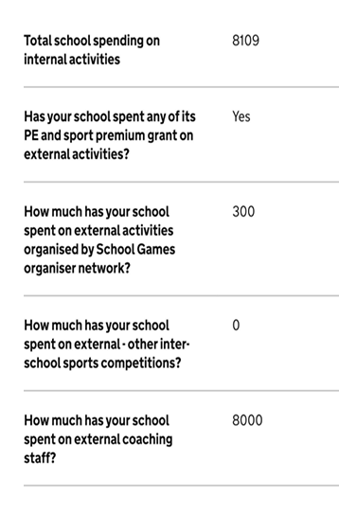
16,454

yes

0

0

840

0

0

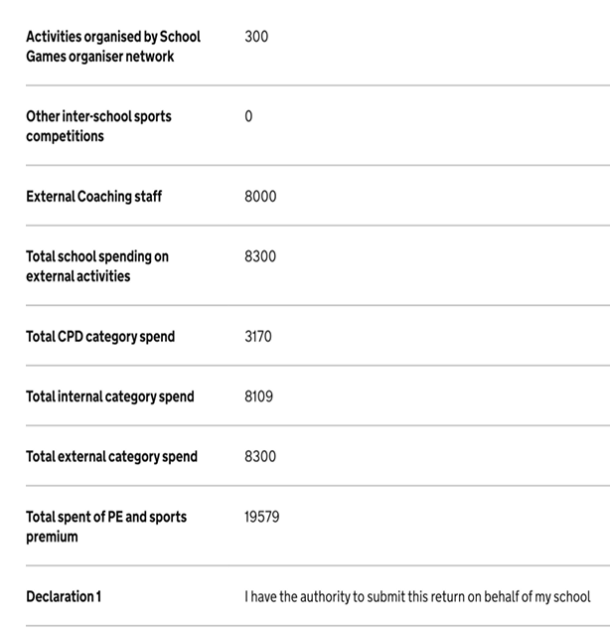
0

0

0
840

1308

16,454

1308

18,602

