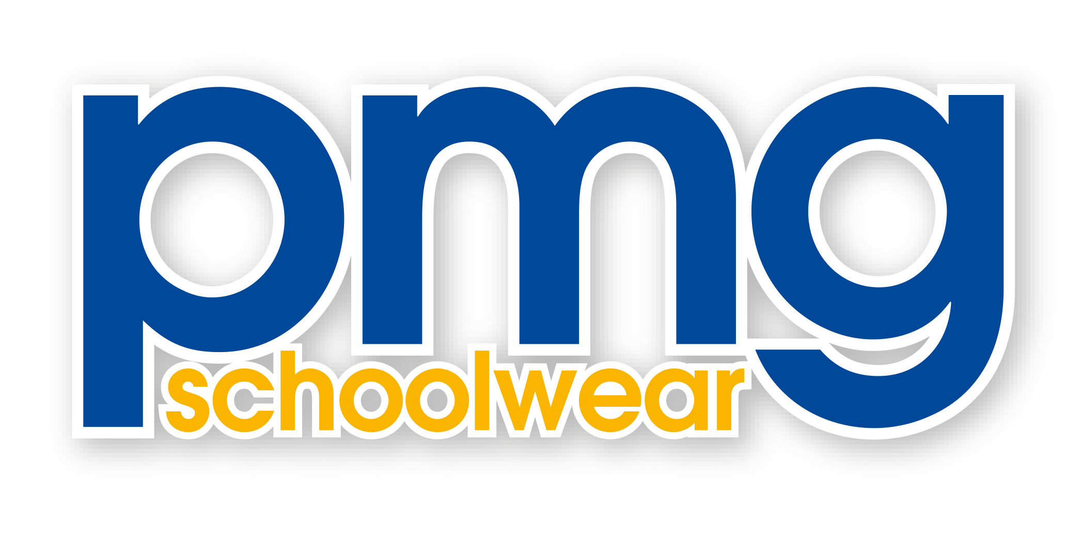
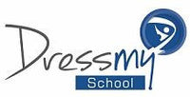

Dear Parents,

This is to let you know that as from 16th June 2023 the ownership of Dress My School passed to PMG Schoolwear.

This will not affect the availability and supply of your school uniform which will continue seamlessly, and we are confident that this change will be beneficial for your school and its parents and the pupils. Uniform is now available at www.pmgschoolwear.co.uk

PMG is a specialist and very experienced supplier of Schoolwear and will be completely focused on providing a first class quality service at competitive prices.

The Dress My School shop at Kembrey Business Park is now closed, but PMG have a shop at 8 Regal Way, Faringdon, Oxon, SN7 7BX where your uniform will be available to buy along with everything you may need for your child for school days – all available under one roof.

During the Summer PMG run an appointment system and you can book your appointment by following the link on the PMG website www.pmgschoolwear.co.uk

If you have any questions you can contact PMG’s Customer services team either by phone on 01895 809321 or by email to customerservices@pmgschoolwear.co.uk

Kind regards,

Paul Gelernter
Managing Director
PMG Schoolwear

