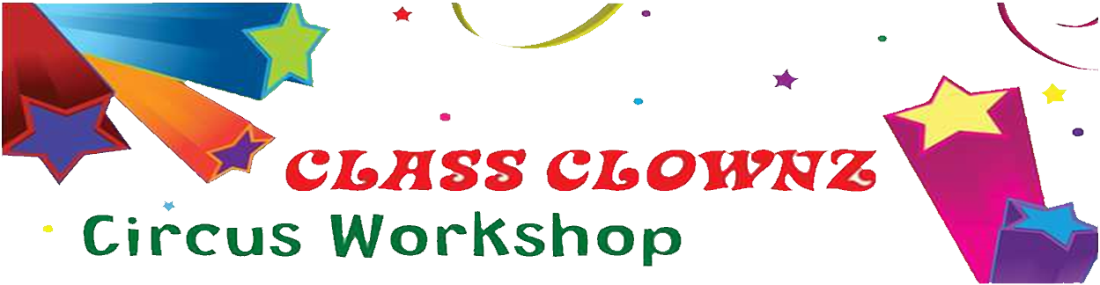
Mark’s Magic Mayhem presents



ROLL UP! ROLL UP!

CLASS CLOWNZ has pitched up at Grange Infant School for
EYFS-Reception – Year 2 children
Join our club to be part of the Greatest Show and learn amazing skills including: Juggling, Balancing, Plate Spinning, Stilt Walking, Drama & Parachute games, Clowning & More!
ROLL UP! ROLL UP! Limited Places Available!
TUESDAYS at 3.20pm to 4.20pm – Only £6.50 per session!
Term 2: 10/11, 17/11, 24/11, 1/12, 8/12, 15/12 - £39.00 (6 weeks)
Please send the following details to Mark Burford via magical.mark@hotmail.co.uk
or call 07940262367 for more information
Class Clownz Club @ Grange Infant School
Child’s Name: ______________________ Age: _____ Class: _____________ Year:_____
Medical Conditions: _____________________________________________________________________
Parent/Guardian Name: __________________________________________________________________
Emergency Contact no: ___________________________________________________________________
Email: _________________________________________________________________________________
Term 2 - £39.00 Payment via Bank Transfer only
Mark Burford – Sortcode: 20-89-16 / Account no: 90205974

