Collective Worship Policy

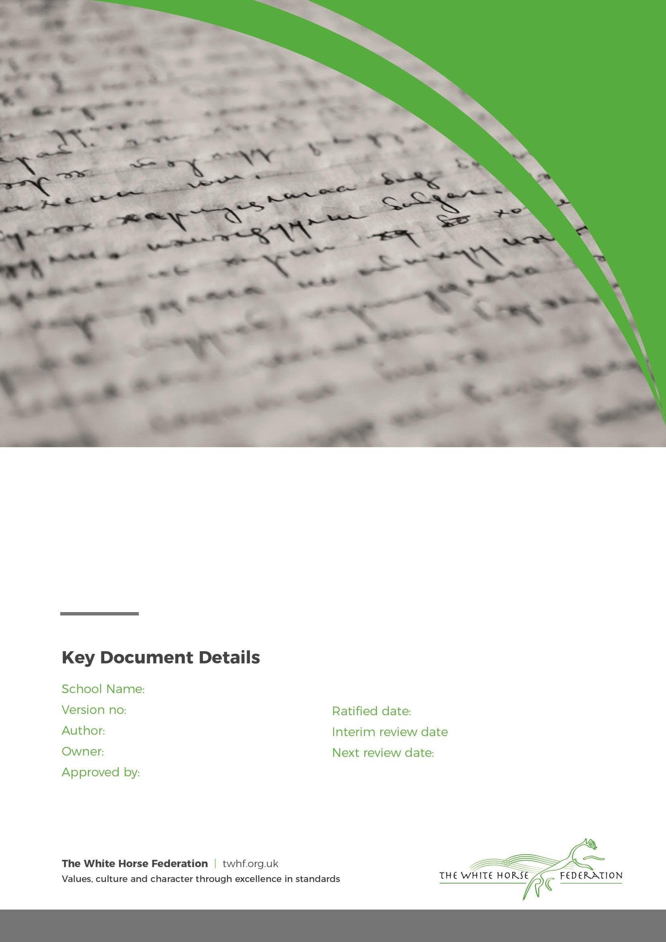
Grange Infant School 2
J Pound H Gordon Principal

September 2025
n/a
September 2026

Collective Worship Policy
The Collective Worship at Grange Infant School pays due regard to statutory requirements and has taken account of the guidance offered by the Local Authority through the new Swindon Agreed Syllabus for Religious Education (SACRE).

In line with the Education Act 1996 (Schedule 31) teaching ‘shall reflect the fact that the religious traditions in Great Britain are in the main Christian, while takin account of the teaching and practices of the other principal religious represented in Great Britain.’
At Grange Infant School, we actively promote British values though our school vision, ethos, agreed rules, curriculum and teaching. As such, we promote tolerance of, and respect for, people of all faiths (or those with no faith), cultures and lifestyles.

We prepare children and young people positively for life in modern Britain by supporting them through our words, actions, and influence, not just within school, but also within the wider community.

Therefore, the Collective Worship Policy of Grange Infant School is consistent with the philosophy and aims of the school. Assemblies are conducted in a manner that is sensitive to the individual faiths and beliefs of all members of the school.

Definition of Collective Worship

Collective Worship is a time when the whole school, or groups within the school meet together in order to consider and reflect on common concerns, issues and interests. It offers all pupils an opportunity to worship through engaging in relevant, meaningful experiences and provides opportunities for the pupils’ spiritual, moral, social and cultural development.

Aims of Collective Worship

For the School:

Collective Worship contributes significantly to the ethos of Grange Infant School and it is our aim that it is a time when the school community can:

- Share common aims and values
- Celebrate achievement and special times
- Explore together the world in which we live
- Develop a community spirit

For the pupils:

We also intend that collective Worship contributes to the development of the pupil as a ‘whole’ person by providing opportunities to:
- Consider spiritual and moral issues
- Explore their own beliefs
- Develop their own spirituality
- Reinforce common ethos and values
- Reinforce positive attitudes
- Develop a sense of community spirit
- Encourage participation and response
- Reflect on that which is considered worthy

The Organisation of Collective Worship

- The Head teacher or other members of staff normally lead assembly, but sometimes visitors or other representatives of local religious groups are invited into the school.

- We conduct assemblies in a dignified and respectful way. Children are expected to behave in an appropriate way as this time is a period of calm reflection

- We take themes of our assemblies from the traditions of the Christian and other faiths and we often reflect the festivals and events of the religious calendars. Sometimes the themes of our assembly reflect and build on topics that we teach as part of the school curriculum, such as the Social and Emotional Aspects of Learning.

- We welcome parents and Governors to attend our assemblies, as this promotes the community spirit of the school and is a practical demonstration of the way the home and the school work together to support the achievements of our children in all aspects of their lives.

Right of withdrawal

At Grange Infant School, assemblies are conducted in a manner as sensitive and inclusive as to ensure that all children feel comfortable to attend the assembly.
However, parents/ carers have the right to withdraw their child from any act or acts of Collective Worship. Those wishing to make such a request are encouraged to discuss with the Head Teacher: a) any concerns they may have and b) practical arrangements for the withdrawal.

