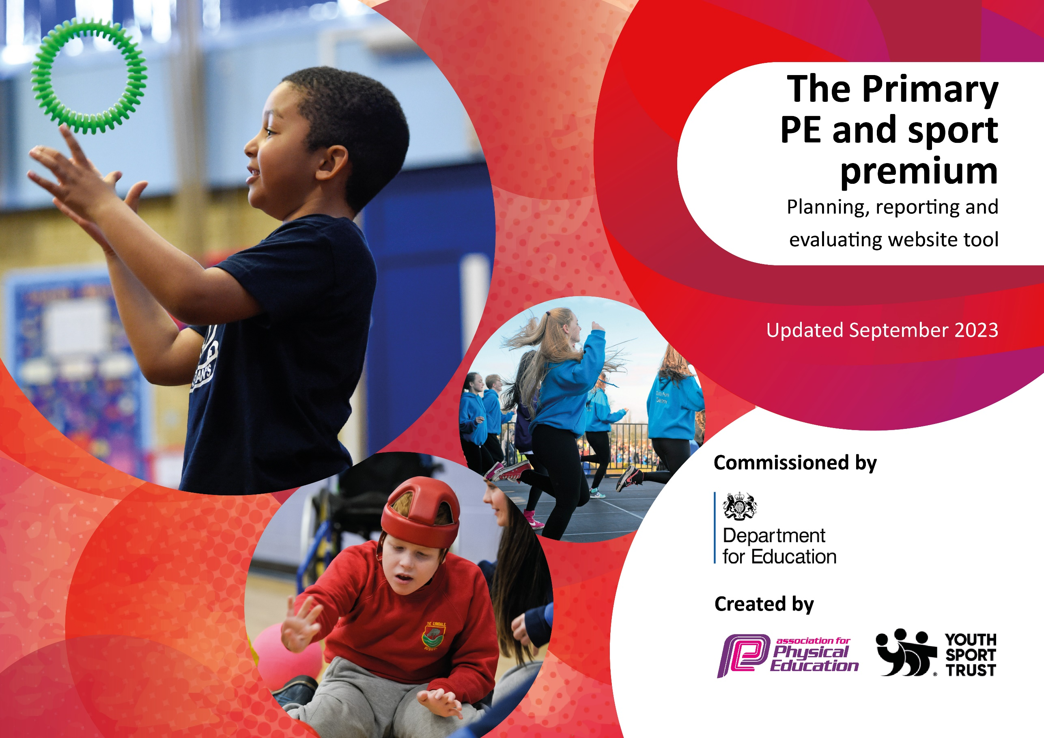

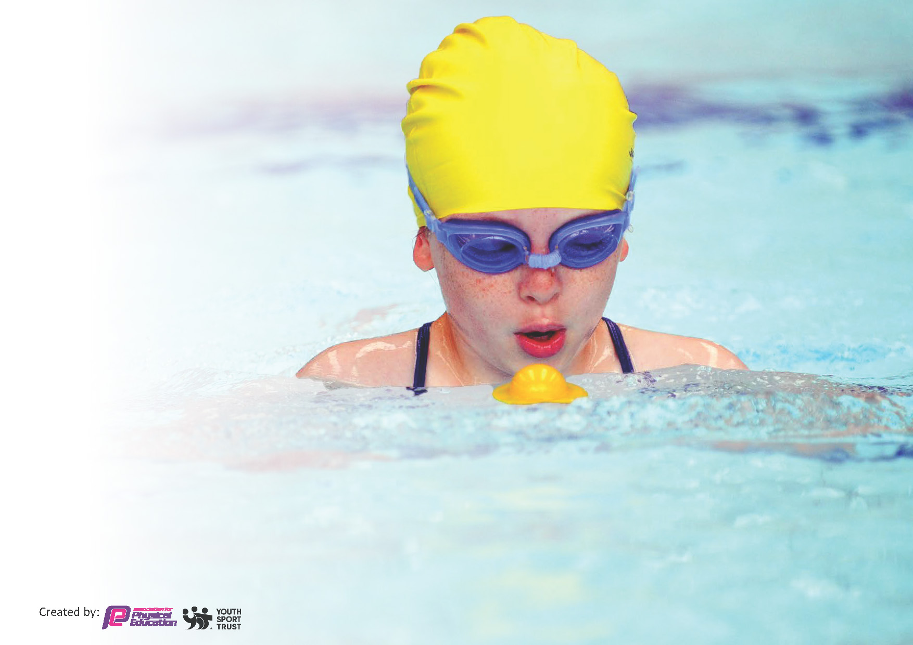
This template can be used for multiple purposes:
by:
- It enables schools to effectively plan their use of the Primary PE and sport premium
- It helps schools to meet the requirements (as set out in guidance) to publish information on their Primary PE and sport premium
- It will be an effective document to support Ofsted inspections enabling schools to evidence progress in Physical Education (PE) and evidence swimming attainment, which forms part of the PE National Curriculum. We would recommend schools consider
the Intent, Implementation and Impact of any spend, as examined within the Education Inspection Framework.

It is important that your grant is used effectively and based on school need.

Schools must use the funding to make additional and sustainable
improvements to the quality of the PE, School Sport and Physical Activity (PESSPA)
they offer. This means that you should use the Primary PE and sport premium to:

- Build capacity and capability within the school to ensure that improvements made now will benefit pupils joining the school in future years
- Develop or add to the PESSPA activities that your school already offers.

The Primary PE and sport premium should not be used to fund capital spend projects; the school’s core budget should fund these. Further detail on capital expenditure can be found in the updated Primary PE and sport premium guidance.

The Primary PE and sport premium guidance, outlines 5 key priorities that funding should be used towards. It is not

necessary that spending has to meet all the key priorities, you should select the priorities that you aim to use any funding towards.

Although completing this template is not a requirement for schools, schools are required to publish details of how they spend this funding. Schools must also outline what the impact this funding has had on pupils’ PE and sport participation and attainment and how any spending will be sustainable in the future. All funding must be spent by 31st July 2024.

The Department for Education has worked closely with the Association for Physical Education (afPE) and the Youth Sport Trust (YST) to develop this template and encourages schools to use it. This template is an effective way of meeting the reporting requirements of the Primary PE and sport premium.
Review of last year’s spend and key achievements (2022/2023)

We recommend you start by reflecting on the impact of current provision and reviewing your previous spend.

Activity/Action | Impact | Comments
Offer a range of variety of sports/activities to all pupils to increase engagement and opportunities for children to broaden experiences.  Building links with outside community projects.  Healthy eating to become more visible and have a higher profile within school.  Improved quality of teaching and learning.  Extended provision in a range of outdoor and adventurous activities. | Children are more active and levels of fitness are raised.  Children have had exposure to different sports that we wouldn’t normally teach in school.  Staff CPD to ensure high quality PE education. They are able to observe lessons of specialist staff and plan further learning opportunities and skills in additional lessons.  Specialist external staff to off wide range of clubs/ CPD with staff. This has ensured that pupils are more confident at a range of different sports and are encouraged to try new games/ sporting activities.  Raised profile of different sports with children and develop leadership skills of these pupils.  Range of different providers taught children in school (Gymnastics and chance to shine program) to increase the awareness of sports and uptake of offers to clubs outside of school and in school.  Focused sports week on improving fitness and awareness of fitness.  Staff are more confident and competent at teaching PE lessons against the national curriculum strands using Primary PE. This has improved staff skills, knowledge and confidence to deliver PE.  Bike ability sessions and equipment has ensured that children in EYFS ride with confidence and safety and has developed balance and coordination.  School has improved children’s life skills through forest schooling and a range of different outdoor pursuits. This has also ensured that children learn about what makes a healthy lifestyle and alternative ways of cooking and food to try. | Sports week ensured that children had the opportunity to experience a range of different sports that they wouldn’t normally. For next year, run sport experiences throughout the year to increase the number of sports/ activities the children can take part in.  Raised awareness of sports clubs and activities that children can do in the Swindon area. Keep this for next year and look at other providers for the children to experience different sports.  Need further awareness of healthy eating – look at outside providers for food nutrition workshops and healthy lifestyle.  Further develop CPD for staff with thinking outside the box and how to support pupils further within the lesson.  Continue with next year as impact of gross/fine motor is evident in EYFS children’s posture and grip. Forest schooling has also ensured that children are learning about healthy lifestyles as well.

Key priorities and Planning
This planning template will allow schools to accurately plan their spending.

Action – what are you planning to do | Who does this action impact? | Key indicator to meet | Impacts and how sustainability will be achieved? | Cost linked to the action
Improve the physical health and well being of pupils  Improve quality of teaching and learning in specific strands of curriculum – balls skills and gymnastics  Healthy lifestyle display introduced around the school  Healthy lifestyle and PE to become more visible and have a higher profile within school. | Children to participate in the ‘Daily Mile’ for up to four sessions a week. Complete sessions within timetable. Teachers to keep track on ongoing miles they have accumulated throughout the school year.  Staff skills, knowledge and confidence to deliver PE is developed and targeted through professional CPD.  Improved delivery of PE sessions through CPD on areas that staff feel less confident in.  Healthy eating to be more visible and have a higher profile within school.  PE and healthy eating to become more visible and have a higher profile within school. Focused sports week as well as individual days and healthy living workshops. | Key indicator 2 -The engagement of all pupils in regular physical activity – the Chief Medical Officer guidelines recommend that all children and young people aged 5 to 18 engage in at least 60 minutes of physical activity per day, of which 30 minutes should be in school.  Key Indicator 1 – The Increased confidence, knowledge and skills of all staff in teaching PE and Sports.  Key indicator 2 -The engagement of all pupils in regular physical activity – the Chief Medical Officer guidelines recommend that all children and young people aged 5 to 18 engage in at least 60 minutes of physical activity per day, of which 30 minutes should be in school.  Key Indicator 3 – The profile of PE and sport is raised across the school as a tool for whole school improvement.  Key Indicator 3 – The profile of PE and sport is raised across the school as a tool for whole school improvement.  Key indicator 2 -The engagement of all pupils in regular physical activity – the Chief Medical Officer guidelines recommend that all children and young people aged 5 to 18 engage in at least 60 minutes of physical activity per day, of which 30 minutes should be in school.  Key Indicator 4 – Broader experiences of a range of sports and activities offered to all pupils | More pupils meeting their daily physical activity goal, more pupils encouraged to take part in PE and Sport Activities.  Increased confidence in teachers skills and knowledge in order to provide high quality lessons that engage and excite children.  Increase awareness in children and parents of what makes a healthy lifestyle.  Increase awareness in children, staff and parents of what makes a healthy lifestyle and a range of different sports. | £8000 for a daily mile track to be purchased and fitted.  £1000 for professional CPD in gymnastics and ball skills  £0  £1000 – healthy eating  £3000 - individual sport days

To further build links with community projects.  Extend provision in a range of outdoor and adventurous activities  Review sports resources and equipment provision.  Increase participation in competitions | Children to experience a range of different sports run by specialist providers.  Children to receive enrichment in outdoor and adventurous activities.  Children will have increased gross and fine motor skills for balance and coordination as well as being able to ride a bike sensibly.  Ensure that children have the skills to lead a healthy lifestyle and improve learning behaviours as well as partake in a range of different outdoor pursuits.  Sports equipment that needs purchasing throughout the year to maintain high standards of teaching and learning.  Increase the number of competitions children take part in  Organise and set up at least 3 intra tournaments with sports. | Key Indicator 4 – broader experience of a range of sports and activities offered to all pupils.  Key Indicator 4 – Broader experience of a range of sports and activities offered to all pupils  Key Indicator 3 – The profile of PE and sport is raised across the school as a tool for whole school improvement.  Key Indicator 5 – increased participation in competitive sport | Increase aware of sports for children in the local area.  Increase children’s balance and coordination skills.  Range of different opportunities for children to take part in adventurous sports.  Children will leave school with the skills to lead a healthy lifestyle.  For all pupils to receive quality first teaching with the correct equipment that is up to date.  Children to take part in a range of different competitions across different sports. | £1000  £1600 – Paul Ashman – bike ability  £3480 – Wild Inspired  £4321 – sports week  £8000  £200

Key achievements 2023-2024
This template will be completed at the end of the academic year and will showcase the key achievements schools have made with their Primary PE and sport premium spending.

Activity/Action | Impact | Comments

Swimming Data
Meeting National Curriculum requirements for swimming and water safety.
Priority should always be given to ensuring that pupils can perform safe self-rescue even if they do not fully meet the first two requirements of the National Curriculum programme of study

Question | Stats: | Further context  Relative to local challenges
What percentage of your current Year 6 cohort can swim competently, confidently and proficiently over a distance of at least 25 metres? | % | N/A – Infant School
What percentage of your current Year 6 cohort can use a range of strokes effectively [for example, front crawl, backstroke, and breaststroke]? | % | N/A – Infant School

What percentage of your current Year 6 cohort are able to perform safe self-rescue in different water-based situations? | % | N/A – Infant School
If your schools swimming data is below national expectation, you can choose to use the Primary PE and sport premium to provide additional top-up sessions for those pupils that did not meet National Curriculum  requirements after the completion of core lessons. Have you done this? | Yes/No | N/A – Infant School
Have you provided CPD to improve the knowledge and confidence of staff to be able to teach swimming and water safety? | Yes/No | N/A – Infant School

Signed off by:

Head Teacher: | Eleanor Rushen-Gough
Subject Leader or the individual responsible for the Primary PE and sport premium: | Eleanor Rushen-Gough
Governor:
Date: | 30.9.23

