|  |  |  |
| --- | --- | --- |
| Dear Year 1 parents and carers, | **Snacks**  Children are provided with healthy fruit snacks and these are accessible at break times. Children are encouraged to select their own snack during this time. | **Dates for your diary:**  4th /5th March Train trip and Brunel Workshop  3rd and 5th March Parents evening  2nd April Trip to SS Great Britain  4th April FOG Easter disco  4th April end of Term 4  Please keep an eye on the school website for updates and dates.  Finally, please remember that if you have any questions, feel free to contact us by sending an email to the school office.  Thank you for your continued support.  Year 1 Team  Mrs Saxby, Mrs Barton and Miss Mandewo |
| We hope you have had a lovely break and are ready for all the new learning that term 4 has to offer. Please continue to ensure children bring their coats to school every day. |
| **PE**  Our PE days will be on Wednesday and Thursday. Please note that on this day it is important that long hair is tied back and children are not wearing hooped earrings. No other jewellery should be worn either. As an active school, children should wear suitable clothing and shoes for PE and other physical activities.  **Water Bottles**  Please can you ensure that your child brings a water bottle to school. If these can be named, it helps us to return them to their owners if they are misplaced. The children are allowed to access these during the school day whenever they wish. The only time we ask them to wait is during our lesson input times. An extra drink can also be provided for lunchtime should you wish. | **Reading**  Your child will receive their reading record and a Little Wandle Letters and Sounds reading book that is chosen to aid their reading ability. These books are designed so that the children can use their phonic knowledge to read to you. Your child should practise reading these books at least 4 times a week. Alongside their phonetically decodable book they will also bring home one of our ‘50 reads’ weekly. The 50 reads books are designed for the children to share with you. Please record any reading that is completed in your child’s reading record so they can gain recognition in school. |

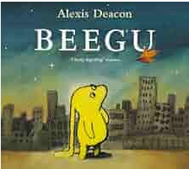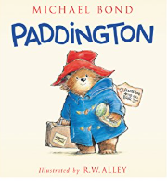

**As mathematicians, we will be learning…**

* to learn addition and subtraction facts of 17 - 20
* to understand fractions ½ and 1/4
* to understand position and ½ and ¼ turn
* to learn days of the week and months of the year

**As writers, we will be learning…**

* to use the book ‘Beegu’ as a stimulus for writing a story ending to entertain
* to use the book ‘Paddington’ as a stimulus for writing a diary
* to sequence sentences
* to use and to join words and clauses
* to choose appropriate adjectives
* to use past tense with accuracy
* to show some accuracy when adding ‘ed’ where there is no change in the root word
* to use well-chosen adjectives
* to begin to punctuate sentences using a question mark

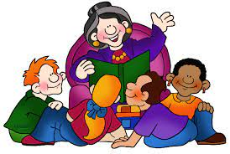

**As scientists, we will be learning…**

* to identify and name a variety of common animals including fish, mammals, amphibians, reptiles and birds
* to name the main parts of the body
* to explain the purpose of each part
* to explore and understand senses
* to recognise the season of spring and discuss observations



**Using our computing skills, we are learning…**

to use ScratchJr to:

* to learn how to keep safe when using the internet
* to choose a command for a given purpose and to join a series of commands
* to identify the effect of changing a value
* to design parts of a project and use their algorithm to create a program

**Year 1**

**Term 4**

**2024/2025**



**In PSHE, we are learning…**

* to know how to keep our bodies healthy and make healthy choices around food and exercise.

**In PE, we are learning…**

* Social Dodgeball—using ball skills to work together, communicate effectively and show how to be a good sports person

**As musicians, we are learning…**

* to recognise what tempo is in music.
* to distinguish between and indicate a fast or slow tempo.
* to take part in ‘call and response’ activities at different tempos.
* to sing and play songs in a variety of tempos and say how they make me feel.

**As historians, we will be learning...**

* to learn about significant historical events and people – Isambard Kingdom Brunel
* to distinguish from fact and opinion using stories
* to sequence events in my life

**In RE, we will be discovering…**

* Christianity - Easter.
* the importance of Palm Sunday. Why was Jesus welcomed like a king?

**In Art, children will…**

* complete an artist study to investigate the style of an artist.
* create a painted landscape inspired by the artist they have studied