Dear Year 1 parents and carers, | Snacks  Children are provided with healthy fruit snacks and these are accessible at break times. Children are encouraged to select their own snack during this time. | Dates for your diary:  19/09 - Jeans for Genes  26/09 – European Languages Day  10/10 – World Mental Health Day  22/10 – TD Day
We hope you have had a great summer break and are ready to start the new school year. We’d like to take this opportunity to welcome you to 1.

PE  Our PE days will be on Monday and Tuesday. Please note that on this day it is important that long hair is tied back and children are not wearing hooped earrings. No other jewellery should be worn either.  Water Bottles  Please can you ensure that your child brings a water bottle to school. If these can be named, it helps us to return them to their owners if they are misplaced. The children are allowed to access these during the school day whenever they wish the only time we ask them to wait is during our lesson input times. An extra drink can also be provided for lunchtime should you wish. | Reading  Next week, your child will receive their reading record and a Little Wandle Letters and Sounds reading book that is chosen to aid their reading ability. These books are designed so that the children can use their phonic knowledge to read to you. Your child should practise reading these books at least 4 times a week. Alongside their phonetically decodable book they will also bring home one of our ‘50 reads’ weekly. The 50 reads books are designed for the children to share with you. Please record any reading that is completed in your child’s reading record so they can gain recognition in school. | Please keep an eye on the school website for updates and dates.  Finally, please remember that if you have any questions, feel free to contact us by sending an email to the school office or speaking to the class teachers.  Thank you for your continued support.  Year 1 Team  Miss Tylee and Mrs Ambrose
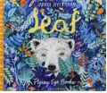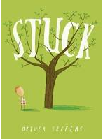
As writers, we will be learning…

to use the book ‘Leaf’ as a stimulus for writing a setting description.
to use finger spaces consistently.
to begin punctuating sentences using a full stop.
to form most lower-case and capital letters in the correct direction, starting and finishing in the right place.
to use adjectives in their writing- colour, e.g. The leaves are red.
to use the book ‘Stuck’ as a stimulus for writing a recount.
to begin punctuating sentences using a capital letter.
to consistently use capital letter for ‘I’.
to form most capital letters correctly
to use adjectives in their writing- size, e.g. big boat, large house
As mathematicians, we will be learning…

to understand numbers and place value up to 20.
to order and compare numbers up to 20.
to calculate one more/one less than numbers up to 20.
to use +, - and = symbols when adding and subtracting.
to partition 5 and 6 and know the related facts.
to understand, order and compare numbers to 50.
to count forwards and backwards to 50
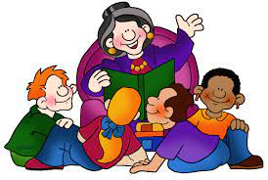
As scientists, we will be learning…

to distinguish between a material & objects.
to identify and name a variety of everyday materials, including wood, plastic, metal, rocks, water.
to describe the simple physical properties of everyday materials – link to uses in world.
to compare and group together materials according to their properties.

Year 1
Term 1
2025/2026

As musicians, we are learning…
Find and keep a steady beat.
Play or clap simple rhythmic patterns using long and short sounds.
Respond to different high and low pitches.
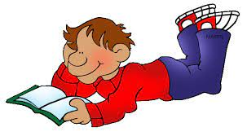
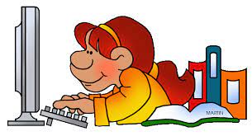
In RE, we will be discovering…
Religion - Christianity
Theme – Creation story
Key Question – Does God want Christians to look after the world?

Using our computing skills, we are learning…

To identify technology.
To identify a computer and its main parts.
To use a mouse in different ways.
To use a keyboard to type on a computer.
To use the keyboard to edit text. · To create rules for using technology responsibly.
In PE, we are learning…
can balance equipment on my head with some control.
I can balance on equipment with some control.
I can change direction and position of my body quickly with some control.
In PSHE, we are learning to…
to celebrate differences.
to understand that actions have consequences and to feel special and safe in school.
In Geography, we will be learning...
To use a world map, atlas and globe to identify where I live.
To use positional language to describe features of a map.
To map out my route to school.
To use basic symbols on a map.
To devise a simple map of my school and construct basic symbol

