|  |  |  |
| --- | --- | --- |
| Dear Year 1 parents and carers, | **Snacks**  Children are provided with healthy fruit snacks and these are accessible at break times. Children are encouraged to select their own snack during this time. | **Dates for your diary:**  4th November Individual school photos  12th / 13th November – Parents Evening  15th November – Children in Need and Fire Safety  21st November – Cinema Trip  12th December – Christmas Jumper Day  18th December – Visit to Churchview nursing home  19th December – Carol Concert  Please keep an eye on the school website for updates and dates.  Finally, please remember that if you have any questions, feel free to contact us by sending an email to the school office or speaking to the class teachers.  Thank you for your continued support.  Year 1 Team  Mrs Saxby, Mrs Barton and Miss Mandewo |
| We hope you have had a lovely October half term and are ready for all the excitement that comes with the lead-up to Christmas. As the weather is getting colder and unpredictable, please can children bring their coats to school every day. |
| **PE**  Our PE days will be on Wednesday. Please note that on this day it is important that long hair is tied back and children are not wearing hooped earrings. No other jewellery should be worn either.  **Water Bottles**  Please can you ensure that your child brings a water bottle to school. If these can be named, it helps us to return them to their owners if they are misplaced. The children are allowed to access these during the school day whenever they wish. The only time we ask them to wait is during our lesson input times. An extra drink can also be provided for lunchtime should you wish. | **Reading**  Your child should practise reading these books at least 4 times a week. Alongside their phonetically decodable book they will also bring home one of our ‘50 reads’ weekly. The 50 reads books are designed for the children to share with you. Please record any reading that is completed in your child’s reading record so they can gain recognition in school. |

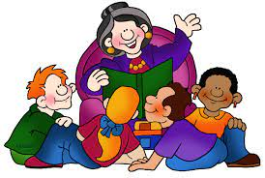 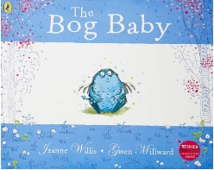 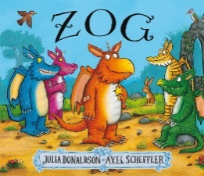

**As mathematicians, we will be learning…**

* to partition numbers 7 to 10 and know the related facts.
* to recognise and name a variety of 2D and 3D shapes.
* to compare 3D shapes and explain their similarities and differences.
* to measure and compare length using non-standard units.
* to measure and compare height using the language of taller than and shorter than.

**As writers, we will be learning…**

* to use the book ‘Bog Baby’ as a stimulus for writing a character description.
* to sequence sentences.
* to begin punctuating sentences using a capital letter and full stop.
* to continue to use adjectives in their writing for size and colour.
* to use adjectives in their writing to show texture – soft, bumpy
* to use the book ‘Zog’ as a stimulus for writing a recount.
* to join words using ‘and’.
* to use adjectives in their writing to show emotions, e.g. proud, excited.
* to spell the days of the week.

**As scientists, we will be learning…**

* to compare and group together materials according to their properties.
* to find out which materials are absorbent.
* to find out which materials are transparent.
* to develop the skills needed to carry out a science experiment.
* to observe changes across the seasons.

**Year 1**

**Term 2**

**2024/2025**

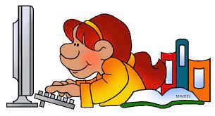

**As musicians, we are learning…**

* to listen to and appraise a variety of music styles.
* to explore pitch through singing and playing on the glockenspiels.

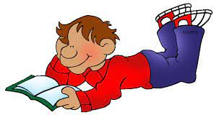

**As artists, we are learning…**

* to develop sketching skills to produce a self-portrait.

**In RE, we will be discovering…**

* why gifts are meaningful and special.
* the Christian Christmas story.

**Using our computing skills, we are learning…**

* to predict an outcome of a command.
* to combine a series of commands.
* to plan a simple program and to test it with the mousebot.

**In PE, we are learning…**

* to move with the ball.
* to hand over and receive a ball.
* to score.
* to cooperate as a team.

**In PSHE, we are learning…**

* to recognise similarities and differences between people in my class, including myself.
* to explore what bullying means and understand how bullying might feel.

**As geographers, we will be learning...**

* to know the difference between human and physical features.
* to begin to read a map and understand its symbols in a key.
* to create our own maps using a simple key and symbols.