|  |  |  |
| --- | --- | --- |
| Dear Year 1 parents and carers, | **Snacks**  Children are provided with healthy fruit snacks and these are accessible at break times. Children are encouraged to select their own snack during this time. | **Dates for your diary:**  6th January Teacher Training Day  7Th January Return to school  Great Fire of London workshop/dress-up day  14th January Stanton Park visit - TBC  29th -31st January Book Fair  3rd February Reading for pleasure afternoon with parents – details to follow  3rd -7th February National Story Telling Week/Children’s Mental Health Week  7th February Number Day  11th February Safer Internet Day  Please keep an eye on the school website for updates and dates.  Finally, please remember that if you have any questions, feel free to contact us by sending an email to the school office.  Thank you for your continued support.  Year 1 Team  Mrs Saxby, Mrs Barton and Miss Mandewo |
| Happy New Year!  We hope you have had a lovely Christmas and are ready for all the new learning that term 3 has to offer. Please continue to ensure children bring their coats to school every day. |
| **PE**  Our PE days will be on Wednesday. Please note that on this day it is important that long hair is tied back and children are not wearing hooped earrings. No other jewellery should be worn either. As an active school, children should wear suitable clothing and shoes for PE and other physical activities.  **Water Bottles**  Please can you ensure that your child brings a water bottle to school. If these can be named, it helps us to return them to their owners if they are misplaced. The children are allowed to access these during the school day whenever they wish. The only time we ask them to wait is during our lesson input times. An extra drink can also be provided for lunchtime should you wish. | **Reading**  Your child will receive their reading record and a Little Wandle Letters and Sounds reading book that is chosen to aid their reading ability. These books are designed so that the children can use their phonic knowledge to read to you. Your child should practise reading these books at least 4 times a week. Alongside their phonetically decodable book they will also bring home one of our ‘50 reads’ weekly. The 50 reads books are designed for the children to share with you. Please record any reading that is completed in your child’s reading record so they can gain recognition in school. |

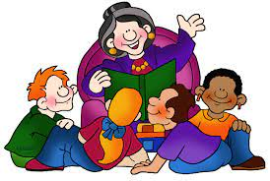 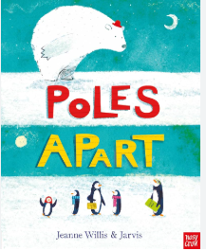 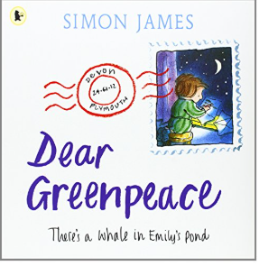

**As writers, we will be learning…**

* to use the book ‘Poles Apart’ as a stimulus for writing a retelling of a story.
* to sequence sentences.
* to use adjectives in their writing to describe senses – what can you see/feel/smell/hear
* to use present tense with accuracy
* to show some accuracy when adding ‘ing’ where there is no change in the root word
* to use the book ‘Dear Greenpeace’ as a stimulus for writing a non-chronological report’
* to use well-chosen adjectives
* to begin to punctuate sentences using a question mark

**As mathematicians, we will be learning…**

* to learn addition facts for 11-16
* to learn subtraction facts for 11-16
* to understanding numbers to 100

**As scientists, we will be learning…**

* to identify and name a variety of common animals including fish, mammals, amphibians, reptiles and birds.
* to identify and name a variety of common animals that are carnivores, herbivores and omnivores.
* to recognise the season of winter and discuss observations.

**Year 1**

**Term 3**

**2024/2025**



**Using our computing skills, we are learning…**

* to know the difference between human and physical features.
* to use software to create pictures
* to use a variety of tools within the software to create different effects of line, brush and tone
* to apply new learning to create a piece of digital art inspired by Mondrian

**In PE, we are learning…**

* Dance – Create a dance inspired by the Great Fire of London.

**In PSHE, we are learning…**

* Making and achieving our dreams and goals, how this feels and how we can work towards these.



**As historians, we will be learning...**

· to recount episodes from stories about the past

· to talk about an event that has happened in the past

· to find answers to simple questions about the past from sources of information

· to understand events of the Great Fire of London

**As musicians, we are learning…**

* to distinguish between long and short notes
* to create long and short notes with our voices and on the glockenspiels
* to use notes of different durations to sing and play our ‘song of the term’.

**In RE, we will be discovering…**

* the power of friendship
* Jesus as a friend – was it easy for Jesus to show friendship?

**In Design and Technology, we are learning…**

· to understand where food comes from.

· to evaluate, plan and design a product.

· to evaluate a product against a criteria.