Dear Year 2 Parents and Carers, | Snacks  Children are provided with healthy fruit snacks and these are accessible at break times. Children are encouraged to select their own snack during this time  Reading  Your child will continue to receive their reading record and a Little Wandle Letters and Sounds reading book that is chosen to aid their reading ability or their free reader chapter book. These books are designed so that the children can use their phonic knowledge to read to you. Your child should practise reading these books at least 4 times a week. Alongside their phonetically decodable book they will also bring home one of our ‘50 reads’ weekly. The 50 reads books are designed for the children to share with you. Please record any reading that is completed in your child’s reading record so they can gain recognition in school. | Dates for your diary:  Monday 24th February back to school.  Monday 3rd March and Wednesday 5th March- Parents evening.  Thursday 6th March- World Book Day.  Wednesday 19th March- Dinomania  Friday 4th April- Easter Disco and End of Term  Miss Sawyer, Mrs Field and Mrs Rudman.
We hope you have had a lovely half term break and are ready to start the new term. Your children have really been incredible this year and the progress we have seen is amazing!

PE
Our PE days have changed and will now be on Monday. Please note that on this day it is important that long hair is tied back and children are not wearing hooped earrings. No other jewellery should be worn either.

Water Bottles
Please can you ensure that your child brings a water bottle to school. Please make sure they are sufficiently named. The children are allowed to access these during the school day whenever they wish the only time we ask them to wait is during our lesson input times. An extra drink can also be provided for lunchtime should you wish.

As writers we will be learning…

to write an innovation to a story.
to write a persuasive letter.
to use adverbs to express manner.
to use subordination and coordination.
to use possessive apostrophes.
to use commas in a list.
As mathematicians we will be learning…
to find 1/3.
to find 2/4.
to recognise ½ is equivalent to 2/4
to find ¾.
to tell the time quarter past and quarter to.
to tell the time in 5-minute intervals.
to find the sum of different amounts of money.
to combine coins.

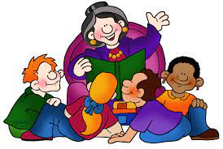

As scientists we will be learning…
to compare the stages of the human lifecycle.
to understand there are healthy and unhealthy foods.
to understand hygiene.
To know how to exercise and what it does for our bodies.
As musicians we will be learning…
to understand rhythm and pulse
to sing, play and compose music using our own rhythms and keeping a steady pulse.
to recognise rising and falling pitches
use a small range of rising and falling pitches to sing, play and compose music
use our new skills to play on Glockenspiels.

Year 2
Term 4
2024/2025

In RE we will be learning….
to know what Easter is.
to know the Easter story.
to know how important it is for Christians to believe that Jesus came back to life.
to know that it is ok to believe different things.
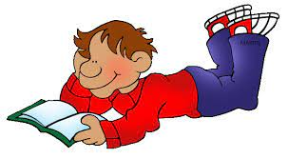
In PE we will be learning…
To throw and catch a ball with control and some accuracy – underarm and overarm.
To hold a bat correctly.
To take part in a batting and fielding game.
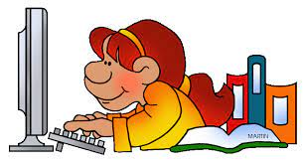

Using our computing skills, we will be learning...
to use a digital device to take a photograph.
to make choices when taking a photograph,
to describe what makes a good photograph.
to describe how photographs can be improved.
to use and understand how tools can be used to change an image.
In PSHE we will be learning:
to know what I need to keep healthy.
to understand how medicines work.
to understand different food groups.
to create a heathy snack.
As Historians we will be learning...
to understand why we remember Mary Anning.
to understand Mary Anning’s life.
to know why Mary Anning was special.
to understand how Mary Anning’s actions affected my life.
To understand where we can get evidence from for Mary Anning’s actions.

