Dear Year 2 Parents and Carers, | Snacks  Children are provided with healthy fruit snacks and these are accessible at break times. Children are encouraged to select their own snack during this time  Reading  Your child will continue to receive their reading record and a Little Wandle Letters and Sounds reading book that is chosen to aid their reading ability or their free reader chapter book. These books are designed so that the children can use their phonic knowledge to read to you. Your child should practise reading these books at least 4 times a week. Alongside their phonetically decodable book they will also bring home one of our ‘50 reads’ weekly. The 50 reads books are designed for the children to share with you. Please record any reading that is completed in your child’s reading record so they can gain recognition in school. | Dates for your diary:  7th January – Trip to SeaCity  15th January – Ukulele Performance (More information to follow)  29th – 31st January - Book fair  3rd February - Reading for pleasure afternoon  3rd February – 7th February - National Story telling week and Children’s Mental Health Week.  7th February – Number Day  11th February – Safer internet day  Please keep an eye on the school website for updates and dates.  Finally, please remember that if you have any questions, feel free to contact us by sending an email to the school office or speaking to the class teacher.  Thank you for your continued support.  Year 2 team,  Mrs Moran, Mrs Field and Mrs Rudman.
We hope you have had a lovely Christmas and New Year.
PE
Our PE days will be on Tuesday. Please note that on this day it is important that long hair is tied back and children are not wearing hooped earrings. No other jewellery should be worn either.

Water Bottles
Please can you ensure that your child brings a water bottle to school. Please make sure they are sufficiently named. The children are allowed to access these during the school day whenever they wish the only time we ask them to wait is during our lesson input times. An extra drink can also be provided for lunchtime should you wish.

As writers we will be learning…
To use adverbs to express manner e.g. quietly, quickly, sadly.
To use adverbials for time to support story structure.
To write forms of sentences: statements, commands and exclamations.
To write a character description
To write a diary entry
To write a retell of a story
To use of technical vocabulary and correct use of adjectives in context.
To use present and past tense mostly correctly and consistently
To write a non- chronological report.

As mathematicians we will be learning…
recall and use multiplication and division facts for the 2, 5 and 10 multiplication tables, including recognising odd and even numbers
choose and use appropriate standard units to estimate and measure length/height in any direction (m/cm); mass (kg/g); to the nearest appropriate unit, using rulers, scales,
compare and order lengths and mass and record the results using >, < and =

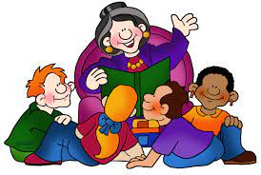

As scientists we will be learning…
identify and compare the suitability of a variety of everyday materials,
find out how the shapes of solid objects made from some materials can be changed by squashing, bending, twisting and stretching

As musicians we will be learning…
to understand rhythm and pulse
to sing, play and compose music using our own rhythms and keeping a steady pulse.
to recognise rising and falling pitches
use a small range of rising and falling pitches to sing, play and compose music
use our new skills to play on Glockenspiels and Ukuleles

Year 2
Term 3
2024/2025

In RE we will be learning….
To understand what we mean by respect.
To understand how it is important for Jewish people to do what God asks them to do.
To know the food and items on a Seder plate and what they represent.
To understand the relationships Jews have with God.
To rank what Jews do in order from most to least important.
To plan a special meal for people you love and respect.
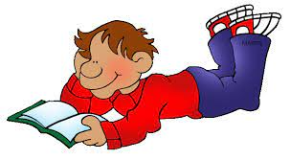
In PE we will be learning…
To throw and catch a ball with control and some accuracy – underarm and overarm.
To hold a bat correctly.
To take part in a batting and fielding game.
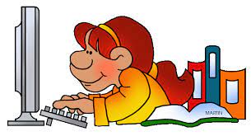

Using our computing skills, we will be learning...
To describe a series of instructions as a sequence
To explain what happens when we change the order of instructions
To use logical reasoning to predict the outcome of a program
To design an algorithm
To create and debug a program that I have written
In PSHE we will be learning:
To choose a realistic goal and think about how to achieve it
To recognise some of my strengths as a learner
To understand how working with other people can help me to learn
To work with other people to solve problem
To know how to share success with other people.
As Historians we will be learning...
To discuss what we already know about the Titanic and to sequence key events.
To know what made the Titanic special and what life on board was like.
T o know why and how the Titanic sank.
To compare and contrast a range of representations of the sinking of the Titanic.
To say why they think more people weren’t saved from the Titanic.

