Dear Parents & Carers,

Fogs are delighted to have some festive treats available to purchase by PRE ORDER ONLY to celebrate the start of the Christmas holidays. These will be delivered to your child’s class to come home with them on the last day of term - Friday 20th December.  
  
Krispy Kreme Doughnuts are available at £6 for half a dozen and £11 for a dozen.  
  
Christmas sweet treat bags containing a chocolate lolly, chewits, candy cane and hairibo are also available at £1.   
  
There will be no playground sales on the day, all items are available by PRE ORDER ONLY! Please use this link to order –

<https://www.pta-events.co.uk/friendsofgrangeschools/index.cfm>  
  
Sales MUST close at 8pm on Tuesday 17th December.  
  
Allergy information for Krispy Kreme products can be found at <https://www.krispykreme.co.uk/nutritionals>

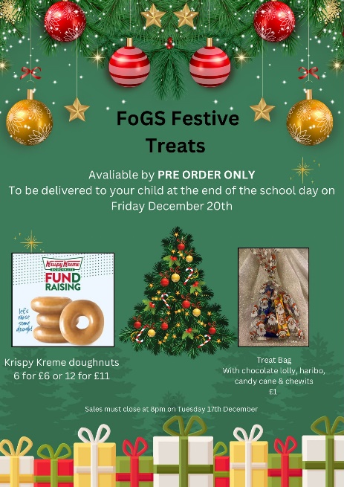  
  
We hope you have a magical Christmas break,  
Your fogs team