Grange Junior School Assessment & Feedback Policy

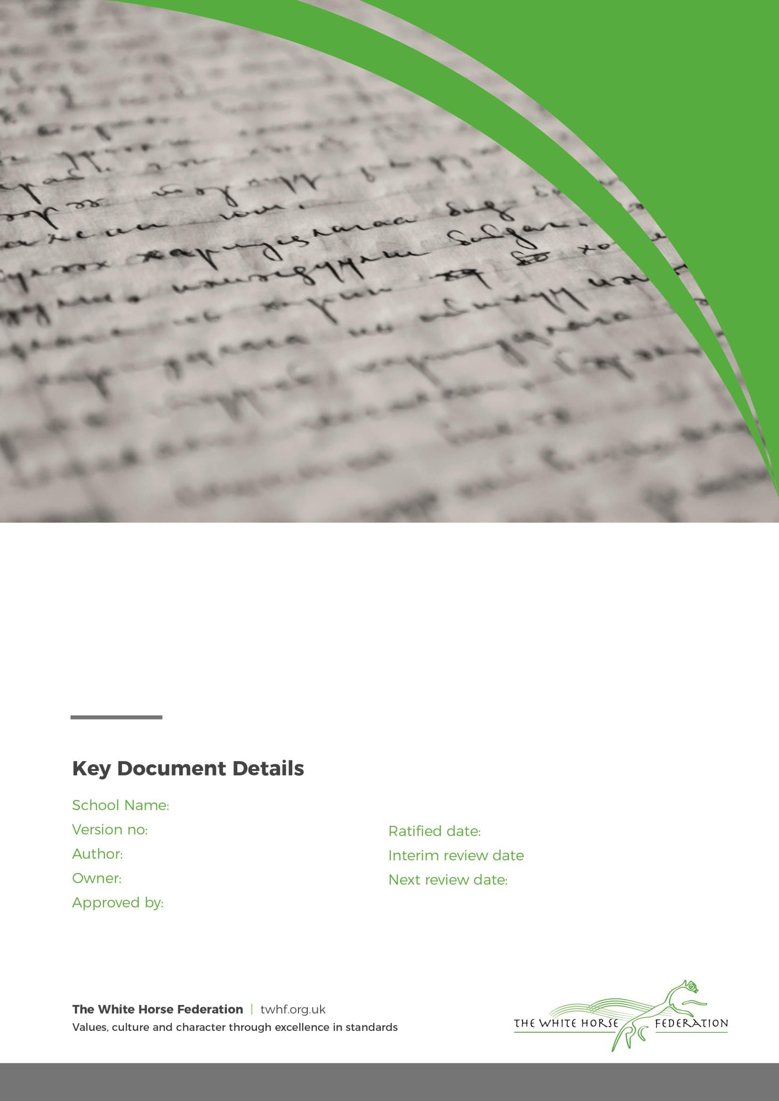Grange Junior School 1

Hannah Gordon Hannah Gordon Hannah Gordon

04/09/2024

n/a 04/09/2025

# Our Vision:

We believe feedback should provide constructive advice to every child, focusing on success and improvement needs against learning objectives; enabling children to become reflective learners and helping them to close the gap between current and desired performance.

Assessment is an essential part of learning. Effective assessment enhances learning by identifying where children are in their journey and where they need to go. The other essential parts of the learning cycle will determine how best to get ‘there’, at what speed, and ensuring that ‘there’ is a challenging place!

# Principles of Effective Feedback

* is integral to the learning process.
* is planned for in advance to ensure maximum impact and manageable workload.
* furthers children's learning, providing support and challenge as appropriate.
* actively engages children to read, reflect and respond to marking.
* is time dependent; the closer to the task, the larger the impact.
* is regular.
* is specific and helpful; linked to the learning objectives.
* is written in language which is easily understood, appropriate for age and ability.
* involves all adults and children in critique.

# Our aim is to raise standards by:

* celebrating success.
* creating an atmosphere of high expectation and mutual respect.
* encouraging children to take ownership and responsibility for their own learning.
* creating an environment where pupils acquire the skills and attitudes that encourage the development of a range of relevant learning behaviours.
* promoting a culture in which formative assessment underpins the learning experience.
* recognising that all children learn in different ways which need to be identified and addressed.
* sharing expertise and examples of good practice.
* encouraging teachers to reflect and evaluate on their own classroom practice.

# Assessment

Effective assessment is divided into two distinct strands; formative assessment which improves learning and summative assessment which measures learning. The best progress is seen when these strands complement each other and are applied regularly and thoroughly.

# Formative Assessment

Formative assessment is used to improve learning before, within and after lessons. It forms an essential part of responsive planning which enables the teacher to tailor lessons to the learning needs of the individuals in the class as part of the learning journey. There are three points at which formative assessment can occur.

* Immediate (at the point of learning)
* Summary (at the end of a lesson/task)

Page **2** of **7**

* Reflective (away from the point of learning)

Research by the Education Endowment Fund (EEF) shows that written and verbal feedback has the most impact if given as close to the point of learning as feasible; if possible within the lesson. All staff provide relevant and regular feedback which enables children to deepen their understanding to develop and improve their work. At Grange Junior School, the class teachers provide feedback in purple, teaching assistants in green and pupils use blue to show their responses to feedback.

To indicate that a child has received feedback at a given point, a VF will be written in the margin with a word or phrase to explain what the feedback referred to. It should be evident in the child's work that this feedback was understood as the remaining work should reflect the feedback. On occasion it may also be appropriate for the child to look back through the earlier work and to 'polish' their work with this feedback in mind.

Between lessons, feedback comments may be used which require a reflective response from children. For some children, it will be necessary to provide a prompt to guide the child with their response but over time children will take more responsibility for responding to short, precise comments. Children will also need to be given set lesson time to read feedback comments, and then a short period of time to make a focussed improvement based on the comments. Ideally, this will be as close to the point of learning as possible.

Year groups will identify in planning which pieces of work will be marked in more detail each week. This builds consensus and relieves the feeling of peer pressure. It also ensures a consistent experience for all children in the cohort.

To ensure consistency within class, across cohorts and across the whole school, staff will follow the Feedback Guidance document (Appendix A)

# Involving Children in Assessment

Research shows that engaging children actively in their own learning leads to tangible school improvement. Children not only need to be given regular opportunity to practice self and peer assessment but they also need to be taught the skills and attitudes needed to effectively assess their own and others performance. At Grange Junior School, children work in pairs or small groups to critique their work against the Steps to Success using a 'prove it' approach to demonstrate their understanding. When appropriate, marking stations are used to provide immediate feedback and ensure that each child moves through challenges at an appropriate pace.

# Summative Assessment

The school uses Pupil Asset to build up a picture of attainment and progress for each child over three terms in Reading, Writing and Maths. Each subject is broken down into strands which have objectives which can be measured and assessed.

The school year is divided into three cycles which each last approximately 12 weeks. At the end of each cycle, teachers will look at children's work to establish which objectives have been met and how proficient each child is in each strand. Four codes are used to indicate the level of proficient against age related expectations: below (BLW), working towards (WTS), expected (EXS) and greater depth (GDS).

These assessments will be used to inform parents about pupil attainment, to inform planning for the next cycle of learning and to inform planning for specific groups of children.

Page **3** of **7**

# Work Sampling

Work sampling by senior leaders, will be undertaken every term with a specific focus. The evidence base will primarily consist of English and Maths books but may also include other work deemed appropriate.

The focus of work sampling will be decided by the senior leader but may well focus on:

The quality of feedback

The consistency of feedback

The evidenced impact of feedback

Outcomes will be shared verbally and in writing with individuals and may be shared with Governors.

# Standardised Assessment

The collection and analysis of standardised assessment is an important aid in tracking progress at Grange Junior School. All year groups will be tested using CanDo Maths Assessments and Headstart Reading Assessments at key points in the year. They are used to validate teach judgements as well as preparing pupils for statutory end of key stage tests.

# SATs

Year 4 and 6 are subject to the national School Assessment Tests. Year 4 are tested in times table knowledge and Year 6 in Reading; Grammar, Spelling and Punctuation and Maths. These tests take place during term 5. Both year groups will participate in Mock assessments to check progress, identify gaps in knowledge and to prepare pupils with the format of questions.

# Sharing Assessment with Parents

Grange Juniors operates an 'open door' policy and parents understand that teachers are regularly available to discuss their child's learning. Meetings can be scheduled by contacting the School Office to arrange a mutually convenient time.

Progress and attainment is shared with parents through parents' evenings and written reports. Parents' evenings occur twice times during the year: October and April. The main report is shared with parents around Easter. In addition, there is a summative report at the end of the year in July. For year 6 this will be the formal reporting of SATs results and teacher assessments for the end of Key Stage. See Appendix B: Reporting to Parents.

# Professional Judgement & Workload

The use of professional judgement pervades throughout the whole area of assessment. The guidance and expectations are just that - there must always be the need for individual and collective professional judgement. This may include decisions pertaining to what to mark, how to mark, when to feedback, how to feedback ... but all judgements are made with the interests of pupil learning and pupil progress being paramount but which also take into explicit consideration the guidance set out in this school assessment policy.

The use of professional judgement must also be a guiding factor in managing one’s own workload. As a school and as a leadership team, we do not subscribe to the notion of ‘death by assessment’. The work and life beyond, of a teacher cannot be compromised by ‘over assessment’. Quality planning and curriculum development, effective teaching and learning, as well as a rich home life, are all important factors which lead to outstanding teaching. Assessment, whilst of vital importance, is not enough in isolation to produce outstanding learning.

Page **4** of **7**

APPENDIX A:

# Assessment Guidance for Grange Junior School

**Learning Objectives**

Every lesson should be planned, delivered and assessed against **one** clear, specific learning objective. This should be clearly presented at the top of work as a title or using a learning slip. The objective might be broken down into Steps to Success so that children know what a good one would look like (WAGOLL). Feedback should be linked to the learning objective and specifically against the Steps to Success.

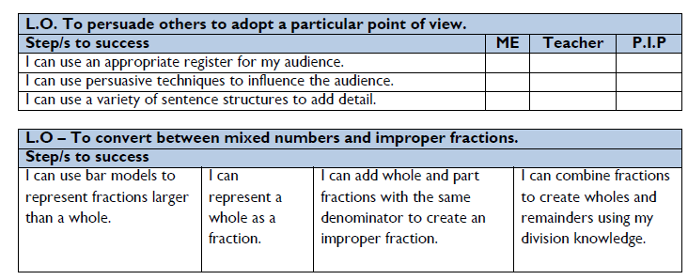

When assessing work, either during or between lessons, staff should tick those steps or the objective once the child has successfully demonstrated understanding. Within the work, Staff should single tick for examples of the objective (if appropriate). Double ticks can be used to show work that has gone the extra mile (GEM).

# Principles of Effective Feedback

* is integral to the learning process.
* is planned for in advance to ensure maximum impact and manageable workload.
* furthers children's learning, providing support and challenge as appropriate.
* actively engages children to read, reflect and respond to marking.
* is time dependent; the closer to the task, the larger the impact.
* is regular.
* is specific and helpful; linked to the learning objectives.
* is written in language which is easily understood, appropriate for age and ability.
* involves all adults and children in critique.

# Marking and Feedback

* Immediate (at the point of learning)
* Summary (at the end of a lesson/task)
* Reflective (away from the point of learning)

Research by the Education Endowment Fund (EEF) shows that written and verbal feedback has the most impact if given as close to the point of learning as feasible; if possible within the lesson. **All staff** provide relevant and regular feedback which enables children to deepen their understanding to develop and improve their work. At Grange Junior School, the class teachers provide feedback in purple, teaching assistants in green and pupils use blue to show their responses to feedback.

Page **5** of **7**

Assessment of children’s work should take place before the next lesson occurs to inform planning. Children requiring further support or who are ready for deepening or next steps should be identified so that future teaching and tasks can be tailored to meet the needs of individuals. To ensure consistency, year groups will identify in planning which pieces of written work will be marked in more detail.

**In Class Feedback**

Feedback Codes: in the margin alongside the point of reference

|  |  |  |
| --- | --- | --- |
| **Code** | **What code means** | **What feedback might look like** |
| VF | Adult has provided 1:1 feedback | Question & response, intervention, support, conferencing |
| CF | Class or group feedback has been provided | Under visualiser, catch up, pre teaching, intervention, carpet club |
| PF | Peer feedback given | EBI – even better if, P.I.P – Prove it Partner, response partner |

Writing Feedback

1. Sp or sound buttons - sp in the margin or beneath a word indicates that there is a spelling mistake. In a piece of work, up to 5 words can be identified in this way. Children may also use this code when writing if they believe a word is misspelled but don't want to break the flow of their writing. Sound buttons may also be used to support a child in finding the correct spelling.
2. ^ - an arrow indicates that there is a word missing somewhere in that line.
3. O – this indicates that there is a piece of punctuation missing somewhere in that line.
4. Ø – this indicates that there is a problem with some punctuation somewhere in the line.
5. // - two diagonal lines indicate that there should be change in paragraph.
6. ? - a question mark in the margin indicates that the sentence does not make sense.

Maths Feedback

We advocate the use of marking stations to enable pupils to self-assess. Attempting 3 questions and then marking will empower pupils to seek support, try again or attempt a harder challenge independently.

* + Correct answers to be indicated with a tick.
  + Incorrect answers to be indicated with a dot.

Foundation Feedback

Up to 3 spelling errors (common exception words, homophones or topic specific words) should be identified using the same annotation as in writing. These should be edited by children using blue.

Page **6** of **7**

APPENDIX B:

# Reporting to Parents Cycle

At Grange Junior School we work closely in partnership with our parents to ensure that the social, emotional, health and educational needs of their children are met effectively.

So that parents feel fully informed about their child’s progress and attainment, we have a programme for reporting to parents.

We are happy to meet and discuss your child’s needs and progress at any time. Please contact the school office to arrange mutually convenient time.

|  |  |  |
| --- | --- | --- |
| September | Meet the Teacher event | 30 minute presentation about the year to  come, an opportunity to ask general questions |
| November | Parents Evening | An opportunity to discuss the progress and share any concerns  At this meeting you will receive your child’s  current level of attainment for Reading, Writing and Maths and their next steps |
| March | SEND Parents Evening | By invitation only – an opportunity for parents of SEND pupils to talk at length with class teacher and SENDCo about your child’s ongoing education, needs and  provision |
| March/April | Mid-Year Reports | Main report to parents with current level of  attainment for Reading, Writing and Maths including next steps |
| April | Parents Evening  *(Not SEND pupils)* | An opportunity to meet with class teacher to  discuss next steps outlined in the mid-year report |
| July | End of Year Reports | Current level of attainment for core subjects and progress information for all other  curriculum areas plus attendance information |

Page **7** of **7**