Pupil premium strategy statement – Grange Junior School
This statement details our school’s use of pupil premium (and recovery premium) funding to help improve the attainment of our disadvantaged pupils.
It outlines our pupil premium strategy, how we intend to spend the funding in this academic year and the outcomes for disadvantaged pupils last academic year.

School overview
Detail | Data
Number of pupils in school | 324
Proportion (%) of pupil premium eligible pupils | 20.4%
Academic year/years that our current pupil premium strategy plan covers (3 year plans are recommended – you must still publish an updated statement each academic year) | 2024/2025 to 2026/2027
Date this statement was published | December 2024
Date on which it will be reviewed | June 2025
Statement authorised by | Hannah Gordon
Pupil premium lead | Hannah Gordon
Governor / Trustee lead | Jo Ockwell

Funding overview
Detail | Amount
Pupil premium funding allocation this academic year | £ 104,540.00
Pupil premium funding carried forward from previous years (enter £0 if not applicable) | £0
Total budget for this academic year | £ 104,540.00

Part A: Pupil premium strategy plan

Statement of intent
Our intention is that all pupils, irrespective of their background or the challenges they face, make good progress and achieve high attainment across all subject areas. We believe that this is best achieved through the development of knowledge and skills through a language rich, experience filled curriculum which makes connections within and between subjects. Whilst socio-economic disadvantage is not always the primary challenge our pupils face, we do see a variance in outcomes for disadvantaged pupils across the school when compared to their peers, particularly in terms of:
Academic attainment
Progression to further and higher education
Employability
Social opportunities

We consider the challenges faced by vulnerable pupils, such as those who have a social worker and young carers. We also take into account the impact of remote education during the pandemic on children’s social, emotional and physical health as well as the impact on academic progress and attainment. The activity we have outlined in this statement is also intended to support their needs, regardless of whether they are disadvantaged or not.
Quality first teaching is at the heart of our approach, with a focus on areas in which disadvantaged pupils require the most support. This is proven to have the greatest impact on closing the disadvantage attainment gap and at the same time will benefit the non-disadvantaged pupils in our school. Implicit in the intended outcomes detailed below, is the intention that non-disadvantaged pupils’ attainment will be sustained and improved alongside progress for their disadvantaged peers.
Our strategy is also integral to wider school plans to provide targeted support for pupils whose education has been worst affected, including non-disadvantaged pupils. Our approach will be responsive to common challenges and individual needs identified through the school’s assessment programme. Our plan will be based on what we know about our pupils and what data we can utilise rather than making assumptions.
To ensure that our approaches are effective we will:

Ensure that the pitch and pace of work provides challenge for every pupil.
Ensure that intervention and support meet the needs of the individuals involved in a timely manner.
Adopt high expectations for all pupils regardless of their advantage or disadvantage.

Key areas of concern to be addressed:
Attainment of disadvantaged pupils is significantly below non-disadvantaged peers. This needs to be swiftly addressed so that they make equivalent progress and reach their full potential.

Challenges
This details the key challenges to achievement that we have identified among our disadvantaged pupils.
Challenge number | Detail of challenge
1 | The vocabulary gap and lack of reading fluency affects pupils’ attainment in reading and other subject areas.
2 | Internal and external assessments indicate that maths attainment among disadvantaged pupils is significantly below that of non-disadvantaged pupils.
3 | Internal and external assessments indicate that writing attainment among disadvantaged boys is significantly below that of non-disadvantaged pupils.
4 | Internal and external assessments indicate that reading attainment among disadvantaged boys is significantly below that of non-disadvantaged pupils.
5 | As a result of significant challenges already faced by our pupils- Covid, school closure, and the current financial challenged faced by families; our pupils mental health and associated resilience has been negatively impacted which in turn affects their ability to learn.
6 | The cost-of-living crisis that is affecting the UK currently will affect our most disadvantaged greatly.Our disadvantaged children are more likely to miss out on real experiences which can reduce their cultural capital and engagement in learning due to contextual limitations
7 | Increasing number of pupils with SEND needs and in particular SEMH needs that require regular and robust adult intervention to ensure that children’s learning is not disrupted and children meet their full potential.

Intended outcomes
This explains the outcomes we are aiming for by the end of our current strategy plan, and how we will measure whether they have been achieved.
Intended outcome | Success criteria
To ensure that Quality first teaching is available to all children in all subject areas and that learning matches need appropriately through the effective use of intervention and scaffolding. | - Effective AFL is used to establish children’s progress and ensure all teaching matched need.  - Books evidence high quality teaching and learning  - SMART targets are use as appropriate and meet need.  - In 2023-24 our RWM measure was 28.6%. We aim to significantly improve on this for our 2024-25 cohort.
To raise the attainment of Pupil Premium children in Reading by improving fluency and phonic knowledge and ensuring children are exposed to high-quality, rich vocabulary in all subjects. | - Children are regularly reading high quality texts.  - Reading attainment improves and is evidence on RAG and in assessments.  - More children achieve EXS in Reading.
To raise the attainment of Pupil Premium children in Maths by ensuring they are secure in key fundamental skills and the application of these to reasoning tasks. | - KS2 Maths outcomes in 2023-24 show that 35.7% of disadvantaged children met the expected standard at the end of KS2.
To raise the attainment of Pupil Premium children in writing by embedding immediate feedback, ETIW (Every Time I Write) and application for grammar for accuracy. | - KS2 writing outcomes in 2022-23 show that 50% of disadvantaged children met the expected standard at the end of KS2.
All children will be emotionally ready to learn and supported when their struggle to regulate their behaviours | - Reasonable adjustments are robust, meet need and consistently in place.  - Pupil voice will be able to confidently articulate how to face different challenges in structured and less structured times.  - All children who require support will have access to ELSA, Pastoral TA and nurture resources.
To continue to provide disadvantaged pupils an enriching, exciting curriculum offer with opportunities to increase cultural capital (subsidised trips, sports coaches, visitors and visits, curriculum sessions) | - Positive pupil voice around the curriculum offer.  - Positive parent voice regarding our curriculum and extended offer.

Activity in this academic year
This details how we intend to spend our pupil premium (and recovery premium) funding this academic year to address the challenges listed above.

Teaching (for example, CPD, recruitment and retention)
Budgeted cost: £ 57,366
 | Activity | Evidence that supports this approach | Challenge number(s) addressed
Planned CPD opportunities for teaching staff leading to improved teaching and pupil outcomes  Actions and Approach  CPD will be strategically planned across the year and in response to monitoring and needs identified in data  Planning clinics will be used regularly to ensure consistency and effective use of the T&L principles |  | The EEF Guide to the Pupil Premium  States that QFT has the biggest impact on pupil outcomes  “High-quality CPD for teachers has a significant effect on pupils’ learning outcomes.” Evidence review: The effects of high-quality professional development on teachers and students – The Education Policy Institute | 1, 2,3,4
QFT teaching is supported through a robust coaching and mentoring programme  Actions and Approach  All staff will receive regular coaching and mentoring opportunities linked to whole school improvement priorities  Live coaching, lesson recordings and paired coaching will be used to continuously improve teaching and share best practise |  | Schools Week;  Research: how can coaching lead to school improvement?  EEF-Effective-PD-Recommendations-Poster.pdf  “Quality Teaching helps every child”  EEF Guide to the Pupil Premium  Consistency in teaching will ensure that all pupil have the same opportunities to make at least expected progress and in some cases better than expected progress | 1,2,3,4
Disadvantaged pupils are supported to improve their reading fluency and enrich their vocabulary so that there is an increased % in combined attainment of RWM at National Average for PP children  Actions and Approach  Identified pupils are provided with regular 1:1 reading opportunities across the week.  Prioritise Rapid Catch up – Little Wandle  Ensure staff are fully trained and offer ongoing coaching activities to maximise the positive impact on outcomes.  Focussed analysis of attainment data- RAG, NGRT |  | Reading is the gateway to all areas of the curriculum.  EEF T&L toolkit – Reading Comprehension strategies +6 months  Research shows that by the age of seven, the gap for vocabulary between pupil premium children and their peers can be as many as 3,000 words.  Increased vocabulary will improve pupils’ ability to articulate their thinking and understanding. | 1 and 4  £14,720 – Rapid Catch up
To raise the attainment of Pupil Premium children in writing by embedding immediate feedback, ETIW (Every Time I Write) and application for grammar for accuracy.  Actions and Approach  Embed a common curriculum for writing with an increased emphasis on oracy and writing stamina  Ensure that there is a high priority placed on ETIW to reduce the errors children are making in their writing  Focussed analysis of attainment data- RAG |  | Quality First Teaching known to be biggest driver in terms of improving attainment of PP children. ‘What happens in the classroom makes the biggest difference’.  EEF Attainment Gap Report 2018 | 3
Improve outcomes in Maths especially around pupils ability to apply mathematical knowledge to problem solving activities.  Actions and Approach  Analyse gaps in learning and track regularly. Use QLA to adapt the Can Do roadmap to teach the most important content first  Deliberate practise sessions  Strategically use of Maths Meetings  Focussed analysis of attainment data- GL assessments, Can Do Assessments, RAG |  | “The impact of mastery learning approaches is an additional five months progress, on average, over the course of a year.”  EEF Teaching and Learning Toolkit: Mastery Learning +5 months. | 1 and 2
Staff training to support children who struggle with emotional self-regulation  Actions and Approach  Ongoing staff training around resilience and risk taking.  Bespoke timetables for those pupils with the most complex needs  Support during unstructured times: Relaxation station during lunchtimes |  | “Social and emotional learning approaches have a positive impact, on average 4 months’ additional progress in academic outcomes over the course of an academic year.”  EEF Teaching and Learning Toolkit: Social and Emotional Learning +4 months “Both targeted intervention and universal approaches have positive overall effects. There is evidence across a range of different interventions with higher impacts for 4 11 approaches that focus on self-management.” | 7

Targeted academic support (for example, tutoring, one-to-one support, structured interventions)
Budgeted cost: £ 25,142
Activity | Evidence that supports this approach | Challenge number(s) addressed
Use of targeted interventions planned through provision maps to support the catch-up of SEND/ Pupil Premium children in Reading, Writing and Maths.  Actions and Approach  Small group intervention for Maths and Reading  Reading Fluency  Times Table focus group  Number Stacks | “There is extensive evidence supporting the impact of high-quality one to one and small group tuition as a catch-up strategy.”  EEF Covid-19 Support Guide for Schools 2020  “Reducing class size has a small positive impact of +2 months on average”. Greater impact is seen when class sizes are reduced by at least 10 pupils.  EEF Teaching and Learning Toolkit: Reducing Class Size +2 months | 1 and 2  £6431.00
Use of targeted support and deliberate practise through EMT’s, Pre and post teaching.  Actions and Approach  Use of assessment to track gaps and tasks children need to undertake for deliberate practise.  Post and Pre teaching used to ensure children know and remember more. | “There is extensive evidence supporting the impact of high-quality one to one and small group tuition as a catch-up strategy.” | 2,3 and 4
Use of learning Mentors to ensure that children with more complex needs are fully supported to access learning in the most appropriate manner  Actions and Approach  Learning Mentors to support children to engage in class  Provide additional support to engage children in learning | “Reducing class size has a small positive impact of +2 months on average”. Greater impact is seen when class sizes are reduced by at least 10 pupils.  EEF Teaching and Learning Toolkit: Reducing Class Size +2 months  Self-regulation strategies | EEF | 5 and 7  £10,688- Learning Mentor  £8023- Learning Mentor

Wider strategies (for example, related to attendance, behaviour, wellbeing)
Budgeted cost: £ 22,032
Activity | Evidence that supports this approach | Challenge number(s) addressed
Subsidising residential trips and enrichment activities to continue to increase children a cultural capital  Actions and Approach  Cultural capital offer mapped out across every year group  Enrichment clubs are offered free of charge  Residentials, schools trips and other enrichment activities are subsidised so all children are included | Support pupils with cultural capital by providing access to a wide range of enrichment experiences and curriculum.  .  Sutton Trust: Outdoor adventure learning +4 months | 5 and 6  £2337.10
Ongoing CPD and supervision for ELSAs from Educational Psychologist to ensure relevance of services offered.  Actions and Approach  Designated ELSA and nurture timetables  Supervision supports staff in their delivery of high-quality sessions | ELSA programs have proved successful in improving social interactions and lead to improvements in challenging behaviours and a reduction in disruptive behaviour in class.  Self-regulation strategies | EEF  Social and emotional learning | EEF | 5 and 7  £365.00
Improved outcomes for vulnerable and anxious children. Support for pupils and families of those exhibiting mental health difficulties  Actions and Approach  External support mechanisms;  - Outdoor Project  - Mosaics of Life  - Little Dinos  - Sport Mentoring | Pupils whose SEMH needs are supported learn better in class as their barriers to learning are reduced/removed.  “Social and emotional learning approaches have a positive impact, on average 4 months’ additional progress in academic outcomes over the course of an academic year.” EEF Teaching and Learning Toolkit: Social and Emotional Learning +4 months | 5 and 7  £19,330

Total budgeted cost: £ 104,540.00

Part B: Review of the previous academic year

Outcomes for disadvantaged pupils
Teaching
As a school we aim to be ambitious for all pupils and ensure that all children consistently receive high-quality teaching and learning enabling them to make good progress. In our 2023 Ofsted inspection, it was noted that ‘Leaders, governors and the trust are ambitious for all pupils’ and that we have rightly places ‘a significant emphasis on curriculum development.’ Our aim is to ensure that children are ready for the next stage of their educational journey. As a school we achieved good in all areas; a significant improvement on our previous inspection.
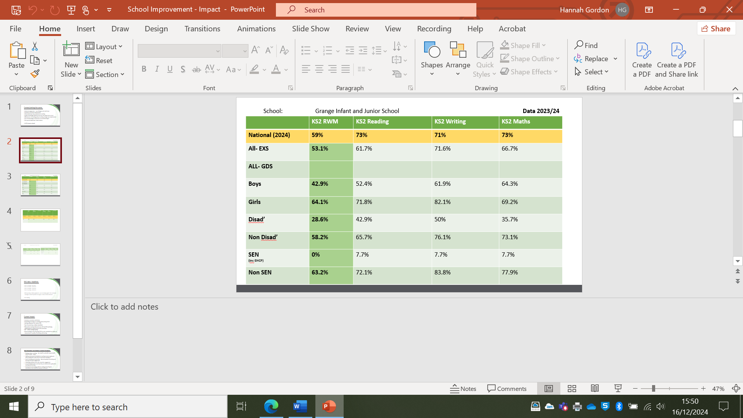
Our national assessment data last year overall were an improvement on the previous year although there are still some significant gaps between our disadvantaged and non-disadvantaged learners. These gaps are evident in all areas and especially when children have more than one barrier to learning such as SEND.

Lessons Learnt

All teachers have access to a new tracking system that focus on individual children on a weekly basis. Children who are falling behind or who need intervention are given so swiftly. Senior Leaders monitor this weekly.

Targeted Academic Support
Our catch-up programme for phonics and our children’s access to well matched books has been incredibly successful. In Ofsted it was noted that ‘All staff prioritise reading’ and that ‘pupils practise reading books that contain the sounds they know.’
Lessons learnt;
The relentless focus on rapid catch up has continued to have a positive impact. It has also been successful having one member of staff delivery the programme to ensure consistency in delivery and approach.
School Led Tutoring

School Led Tutoring has been offered to children in Year 5 and 6. Uptake was good and children made excellent progress in maths. There were 13 children who had school led tutoring and of these 9 children achieved a scaled score of at least 100. Children made good progress with an average scaled scored increase of 8.4 scaled score increments since October.
Lesson Learnt:
The sessions had a positive impact on children’s level of confidence and provided them the skills to be more resilient learners.
Lesson Learnt

The Pastoral Team have been invaluable in knowing our families and supporting them by knowing their specific needs. This supports children in being ready for learning and more able to regulate their emotions. Moving forward a new model for Tas and Mentors is being rolled out to support further consistency in our approach.

Externally provided programmes
Please include the names of any non-DfE programmes that you used your pupil premium (or recovery premium) to fund in the previous academic year.
Programme | Provider
Little Wandle SSP | Collins
Can Do Maths | Buzzard Publishing
Discovery RE | Discovery RE
Jigsaw PSHE | Jigsaw PSHE

Service pupil premium funding (optional)
For schools that receive this funding, you may wish to provide the following information: How our service pupil premium allocation was spent last academic year
Last academic year this was used to support funding of our pastoral services.
The impact of that spending on service pupil premium eligible pupils
This allows children to have regular check-ins and access to more formal pastoral support such as ELSA and Drawing and Talking.

Further information (optional)
N/A

