Dear Year 3 and 4 parents and carers, | Snacks  Children are most welcome to bring in a snack at playtime. As per healthy schools’ guidance, we ask that these are fruit or vegetables where possible. | Dates for your diary:  2nd October 2024 – Individual Photos  15th – 22nd Oct 24 – Book Fayre  24th October 24 – TD Day
We hope you have had a great summer break and are ready to start the new school year. We’d like to take this opportunity to welcome you to Year 3 and 4.
PE  Our PE days will be on Wednesday and Thursday. Please can children come into school in their PE kits on this day. Please note that it is important that long hair is tied back on these days and children are not wearing hooped earrings and other jewellery should not be worn. | Reading  In due course, your child will receive their reading record and an appropriate reading book. Reading is crucial part of our culture here at Grange. We ask children to read at least 3 times a week and record it in their reading record. Every reading night counts towards our reading reward scheme. We hope to see lots of children achieving 250 nights this year! | Please keep an eye on the school website for updates and dates.  Finally, please remember that if you have any questions, feel free to contact us by sending an email to the school office or speaking to the class teachers.
Water Bottles  Please can you ensure that your child brings a water bottle to school. If these can be named, it helps us to return them to their owners if they are misplaced. The children are allowed to access these during the school day whenever they wish; the only time we ask them to wait is during our lesson input times. An extra drink can also be provided for lunchtime should you wish. | Times Tables and Spellings  In due course, your child will receive their login for Times Table Rockstars and Spelling Sheds. These are the two tools we use for homework at Grange. Times Tables and Spellings are essential areas of Maths and English so please provide your child with time to complete their homework. | Thank you for your continued support.  Mrs Arthur – Ash class and Year group Lead  Mrs Dias – Ash class  Miss Baker – Beech class  Mrs Whitehouse – Elm class  Mrs Hodge – Maple class  Mr Foord – Oak class
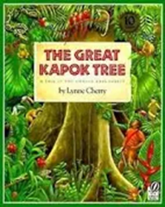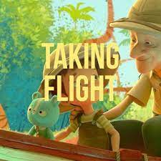
As writers we will be learning…
to use ‘The Sound Collector’ as a stimulus for writing our own poems.
to use ‘The Great Kapok Tree by Lynne Cherry’ as a stimulus for writing our own story setting about the rainforest where the Kapok tree is.
to use ‘Taking Flight (Animation- literacy shed)’ as a stimulus for writing our own diary entry from the little boy’s perspective.
As mathematicians we will be learning…
Year 3
to represent, read, recognise, partition and write 3-digit numbers.
to count up and back in steps of 50 and 100
to compare and order 3-digit numbers
to add 2 and 3-digit numbers using number lines, bridging, compensating and mental strategies
Year 4
to represent, read, recognise and write 4-digit numbers.
to count in multiples of 25 and 1000
to compare and order 4-digit numbers
to round 2, 3 and 4 digit numbers to the nearest 10, 100 and 1000
to recall and use multiplication facts for the 6, 9 and 7 times table

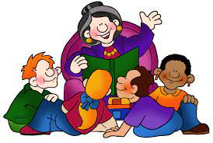
As Artists and Designers, we will be learning …

about the skill of drawing.
Children will be looking at portraits and self-portraits.
They will create their own self-portrait
They will use oil pastels to create their self-portrait.

As scientists we will be learning…

to explore solids, liquids and gases
to analyse different changes in states of matter
to describe and explain the water cycle

Year 3 and 4
Term 1
2024/2025
As musicians we are learning…

to understand the music style of ABBA
to learn the lyrics and perform Mamma Mia in class


In RE we will be discovering…
Religion: Judaism
Theme: Beliefs and Practices
Key Question: How special is the relationship Jews have with God?
In PE we are learning…

Dodgeball
Netball


As French speakers we will be learning about…
Je peux ‘I am able’
To recognise, remember and spell 10 action words in French
To use positive and negative sentence structures
Using our computing skills, we are…

Explore how a network can share messages with another network to form the internet. Look at different network devices such as routers.
On-line safety: Self-image and identity.
PSHE:

Being me in my own world
Identifying goals for the year

As historians we will be learning...

Time period: Ancient Egyptians
to identify and describe the achievements and key features of this era
to compare Ancient Egyptians with other ancient civilizations in the world

