Dear Year 4 parents and carers, | Snacks  Children are most welcome to bring in a snack at playtime. As per healthy schools’ guidance, we ask that these are fruit or vegetables where possible. | Dates for your diary:  19/09 - Jeans for Genes  26/09 – European Languages Day  01/10 – Individual Photos  10/10 – World Mental Health Day  16/10 & 17/10 & 20/10 – Book Fair  22/10 – TD Day
We hope you have had a great summer break and are ready to start the new school year. We’d like to take this opportunity to welcome you to Year 4.
PE  Our PE days will be on Tuesday and Thursday. Please can children come into school in their PE kits on this day. Please note that it is important that long hair is tied back on these days and children are not wearing hooped earrings and other jewellery should not be worn. | Reading  In due course, your child will receive their reading record and an appropriate reading book. Reading is crucial part of our culture here at Grange. We ask children to read at least 4 times a week and record it in their reading record. Every reading night counts towards our reading reward scheme. We hope to see lots of children achieving 250 nights this year! | Please keep an eye on the school website for updates and dates.  Finally, please remember that if you have any questions, feel free to contact us by sending an email to the school office or speaking to the class teachers.
Water Bottles  Please can you ensure that your child brings a water bottle to school. If these can be named, it helps us to return them to their owners if they are misplaced. The children are allowed to access these during the school day whenever they wish; the only time we ask them to wait is during our lesson input times. An extra drink can also be provided for lunchtime should you wish. | Times Tables and Spellings  In due course, your child will receive their login for Times Table Rockstars and Spelling Shed. These are the two tools we use for homework at Grange. Times Tables and Spellings are essential areas of Maths and English so please provide your child with time to complete their homework. | Thank you for your continued support,  Mrs Arthur, Miss Connell and Mr Dunn
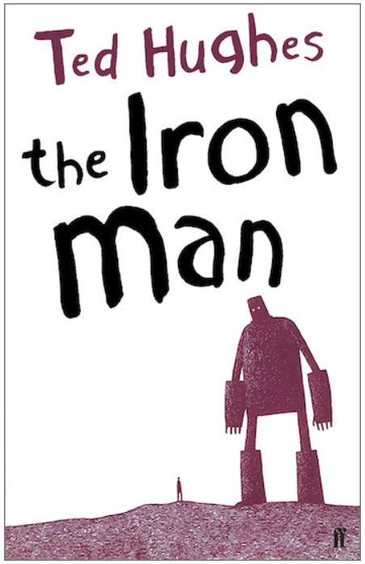
As writers we will be learning…

to use ‘The Magic Box’ as a stimulus for writing our own poems.
to use ‘Iron Man by Ted Hughes’ as a stimulus for writing our own setting description and a diary entry.

As mathematicians we will be learning…
Represent, recognise, compare, order, read and write 4-digit numbers using numerals and words
Identify 4-digit numbers of a number line
Round 2, 3 and 4-digit numbers to the nearest 10, 100 and 1000.
Identify and describe 2D shapes
Identify and draw lines of symmetry in 2D shapes

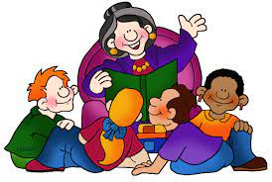
As Artists and Designers we will be learning …
Drawing: Self Portraits
Experimentation with pencil gradients and different techniques.
Skills sessions on drawing and shading facial features.
Looking at the features and the symmetry and proportion of the face.
Annotating and reflecting on final piece.
As scientists we will be learning…
Magnets
Compare how things move on different surfaces.
Notice that some forces need contact between two objects, but magnetic forces can act at a distance.
Observe how magnets attract or repel each other and attract some materials and not others.
Compare and group together a variety of everyday materials on the basis of whether they are attracted to a magnet, and identify some magnetic materials.
Describe magnets as having two poles.
Predict whether two magnets will attract or repel each other, depending on which poles are facing.

Year 4
Term 1
2025/2026

As musicians we are learning…
Woodwind Instrument – Recorder
Rehearse and learn a simple instrumental part by ear or from notation, using the notes C, D, E, F, F♯, G, G♯, A, B and B♭.



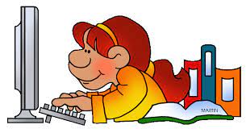
In RE we will be discovering…
Religion: Sikhism
Theme: The Amrit Ceremony and the Khalsa
Key Question: Does joining the Khalsa make a person a better Sikh?
In PE we are learning…

Dance – Eco Warrior
Multi-Skills

As French speakers we will be learning about…

Greetings
Numbers 0 – 10
Colours
Using our computing skills, we are…

Online Safety – Project Evolve
Self-Image and Identity

Computing Systems and Networks –

PSHE:

Being me in my own world
Identifying goals for the year
As historians we will be learning...

About Stone Age to Iron Age
Settlements
Hunters and gathers
Stonehenge
Iron Age hill forts

