Dear Year 6 parents and carers, | Snacks  Children are most welcome to bring in a snack at playtime. As per healthy schools’ guidance, we ask that these are fruit or vegetables where possible. | Dates for your diary:  19/09 - Jeans for Genes  23/09 – School Nurse  26/09 – European Languages Day  01/10 – Individual Photos  10/10 – World Mental Health Day  16/10 & 17/10 & 20/10 – Book Fair  22/10 – TD Day
We hope you have had a great summer break and are ready to start the new school year. We’d like to take this opportunity to welcome you to Year 6.
PE  Our PE days will be on Tuesday (Choughs and Ravens), Wednesday (Falcons) and Thursday (all Year 6). Please can children come into school in their PE kits on this day. Please note that it is important that long hair is tied back on these days and children are not wearing hooped earrings and other jewellery should not be worn. | Reading  In due course, your child will receive their reading record and an appropriate reading book. Reading is crucial part of our culture here at Grange. We ask children to read at least 4 times a week and record it in their reading record. Every reading night counts towards our reading reward scheme. We hope to see lots of children achieving 250 nights this year! | Please keep an eye on the school website for updates and dates.  Finally, please remember that if you have any questions, feel free to contact us by sending an email to the school office or speaking to the class teachers.
Water Bottles  Please can you ensure that your child brings a water bottle to school. If these can be named, it helps us to return them to their owners if they are misplaced. The children are allowed to access these during the school day whenever they wish; the only time we ask them to wait is during our lesson input times. An extra drink can also be provided for lunchtime should you wish. | Times Tables and Spellings  In due course, your child will receive their login for Times Table Rockstars and Spelling Shed. These are the two tools we use for homework at Grange. Times Tables and Spellings are essential areas of Maths and English so please provide your child with time to complete their homework. | Thank you for your continued support,  Miss Humphries (Year Group Lead), Mrs Dias and Mr Bailey
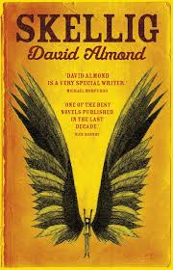
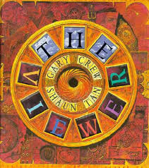
As writers we will be learning…
to use ‘The Magic Box’ as a stimulus for writing our own poems.
to use ‘Skellig by David Almond’ as a stimulus for writing our own narrative stories with a focus on setting description.
to use ‘The Viewer by Shaun Tan’ as a stimulus for writing our own diary entry from Tristan’s perspective.
As mathematicians we will be learning…

to read, recognise and write 7-digit numbers.
to multiply and divide decimals by 10, 100 and 1000.
to find common multiplies and factors.
to multiply and divide three- and four-digit numbers by two-digit numbers using a written method.

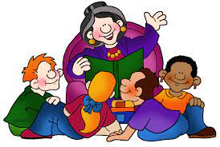
As Artists and Designers we will be learning …
about the skill of drawing.
Children will be looking at portraits and self-portraits.
They will create a self-portrait in a Mark Powell style.
They will use biro to create their self-portrait.

Mechanical systems – pulleys
Investigate, plan, make and evaluate a child’s moving toy.
As scientists we will be learning…

Recognise that light appears to travel in straight lines.
Use the idea that light travels in straight lines to explain that objects are seen because they give out or reflect light into the eye
Explain that we see things because light travels from light sources to our eyes or from light sources to objects and then to our eyes
Use the idea that light travels in straight lines to explain why shadows have the same shape as the objects that cast them.

Year 6
Term 1
2025/2026

As musicians we are learning…

to understand the music style of Carole King from the 70s.
to sing the song You’ve Got A Friend - a song about friendship by Carole King.

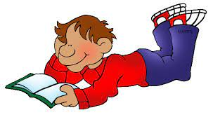
In RE we will be discovering…
Religion: Islam
Theme: Beliefs and Practices
Key Question: What is the best way for a Muslim to show commitment to God?
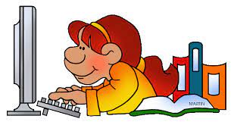
In PE we are learning…

Dance
Gymnastics

As French speakers we will be learning about…

Greetings
Numbers 0 – 10
Colours
Using our computing skills, we are…

Online Safety – Project Evolve
Self-Image and Identity

Computing Systems and Networks – Communication and Collaboration

PSHE:

Being me in my own world
Identifying goals for the year
As geographers we will be learning...

about Trade across the world
imports and exports
transportation of goods
importance of Fair Trade

