|  |  |  |
| --- | --- | --- |
| Dear Year 6 parents and carers, | **Snacks**  Children are most welcome to bring in a snack at playtime. As per healthy schools’ guidance, we ask that these are fruit or vegetables where possible. | **Dates for your diary:**  5th November 2024 – UK Parliament Assembly  12th – 13th November 2024 – Parents evening  12th November 2024 – Rocksteady Workshop  15th November 2024 – Children in Need  12th December 2024 – Percussion Roadshow |
| We hope you have had a great half-term and are ready to start the next term at Grange Junior School. We’d like to take this opportunity to notify you of what to expect over this term. |
| **PE**  Our PE days will be on Monday and Thursday. Please can children come into school in their PE kits on this day. Please note that it is important that long hair is tied back on these days and children are not wearing hooped earrings and other jewellery should not be worn. | **Reading**  Reading is crucial part of our culture here at Grange. We ask children to read at least 3 times a week and record it in their reading record. Every reading night counts towards our reading reward scheme. We hope to see lots of children achieving 250 nights this year! | Please keep an eye on the school website for updates and dates.  Finally, please remember that if you have any questions, feel free to contact us by sending an email to the school office or speaking to the class teachers. |
| **Water Bottles**  Please can you ensure that your child brings a water bottle to school. If these can be named, it helps us to return them to their owners if they are misplaced. The children are allowed to access these during the school day whenever they wish. The only time we ask them to wait is during our lesson input times. An extra drink can also be provided for lunchtime should you wish. | **Times Tables and Spellings**  Times Table Rockstars and Spelling Sheds are used for homework at Grange.  **Year 6 Homework**  In preparation for Year 6, Year 6 will shortly be receiving an additional weekly piece of homework. Please watch this space – more information to follow. | Thank you for your continued support,  Miss Pound (Year Group Lead), Miss Humphries and Mr Dunn |

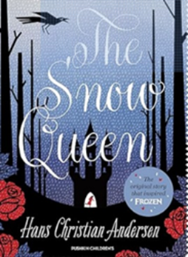

**As mathematicians, we will be learning…**

* Compare fractions.
* Order fractions.
* Find equivalent decimals, fractions and percentages.
* Find missing angles on a line, at a point and vertically opposite.

**As writers, we will be learning…**

to use ‘The Snow Queen’ as a stimulus:

* To write a persuasive letter to persuade to save the ice palace (from the perspective of the Snow Queen)
* To write an alternative Ending with character description.

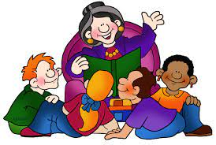

**As artists, we will be learning …**

* Focus: Drawing
* Art Movement: Modernism
* Focus: Portrait
* Media: Biro
* Art Influence: Mark Powell

**As scientists, we will be investigating…**

* mirrors and shiny surfaces and how they alter the direction in which light travels and that when they see objects, light enters the eye.
* first hand refraction, colours of light and the making of a periscope.
* the British scientist Isaac Newton and the invention of the first reflecting telescope.

**Year 6**

**Term 2**

**2024/2025**

**As musicians, we are learning…**

* to understand the style of music ‘Pop and Neo soul’
* to sing the song Happy by Pharrell Williams.

**In RE, we will be discovering…**

* Religion: Christianity
* Theme: Christmas
* Key Question: Do Christmas celebrations and traditions help Christians understand who Jesus was and why he was born?



**In PE, we are learning…**

* Netball
* Gymnastics

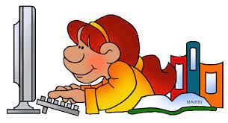

**Using our computing skills, we are…**

* Online Safety – Project Evolve
* Online Bullying
* Health, Well-being and Lifestyle
* Teach Computing - Creating Media
* Webpage Creation
* Using Google Slides

**In PSHE, we are learning about:**

* Celebrating difference:
* Perceptions of normality
* Understanding disability
* Power struggles
* Understanding bullying

**In Geography, we will be learning about...**

**Trade and Economics:**

* What do we trade?
* Who do we trade with?
* Imports and Exports
* Fair Trade The global economy
* How has trading changed?

**As French speakers, we will be learning about…**

* At School
* Introduce vocab for school subjects
* Expressing an opinion on school subjects