|  |  |  |
| --- | --- | --- |
| Dear Year 6 parents and carers, | **Snacks**  Children are most welcome to bring in a snack at playtime. As per healthy schools’ guidance, we ask that these are fruit or vegetables where possible. | **Dates for your diary:**  Tuesday 4th February – Trip to Bletchley Park  Friday 7th February – NSPCC Number Day  Tuesday 11th February - Safer Internet Day  Friday 7th March - Class Photographs  Tuesday 18th March – Trip to Parliament |
| We hope you have had a great half term and are ready to start the next term at Grange Junior School. We’d like to take this opportunity to notify you about what to expect over this term. |
| **PE**  Our PE days will be on Monday and Tuesday. Please can children come into school in their PE kits on this day. Please note that it is important that long hair is tied back on these days and children are not wearing hooped earrings and other jewellery should not be worn. | **Reading**  Reading is crucial part of our culture here at Grange. We ask children to read at least 3 times a week and record it in their reading record. Every reading night counts towards our reading reward scheme. We hope to see lots of children achieving 250 nights this year! | Please keep an eye on the school website for updates and dates.  Finally, please remember that if you have any questions, feel free to contact us by sending an email to the school office or speaking to the class teachers. |
| **Water Bottles**  Please can you ensure that your child brings a water bottle to school. If these can be named, it helps us to return them to their owners if they are misplaced. The children are allowed to access these during the school day whenever they wish. The only time we ask them to wait is during our lesson input times. An extra drink can also be provided for lunchtime should you wish. | **Times Tables and Spellings**  Times Table Rockstars and Spelling Sheds are the two tools we use for homework at Grange. Times Tables and Spellings are essential areas of Maths and English so please provide your child with time to complete their homework.  As per our letter home during Term 2, we will continue with our CGP books for Reading, Maths and SPaG. | Thank you for your continued support,  Miss Pound (Year Group Lead), Mrs Dias, Miss Humphries and Mr Dunn |

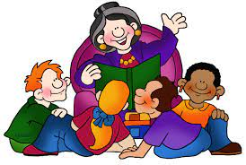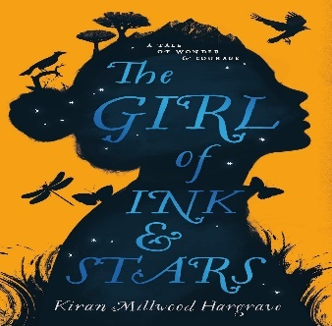

**As writers we will be learning…**

to use ‘The Girl of Ink & Stars’ as a Kiran Hargrave:

* To know the features of a myth
* To understand the story mountain for a myth
* To write a character description focusing on past progressive
* To write a paragraph that builds tension and suspense
* To use a range of sentence openers to describe the main character
* To write a setting description of your imaginary place

**As mathematicians we will be learning…**

* Ratio and proportion
* Measurement area and volume
* Multiply and dividing fractions
* Measurement converting units

**As scientists we will be investigating…**

* how to recognise that living things have changed over time and that fossils provide information about living things that inhabited the Earth millions of years ago.
* how to recognise that living things produce offspring of the same kind, but normally offspring vary and are not identical to their parents.
* how to identify how animals and plants are adapted to suit their environment in different ways and that adaptation may lead to evolution.

**As Artists and Designers, we will be learning …**

* about mechanical systems particularly using CAMs
* to design
* to make
* to evaluate

**Year 6**

**Term 3**

**2024/2025**

**As musicians we are learning…**

* to use two new pieces, Bacharach Anorak and Meet The Blues, to learn to play the pieces and then explore improvising with the repertoire.

**In RE we will be discovering…**

* Religion: Christianity
* Concept: Salvation
* Theme: Beliefs and Meaning
* Key Question: Is anything ever eternal?



**In PE we are learning…**

* Commando Joes
* Football



**Using our computing skills, we are…**

* Online Safety – Project Evolve
* Online Reputation
* Copyright and Ownership
* Teach Computing - Programming
* Variables in Games
* Using Scratch

**As French speakers we will be learning about…**

Healthy Lifestyles

* Name and recognise 10 foods and drinks that are considered good for your health and bad for your health.

**In PSHE we are learning about:**

* Dreams and Goals:
* Personal learning goals, in and out of school
* Emotions in success
* Recognising achievements
* Compliments

**In History we will be learning about...**

* WORLD HISTORY / BRITISH HISTORY
* A significant turning point in British history – World War II.