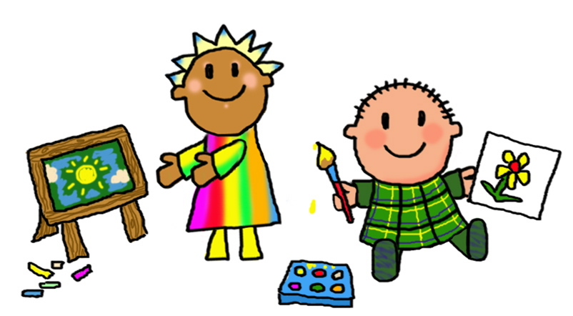 Welcome to Class One!
I hope you have had a lovely Christmas break and Happy New Year!
This half term we will be starting our new topic ‘’’ Our Local Area”

Science The area we will be learning about in science will be ‘Seasons’.
We will be learning about the different months, weather and changes.
Reception will be exploring the seasons too and noticing changes in their natural environment and describing it.
As part of learning about our world, we will also be looking at the environment and introduce recycling, looking after our local area, and ways we can help the planet. This also links to understanding materials.
Geography – In Geography we will be learning about “Lets Explore Kirklees”
This will cover looking at our local environment, maps, landmarks and locating places of interest.
Reception Children will look at their local environment. Talk about where we live, jobs in the community and their importance to the community and linking it to their book of the Everywhere Bear and the local area.
Reception will recognise different weather and climates and be able to select appropriate clothes.

Computing – We will be finding out about Comic Creations!

Art/DT – This half term children in class one will be
MAKING A MOVING STORY BOOK in Design and Technology. Investigating different ways of joining and designing.
Reception children will enjoy also join in with making story books, and develop using tools, techniques, joining and cutting with scissors skills.

Music – We are working on the Charanga theme ‘ In the Groove!”

PE – Dance and bike-ability.

MFL- We are continuing to learn simple Spanish phrases

PSHCE- Health and Wellbeing.

Phonics/English | Maths
Areas covered this term will include:  The children will continue to build upon and learn new phonics.  Reception Children have started learning digraphs (when 2 letters make 1 sound) and phase 3.  Children will do phonics daily and read 3 times a week. Reading books will be sent home every Thursday/Friday and must be returned weekly before they will be swapped..  Year One will continue to learn alternate sounds of phase 5.  They will also read 3 times a week.  Alongside phonics the children will do English.  Reception will look at the book “The Everywhere Bear”  While Year One will learn the read the book “Hermelin”. To prepare to write their own detective story.  The class will also do regular handwriting practise and letter formation. | Areas covered this half term include:  The children follow the NCTEM.  Year One objectives include:  Pupils will be able to :  Explain that addends can be represented in any order. This is called the commutative law  Explain that the = sign can be used to show that the whole and the sum of the parts are equal  Pupils add parts to find the value of the whole and write the equation  Pupils will work on finding the missing addend in an equation. Be able to partition a whole into two parts and express this with a subtraction equation. Pupils will be able to represent ‘first, then, now’ stories with addition equations  Finally Pupils work out the missing part of a subtraction story and equation if the other two parts are known and understand that addition and subtraction are inverse operations.  Reception will be working on numbers 6-10  They will be covering and understanding how numbers are formed, can be partitioned, Comparing more and fewer, subitising.

Weekly routines

PE lessons currently take place on THURSDAY afternoons, with our qualified PE coach Laura.
There will be NO OUTDOOR learning this half term.

Homework is given it will be set on a Friday.
ALL children will get a reading book
Year One will have
Ed Shed
Maths shed
Year Reception will have:
Ed Shed

Please read at home as often as possible.
Reading in school will happen three times a week, then that book will be sent home for you to share, listen and read with your child.
A reading for pleasure book will also be optional to take home every Friday.
These are for you to read to and with your child to promote and enjoy the love of books.

Notes
Please do try to support your child by helping them to be ready to come into school with all equipment required (book bags, water bottles, coats etc.) and to encourage them to come into class independently.
Water only in water bottles.
Children can bring in their own healthy snacks for playtime if they wish.
Please name all clothing.
Thank you in advance for your support, if you do have any questions or concerns please do not hesitate to call in and see me or contact me by e-mail maggie.whittaker@grangemoorps.co.uk

Many thanks Mrs Whittaker

Work hard, aim high

SCIENTIFIC VOCABULARY.
Weather Graph
Harvest Grow
Hibernate Frost
Protect Rainfall
Compare Sleet
Geography
United Kingdom, West Yorkshire, Kirklees, settlement, location, village, town, city, urban, rural, centre, diverse, travel, transport, leisure

