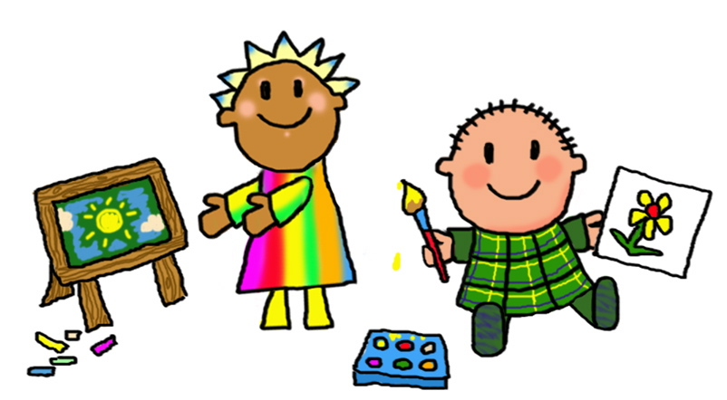 Happy New Year! Welcome back I hope you have had a lovely break!
This half term we will be starting our new topic ‘The history of medicine’
Science Our topic will be ‘Animals including humans’ for Y3 and Y4. Year 2 will be learning about ‘Exploring materials’
History – Our topic is ‘Pain, pus and blood: The history of medicine!’
Computing – We will be finding out about Document editing and infographics, Year 2 will focus on Internet research
Art/DT – We will be looking at developing the topic ‘Painting and mixed media: Life in colour’
Music – We are working on the Charanga topic ‘ I wanna play in a band’
PE – Games
MFL- We will be continuing to learn Spanish phrases and developing simple conversation
English | Maths
Areas covered this term will include:  Our first text will be ‘The rhythm of the rain’. Through the use of our vehicle text we will develop sentence writing, extended writing, narrative and information leaflet writing  Children will also continue to focus on basic skills including daily phonics, spelling, punctuation, grammar and handwriting. | Areas covered this half term include:  Year 2 Addition and subtraction of two digit numbers  Year 3 ‘Manipulating the additive relationship and securing mental calculation’  Year 4 ‘Understanding and manipulating multiplicative relationships’  • Using and applying mathematical knowledge and skills in problem solving  Children will be encouraged to develop mental and oral skills. We will also be working to develop skills through maths mastery sessions.  Children should also be encouraged to continue to work on learning their times tables.  Year 2 should learn their 2, 5 and 10 times tables by working on number patterns and then begin to work upon their 3 and 4 times tables when ready. Once confident feel free to learn the others.  Year 3 and 4 should build upon their knowledge of the 2,5,10 tables and develop their 3,4 and 8’s then develop 6,7,9,11 and 12’s to ensure all tables and learned by the end of Year 4.  Regular use of songs and games including Daily Ten, Hit the Button and My Maths will help your child to practise and become fluent in their tables. Year 4 children may enjoy using URBrainy MTC to support rapid responses and recall.

Weekly routines  PE lessons currently take place on Friday afternoons for Year2,3 and 4. Year 4 will also have a shorter session on Monday afternoons.  This half term, Year 3 will be learning to play the ukulele and Year 4 will learn the violin.  When homework is given it will be set on a Friday to be completed by the following Wednesday unless it is a longer Topic related project.  Please read at home as often as possible.  We will change reading books each Tuesday and Thursday. It is important to read each book a few times to develop flow, accuracy and comprehension. Where possible your child will read individually in school at least once each week and within guided and whole class reading groups during the week.  Your child will choose a library book every week and will need to bring it in ready to change the following week. | Expectations for Class Two  • Your child should read frequently at home. Please write any comments in their reading diaries and sign them regularly. Our class has a raffle ticket system for reading where a winner will be drawn each half term.  • Your child should complete their homework each week. Homework will take the form of weekly spellings on Spelling Shed, regular reading and developing times tables. Occasional topic based projects may also be set (usually one per half term), this will be advised through the Arbor system.
Notes
Please support your child by helping them to be ready to come into school with all equipment required (book bags, water bottles, reading records, coats etc.), and to encourage them to come into class independently. At the end of each day the children will be brought into the playground in a single file line. This will enable staff to send children to parents/carers once we have identified them.
Thank you in advance for your support, if you do have any questions or concerns please do not hesitate to call in and see me or contact me by e-mail jo.roclawski@grangemoorps.co.uk

Many thanks Mrs Roclawski

Work hard, aim high

Key Vocabulary for this half term
This half term we will be using the vocabulary listed below. Please spend some time reading and talking about it.
Science
Year 2
Science Vocab:
Weather Graph
Harvest Grow
Hibernate Frost
Protect Rainfall
Sleet Compare

Year 3 and 4
digestive system series of organs that break down food
oesophagus tubes running from mouth to stomach
saliva a fluid in the mouth which helps break down food
peristalsis the movement of food through parts of the digestive system
incisors front teeth for cutting food molars wide, flat teeth for grinding food
enamel very hard layer covering the tooth
fluoride ingredient in toothpaste that helps prevent cavities forming
consumer an animal which gets its food from other living things
predator an animal that gets its food from killing and eating other animals
tundra region found in the Arctic, where the climate is cold and windy
hide the skin of an animal

