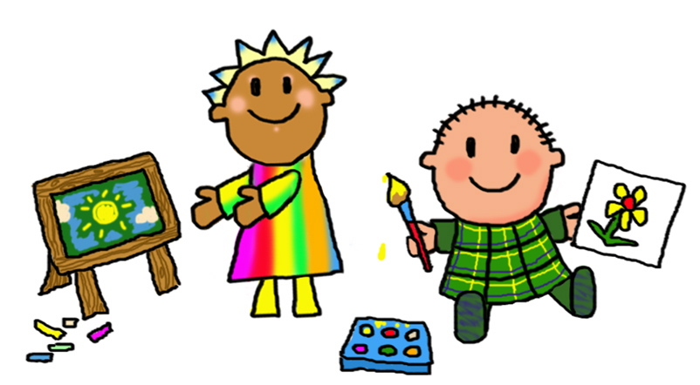 Welcome back I hope you have had a lovely half term break!
This half term we will be starting our new topic ‘’
Science Our topic will be ‘Living things and their habitats’ for Y3 and Y4. Year 2 will be learning about ‘Plants’
Geography – Our topic is ‘Rainforests’
Computing – We will be finding out 3D design
Art/DT – We will be looking at developing the topic ‘Painting and mixed media: Life in colour’/ Cooking and nutrition
Music – We are working on the Charanga topic ‘Zoo time ’
PE – Gymnastics
MFL- We will be continuing to learn Spanish phrases and developing simple conversation
English | Maths
Areas covered this term will include:  Our first text will be ‘Jemmy Button. Through the use of our vehicle text we will develop sentence writing, extended writing, return narrative and letter writing.  Children will also continue to focus on basic skills including daily phonics, spelling, punctuation, grammar and handwriting. | Areas covered this half term include:  Year 2 Time  Year 3 Right angles, adding and subtracting across 10, column addition  Year 4 Perimeter, addition and subtraction  • Using and applying mathematical knowledge and skills in problem solving  Children will be encouraged to develop mental and oral skills. We will also be working to develop skills through maths mastery sessions.  Children should also be encouraged to continue to work on learning their times tables.  Year 2 should learn their 2, 5 and 10 times tables by working on number patterns and then begin to work upon their 3 and 4 times tables when ready. Once confident feel free to learn the others.  Year 3 and 4 should build upon their knowledge of the 2,5,10 tables and develop their 3,4 and 8’s then develop 6,7,9,11 and 12’s to ensure all tables and learned by the end of Year 4.  Regular use of songs and games including Daily Ten, Hit the Button and My Maths will help your child to practise and become fluent in their tables. Year 4 children may enjoy using URBrainy MTC to support rapid responses and recall.

Weekly routines  PE lessons currently take place on Friday afternoons for Year2,3 and 4. Year 4 will also have a shorter session on Monday afternoons.  Year 4 will be going swimming every Thursday – please refer to previous letter for details.  Please read at home as often as possible.  We will change reading books each Tuesday and Thursday. It is important to read each book a few times to develop flow, accuracy and comprehension. Where possible your child will read individually in school at least once each week and within guided and whole class reading groups during the week.  Your child will choose a library book every week and will need to bring it in ready to change the following week. | Expectations for Class Two  • Your child should read frequently at home. Please write any comments in their reading diaries and sign them regularly. Our class has a raffle ticket system for reading where a winner will be drawn each half term.  • Your child should complete their homework each week. Homework will take the form of weekly spellings on Spelling Shed, regular reading and developing times tables.  Homework project  This half term I would love to see a Rainforest inspired piece of homework. This could be a ‘Rainforest in a box’ using a shoe box/small box and be similar to  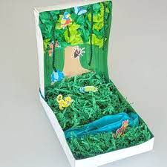 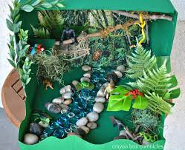 (there are lots of ideas on the internet. Try to think about the layers of the rainforest),  or if you prefer a poster, fact-file or other creative presentation.  Please could you encourage your child to complete this by the final week of half-term.
Notes
Please support your child by helping them to be ready to come into school with all equipment required (book bags, water bottles, reading records, coats etc.), and to encourage them to come into class independently. At the end of each day the children will be brought into the playground in a single file line. This will enable staff to send children to parents/carers once we have identified them.
Thank you in advance for your support, if you do have any questions or concerns please do not hesitate to call in and see me or contact me by e-mail jo.roclawski@grangemoorps.co.uk

Many thanks Mrs Roclawski

Work hard, aim high

Key Vocabulary for this half term
This half term we will be using the vocabulary listed below. Please spend some time reading and talking about it.
Science | Geography
Year 2 Plants  They will cover understanding seeds grow into plants, how plants  can grow in different environments. Children will know the  difference between deciduous and evergreen trees.  Learn about fruit trees and vegetables. Children will observe  and record the growth of a plant.  Science Vocab: Predict, plant, tree, seed, oak  Flower, root, leaf, petal, stem  Weed, daisy, dandelion, wild, buttercup  Evergreen, deciduous, seasons, bush, branch  Vegetable, farm, tractor, supermarket, fruit  Observe, adult plant, seedling, young plant, growth | Rainforest  Equator  tropic  tropical  Cancer  Capricorn  climate  layer  forest floor  understory  canopy  emergent  flora  fauna  tribe  tribal  indigenous
Year 3 and 4
adapted changed to suit an environment
camouflage a way of blending or hiding in your surroundings
coastal at or near the coast, or beach
grassland areas containing grass
classify to arrange in classes or groups according to shared qualities or characteristics
species a grouping or kinds of animals with similar characteristics
sub group a group within a larger group
classification key a series of questions that help to identify a species
region a large space or area
blubber a layer of fat beneath the skin of sea mammals
ecosystem a community of living things
oxygenised contains oxygen

