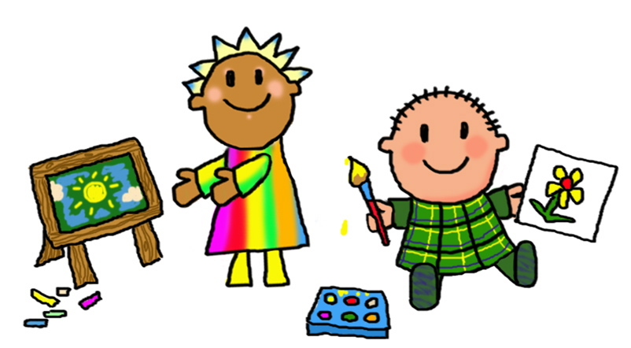 Welcome back I hope you have had a lovely half term break!
This half term we will be starting our new topic ‘’
Science Our topic will be ‘Living things and their habitats- conservation’ for Y3 and Y4. Year 2 will be learning about ‘Uses of everyday materials’
History – Our topic is ‘Who let the Gods out! Ancient Greece’’
Computing – We will be beginning to work on programming
Art/DT – We will be looking at developing the topic ‘Ancient scrolls’
Music – We are working on the Charanga topic ‘Zootime’
PE – Gymnastics
MFL- We will be continuing to learn Spanish phrases and developing simple conversation including ‘My house’
This half term we will be beginning our work on ‘My Happy Mind’ which supports RHSE, PHSE and understanding of Mental Health and Well being
English | Maths
Areas covered this term will include:  Our first text will be ‘Egyptology’. Through the use of our vehicle text we will develop sentence writing, extended writing, mystery narrative and diary writing.  Children will also continue to focus on basic skills including daily phonics, spelling, punctuation, grammar and handwriting. | Areas covered this half term include:  Year 2 Multiplication and 2,5 and 10s  Year 3 Fractions – unit and non-unit fractions  Year 4 Fractions and Fractions greater than 1  • Using and applying mathematical knowledge and skills in problem solving  Children will be encouraged to develop mental and oral skills. We will also be working to develop skills through maths mastery sessions.  Children should also be encouraged to continue to work on learning their times tables.  Year 2 should learn their 2, 5 and 10 times tables by working on number patterns and then begin to work upon their 3 and 4 times tables when ready. Once confident feel free to learn the others.  Year 3 and 4 should build upon their knowledge of the 2,5,10 tables and develop their 3,4 and 8’s then develop 6,7,9,11 and 12’s to ensure all tables and learned by the end of Year 4.  Regular use of songs and games including Daily Ten, Hit the Button and My Maths will help your child to practise and become fluent in their tables. Year 4 children may enjoy using URBrainy MTC to support rapid responses and recall.

Weekly routines  PE lessons currently take place on Friday afternoons for Year2,3 and 4. Year 4 will also have a shorter session on Monday afternoons.  Year 4 will be going swimming every Thursday – please refer to previous letter for details.  Please read at home as often as possible.  We will change reading books each Tuesday and Thursday. It is important to read each book a few times to develop flow, accuracy and comprehension. Where possible your child will read individually in school at least once each week and within guided and whole class reading groups during the week.  Your child will choose a library book every week and will need to bring it in ready to change the following week. | Expectations for Class Two  • Your child should read frequently at home. Please write any comments in their reading diaries and sign them regularly. Our class has a raffle ticket system for reading where a winner will be drawn each half term.  • Your child should complete their homework each week. Homework will take the form of weekly spellings on Spelling Shed, regular reading and developing times tables.
Notes
Please support your child by helping them to be ready to come into school with all equipment required (book bags, water bottles, reading records, coats etc.), and to encourage them to come into class independently. At the end of each day the children will be brought into the playground in a single file line. This will enable staff to send children to parents/carers once we have identified them.
Thank you in advance for your support, if you do have any questions or concerns please do not hesitate to call in and see me or contact me by e-mail jo.roclawski@grangemoorps.co.uk

Many thanks Mrs Roclawski

Work hard, aim high

Key Vocabulary for this half term
This half term we will be using the vocabulary listed below. Please spend some time reading and talking about it.
Science | History
Year 2 Uses of everyday materials  material anything that is used to make something else  property the way in which a material is described  obstacle something that blocks the way  construction the process of building something  stretchy something that can pull apart without breaking; elastic  elastic something that can pull apart without breaking; stretchy  force a pressure applied to something that makes it change shape or move  bend to shape or force something into a curved shape | Legend  myth  BC AD  empire  civilisation  Athens  Sparta  City-state  conflict  Gods Goddesses  Olympia  Olympic Games  humanity  inequality  freedom  democracy
Year 3 and 4
migrate to move from one area to another
monsoon rainy season
deforestation the cutting down of forests, including rainforests
biodiversity the variety of living things
emissions the production or discharge of something, especially gas or radiation pollution harmful or poisonous substances
pesticide a chemical substance used to kill insects that harm plants and crops
contaminate to make something impure by adding a poisonous or polluting substance
drought a long period of time where there is a shortage of water
freshwater water that does not contain salt
marine sanctuaries ocean areas that protect the wildlife from harm
conservation areas areas on land or sea that protect the wildlife from harm

