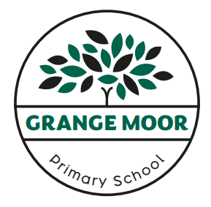
Grange Moor Primary School
Subject Intent Statements

Subject: Music | Subject Leader: Mark Rodgers | Review date: January 2024

Pupils at Grange Moor Primary School enjoy a broad and balanced music curriculum that encourages them to develop an interest in music through dedicated music lessons, singing, taking part in musical performances and being given the opportunity to learn an instrument through Musica Kirklees.
As a school we are acutely aware of the importance of ensuring Music has a prominent position in our curriculum and children follow a clear progression of skills that enable them to become enthusiastic and confident musicians. The Music curriculum is arranged in the following areas:
- Performing: controlling sounds through singing and playing
- Composing: creating and developing musical ideas
- Appraising: responding and reviewing
- Listening and applying knowledge and understanding
The curriculum is delivered in a number of ways. As a school we use the Charanga music scheme of work that provides week-by-week lessons for each year group in the school from EYFS up to Year Six. Children enjoy the lessons which are lively, practical and engaging and the scheme supports all the requirements of the national curriculum. Alongside this, we provide a range of singing opportunities be it as a whole school, as a key stage, in class or as part of a choir. Music is an integral part of our Christmas performances and we pupils from Year Two upwards are invited to join our Young Voices choir that performs at Sheffield Arena every year.
Currently, every child from Year One to Year Six has a weekly music lesson where they learn an instrument for a half-term. This year music lessons are being delivered by staff from Musica Kirklees in recorder, violin, ukulele, djembe and flute.
We have a singing assembly every Tuesday afternoon, delivered through our Young Voices registration and Sing Up. The Young Voices choir practices weekly from September through to January.
Several of our pupils learn musical instruments and at present Musica Kirklees are providing teachers for pupils who are learning the keyboard, guitar, ukulele, clarinet and flute. This is offered to all pupils and financial assistance is provided by school to ensure that this is not a barrier to learning an instrument.
The impact of our Music Curriculum will be that our pupils are fostering a love of music and are becoming well-equipped with the musical skills that enable them to progress through each step of their learning. Pupils across school are enthused by and engaged with a wide variety of music activities.

