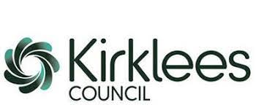
Grange Moor Primary School

Operation Encompass Safeguarding Statement

Our Designated Senior Leads for Safeguarding are Mr. M. Rodgers, Mrs. J. Roclawski and Mrs. C. Gray

Our school is part of Operation Encompass. This is a police and education early intervention safeguarding partnership which supports children and young people who experience Domestic Abuse.

Operation Encompass means that the Education Safeguarding Service will share information about Domestic Abuse incidents with our school PRIOR to the start of the next school day when the police have been called to a domestic incident.

Once DSL has attended at an Operation Encompass briefing, they will cascade the principles of Operation Encompass to all DDSL’s.

Our parents are fully aware that we are an Operation Encompass school.

The Operation Encompass information is stored in line with all other confidential safeguarding and child protection information.

The DSL has also led training for all school staff and Governors about Operation Encompass, the prevalence of Domestic Abuse and the impact of this abuse on children. We have also discussed how we can support our children following the Operation Encompass notification.

We are aware that we must do nothing that puts the child/ren or the non-abusing adult at risk.

The Safeguarding Governor will report on Operation Encompass in the termly report to Governors. All information is anonymised for these reports.

