

How it Works

The Grange Know and Remember curriculum allows for subject specific skills to be built upon as a spiral curriculum. The Grange curriculum is split into 2 halves.

Remember More

These skills are taken from the “Remember more” curriculum with targets set from that module. The remember more curriculum is a rolling plan with skills returned to each year to build upon prior learning

Know More

The knowing more curriculum is the vast amount of content that the pupils learn during the time at Grange school– everything from the bones of the skeleton to Egyptian mummies! The skills learnt in the remember more curriculum is then applied to the new content each term.

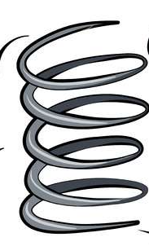

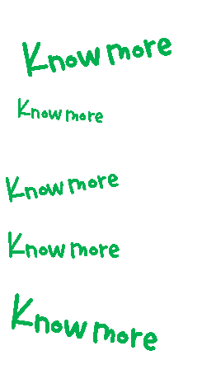

Remember More



Remember More– Using sources of evidence

Teachers will use the sources of evidence module to understand the skill being taught. The skill is broken down into the initial skill within this area to the most advanced application of it. This allows for teachers to understand how that skill advances and builds upon prior learning.

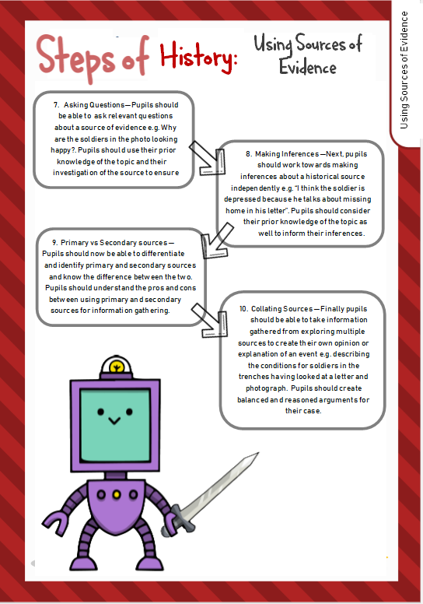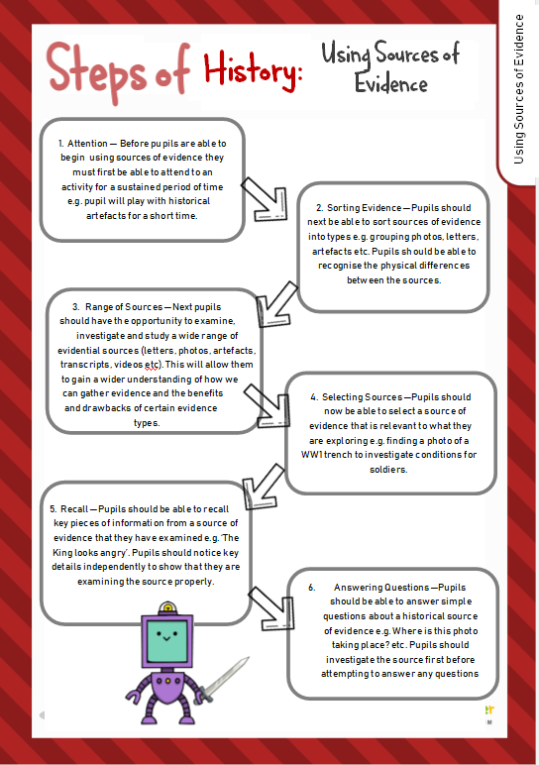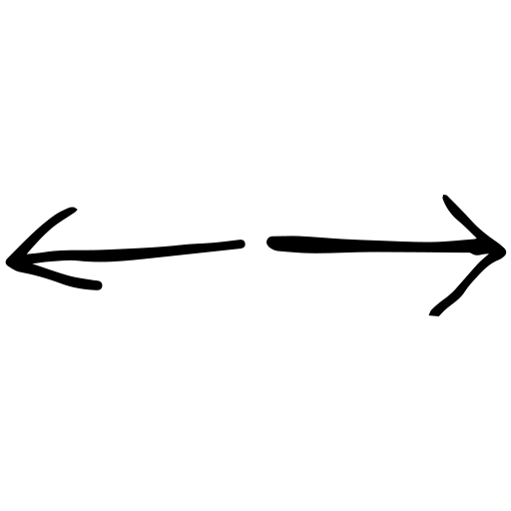

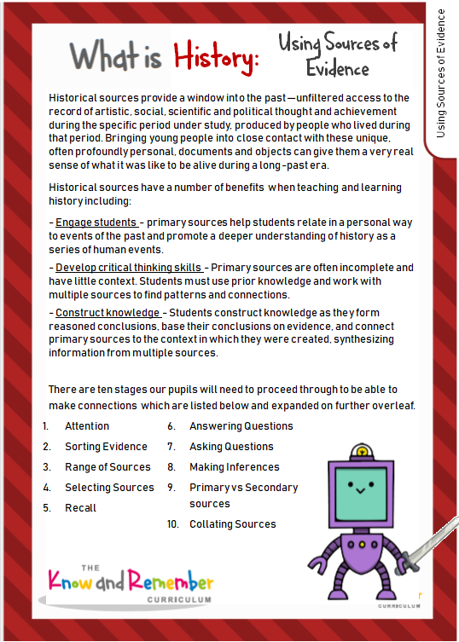

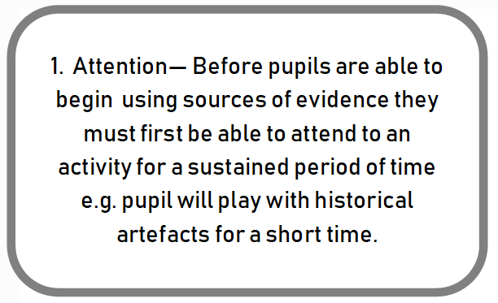

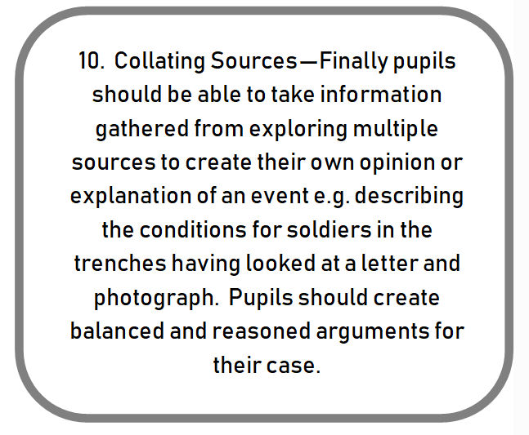

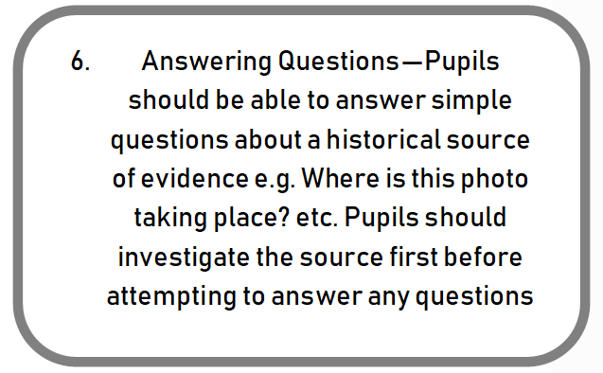



Remember More– Target setting

Teachers choose a target from classroom monitor that the pupils has not secured from the list of suggested targets from the module. If the module is taught for half a term the teacher will decide which targets to set based on gaps in pupil’s learning.

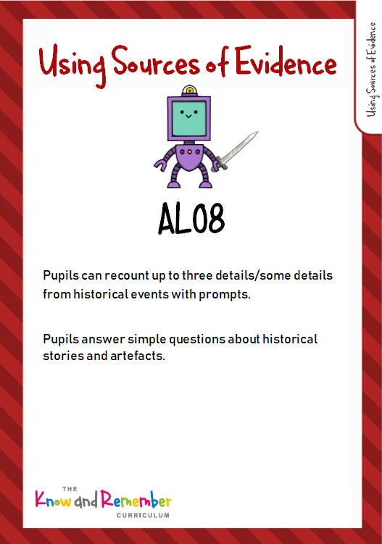

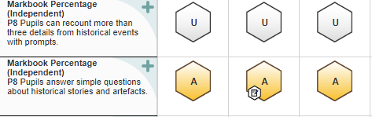

Pupils answer simple questions about historical stories and artefacts (AL08)









Know More – The Black Death

The Know More module outlines where that content is linked to previous learning across the whole curriculum.

Teachers will make these links explicit wherever possible through the lesson content

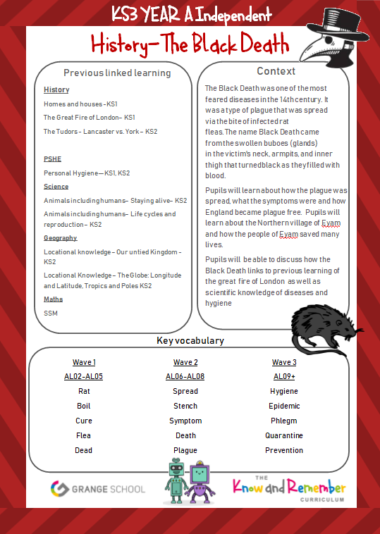



The context gives teachers the background information about the topic and how it will be taught with the key foci. The context also gives teachers basic information on the content of the module



The key vocabulary forms the basis of the module. Staff will follow the vocabulary policy to ensure that vocabulary is used effectively to build our pupil’s vocabulary toolkit.



Know More – The Black Death

The first session always links to previous learning. This should allow for pupils to reflect on their own knowledge of the subject gathered through previous topics

(e.g. The Great Fire of London).

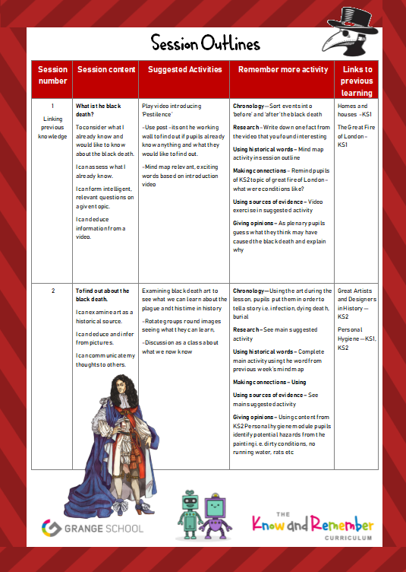



For each session there is a lesson plan with suggested activities. Teachers can use this scaffold to meet pupils individual need. Teachers can adapt or change the activities as needed.





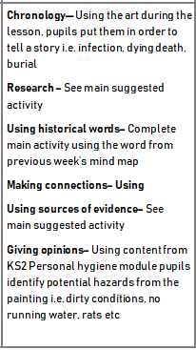



For each session there is an activity that links to the **Remember More** topic being delivered. Teachers will incorporate that activity into the session – sometimes the activity will already form part of the suggested activities.