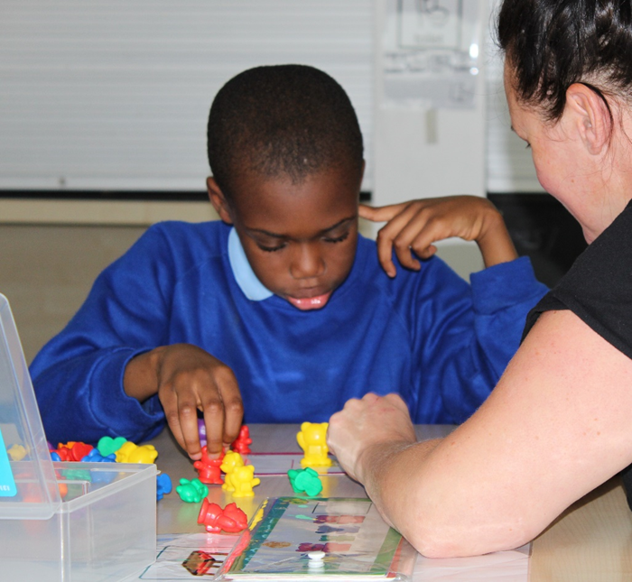
Progression Guidance

Assessment, Moderation and pupil outcomes
Aims:
Assessment at Grange school plays a vital role in ensuring that accurate dates in collected and moderated, leading to accurate measures of progress.
Assessment at Grange School ensures the following:
- That all teaching and learning is accurate and appropriately targeted.
- That teaching builds on what pupils have learned.
- That feedback to students on what they have learned so far and what they need to do to improve is highly effective and focused on next steps.

Rational of progress measurement:
Grange school’s measurement of attainment and progress is based on a bespoke assessment system. This is designed to:
- Accurately support a pupil’s development through the securing of specific outcomes.
P Scale Level | Grange Assessment Level
P1 | AL01
P2 | AL02
P3 | AL03
P4 | AL04
P5 | AL05
P6 | AL06
P7 | AL07
P8 | AL08
P9 | AL09
NCL1 | AL09
NCL2 | AL10
NCL3 | AL11
NCL4 | AL12
- Have outcomes that are based upon longitudinal moderated targets at different levels which can be accurately be measured and assessed through classroom observations by class teachers.
For example:
Jake has achieved 47/120 outcomes in reading = 60% of AL05 in Reading.
Pupils can also be assessed as emerging or developing towards a target.

Although these outcomes have been developed to produce a highly effective custom-built assessment system, there can be broad comparisons made to the previous P scale and previous national curriculum levels of assessment.
Within each level there are 10 outcomes which can be achieved at that level of each area of learning/subject so a pupil will be assessed as working at a percentage of that level.

Assessment Procedure
Pupils are baselined upon entry to the school. This assessment takes place over the first half term of the pupil’s first year, with class teachers using the outcomes of different areas of learning/subjects by class teachers.

For each outcome the pupils will be assessed as either:
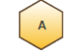
Emerging Developing Secure

For example, =
“The pupil shows interest in playing with shapes in sand/water”
Emily is secure in this outcome.
The pupil can make/find specific shapes upon request in the sand/water”
Emily is developing in this outcome.
Based upon the outcomes the pupil is yet to secure, the teacher will sent a target. This will be developed by teachers and session leaders building opportunities for summative and formative assessment into their teaching on a day to day basis.
Emily will make/find specific shapes upon request in sand or water.

The teachers will assess the pupil on progress they have made against any other outcomes in that area too.
At the end of each term the teacher will reassess the pupil against their target and input their progress into the data system. For each target the child secures, their overall assessed level will increase by 10%.
Emily now can make and find specific shapes upon request in sand/water.
Assessed Level:
Autumn Term – 50% of AL05
Spring Term – 60% of AL05

When assessment of a pupil’s progress against each outcome is inputted into Grange’s school’s data system and a score in that area is produced.
Emily is working at 50% of AL05 in shape, space and measure.

Progression Guidelines
ABOVE EXPECTED PROGRESS | Student has exceeded the expected number of descriptors
EXPECTED PROGRESS | Student has achieved the expected number of descriptors
BELOW EXPECTED PROGRESS | Student has made some progress, however they have not achieved the expected number of descriptors
NO ADDITIONAL PROGRESS ASSESSMENT ACHIEVED | Student has not secured any additional assessment progress during the assessment period.
For each group of learners there will be a specific number of outcomes to be achieved to meet expected progress. This will consider a learners age, key stage, starting point and previous levels of achievement.

Early Years Foundation Stage (2 Years) - Nursery and Reception
Number of outcomes to be secured per subject/ strand of subject per year
EYFS curriculum (S1-S7)
Above Expected – 4+ secure
Expected – 3 secure
Below Expected - 2 secure or less
No progress

Key Stage 1 (2 Years) YR 1 & 2
Number of outcomes to be secured per subject/ strand of subject per year
Structured curriculum (AL02-AL05) | Independent curriculum (AL06+)
Above Expected – 4+ secure | Above Expected- 6+ secure
Expected – 3 secure | Expected - 4-5 secure
Below Expected - 2 secure or less | Below Expected - 3 secure or less
No progress | No progress

Key Stage 2 (4 Years) YR 3 - 6
Number of outcomes to be secured per subject/ strand of subject per year
Structured curriculum (AL02-A0L5) | Independent curriculum (AL06+)
Above Expected – 3+ secure | Above Expected - 4+ secure
Expected – 2 secure | Expected – 3 secure
Below Expected – 1 secure or less | Below Expected - 2 secure or less
No progress | No progress

Key Stage 3 (3 Years) YR 7 - 9
Number of outcomes to be secured per subject/ strand of subject per year
Structured curriculum (AL02-AL05) | Independent curriculum (AL06+)
Above Expected – 3+ secure | Above Expected - 4+ secure
Expected – 2 secure | Expected – 3 secure
Below Expected – 1 secure or less | Below Expected - 2 secure or less
No progress | No progress

Key Stage 4 (2 Years) YR 10 - 11
Number of outcomes to be secured per subject/ strand of subject per year
Structured curriculum (AL02-AL05) | Independent curriculum (AL06+)
Above Expected – 3+ secure | Above Expected – 4+ secure
Expected – 2 secure | Expected – 3 secure
Below Expected – 1 secure or less | Below Expected - 2 secure or less
No progress | No progress

