Pupil Premium
IMPACT REPORT
2020/2021

- Overview
Pupil Premium 2020-2021
Number of Pupils (Reception – Year 11) | 179
Number of disadvantaged Pupils | 111
Percentage of whole school | Primary Percentage – 59.3%  Secondary Percentage – 64.8%
Academic year | 2020 – 2021
Publish date | September 2020
Review date | July 2021
Statement authorised by | Head teacher – R. Clifford
Pupil Premium Lead | Jane Jones
Governor Lead | Anne Jones

In the 2020 – 2021 financial year, school received the following funding for each child registered.
- £1345 for eligible primary pupils
- £955 for eligible secondary school pupils
- School also received £2300 for each Looked After Child (LAC) Pupil Premium (2 pupils) that was to be spent to fulfil those student’s individual Personal Educational Plans (PEPs) in line with current guidance
The total funding allowance for 2020/21 was £127, 065 and this equates to 54 primary pupils and 57 secondary pupils.
In addition to the above Pupil Premium Funding, the school received an additional Covid-19 Catch-up Premium Grant – please see associated Catch Up Plan.
Disadvantaged Pupils Barriers to Success
- Outcomes and progress can be impacted by several factors - all pupils at Grange have an Education Health Care Plan, and all pupils have a diagnosis of autism and additional complex learning difficulties.
- Pupils can also have additional social and emotional mental health difficulties.
- As a school we have a strong focus on identifying barriers that each pupil may face.
- The impact of Covid-19 has been significant for many of our families
- Long term outcomes show that only 32% of autistic adults are in paid employment.
How we planned to spend academic years allocation 2020-21
The aim of pupil premium in the 2020-21 academic year was to narrow progress gaps between ‘All pupils’ and entitled to ‘Pupil Premium Funding, in addition, the catch-up premium was designed to mitigate the effects of the unique disruption caused by (COVID-19).

As a school we recognise the need to maintain high standard of education of all and we strive to ensure outstanding teaching and learning across all areas. As a result of these aims our Pupil Premium Plan/Catch up funding plan was based on a tiered spending plan in three key areas:
- Teaching
- Targeted academic support
- Wider strategies
The school has used research and supporting evidence from The Education Endowment Fund in order to develop this plan. www.educationendowmentfoundation.org.uk
The EEF recommends that great teaching is the most important lever schools have to improve outcomes for their pupils. Many of the most effective ways to raise attainment involve will benefit all groups of pupils.
- Strategic Aims for Disadvantaged Pupils Academic Achievement
Chosen area of Focus - Teaching
Expected Outcome 1: 85% of teaching is outstanding and no teaching is less than good. Resulting in 100% of pupil premium students to achieve expected progress in English and maths, with at least 25% achieving exceeded rates of progress.
The continued priority of the school is to develop outstanding quality first teaching. As a school we are committed to ensuring that teachers are supported to ensure the highest possible outcomes for our pupils. In order to develop this, we have designed a bespoke teaching, learning and assessment system in which all teachers are trained.

The following area are included in the Pupil Premium Plan:

- Continued bespoke CPD offer for teachers and TA’s across the school
- Maths mastery school programme
- Development and implementation of the Know and Remember Curriculum
- Wave 1 offer further developed alongside multi-agency partners
- Vocabulary training for all teachers
- Aiming for Excellence teaching assistant training programme
- Autism level 1 training for all new staff and updates
- Continued development and refinement of assessment and tracking systems
- Quality of Education - Deputy Head roles
- Assistant Head leaders for English and maths
- Middle leader development (NPQML) and subject leader training
- Development of bespoke Careers programme covering all key stages across the school and daily dedicated teaching time

Data Analysis
From analysis of progress data for 2019-2020 the curriculum area of focus for pupil premium initiatives are:
- Writing – 96% of pupils achieved outstanding progress in writing compared to 100% of none pupil premium pupils
- Science – 94% of pupils achieved outstanding progress in science compared to 99% of none pupil premium pupils
- Foundation subjects – pupil premium pupils achieve less well than their none pupil premium peers in foundation subjects.
Impact:
In writing PP pupils achieved a higher combined percentage of expected and above progress than their NPP peers.
 | Pupil Premium Pupils | Non-Pupil Premium Pupils | Difference
Writing 19/20 | 96% | 100% | -4
Writing 20/21 | 92% | 89% | +3

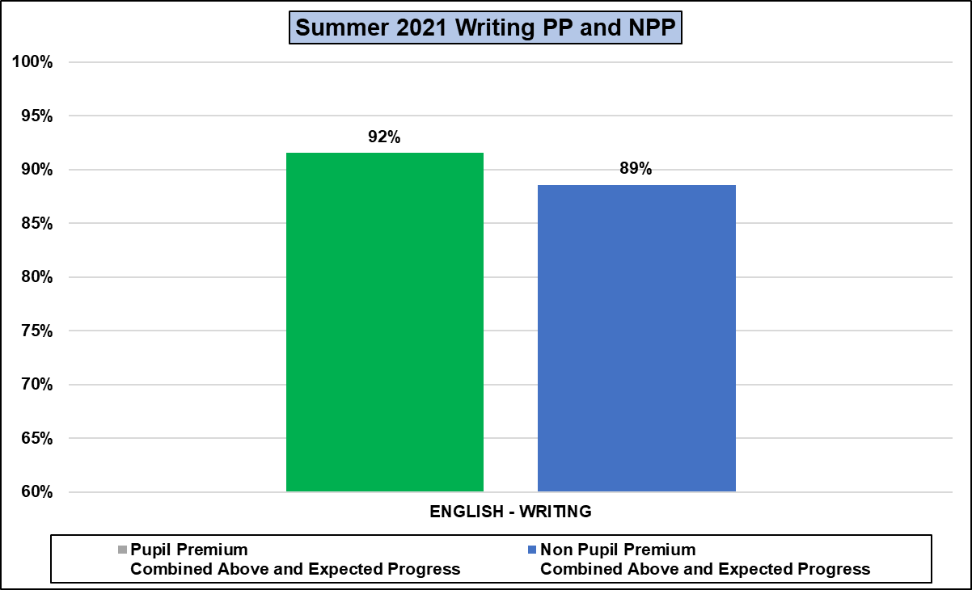

 | Pupil Premium Pupils | Non-Pupil Premium Pupils | Difference
Science 19/20 | 94% | 99% | -5
Science 20/21 | 99% | 99% | 0

In science the gap between PPP and NPP has reduced from -5% to 0% with attainment the same between both sets of pupils,
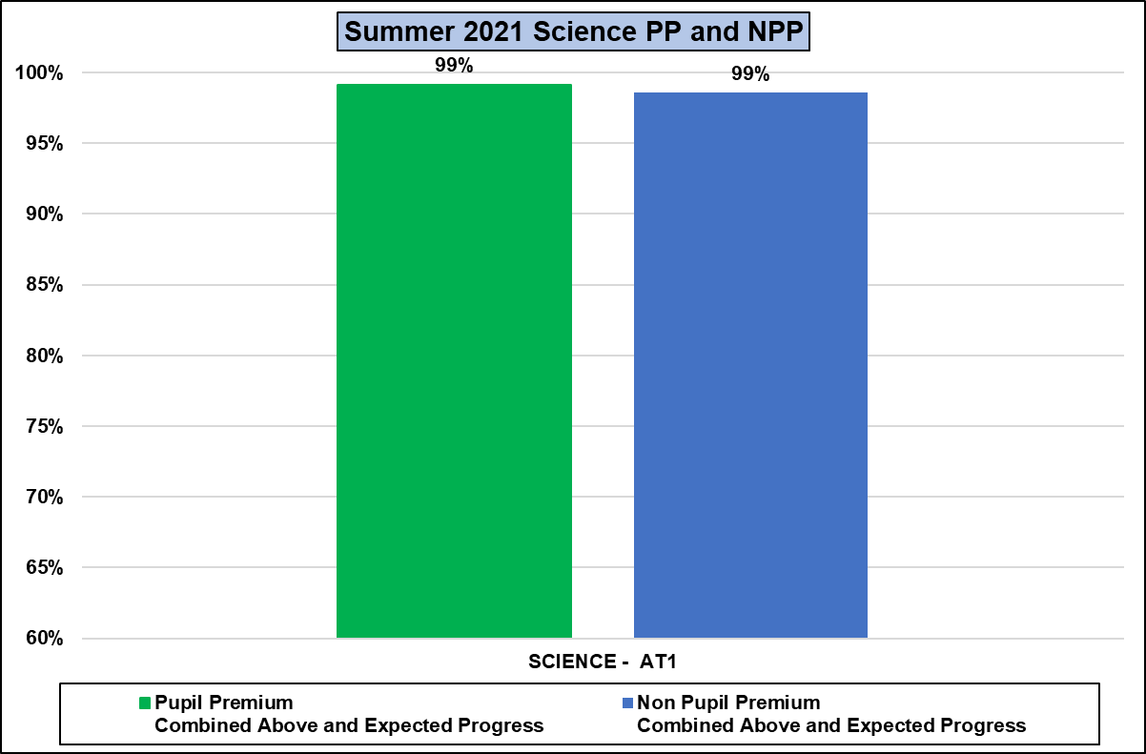

Intended Impact:
Pupil Premium Pupils will meet whole school targets for progress in foundation areas and the gap between PPP and None PPP will decrease from the gaps detailed above.

Subject | Pupil Premium Pupils Outstanding Progress % | Non-Pupil Premium Students Outstanding Progress % | Pupil Premium/Non Pupil Premium Gap | Pupil Premium Pupils Combined Expected and Above Expected Progress | Non- Pupil Premium Pupils Combined Expected and Above Expected Progress | Pupil Premium/Non Pupil Premium Gap | Change
Art | 93% | 98% | -5% | 99% | 100% | -1% | +4
Computing | 94% | 95% | -1% | 100% | 97% | 3% | +4
Design and Technology | 87% | 95% | -8% | 92% | 94% | -2% | +6
Food Technology | 94% | 94% | 0% | 92% | 88% | 4% | +4
Geography | 86% | 93% | -7% | 98% | 96% | 3% | +10
History | 95% | 97% | -2% | 94% | 94% | 0% | +2
MFL | 95% | 98% | -3% | 97% | 99% | -1% | +2
Music | 94% | 97% | -3% | 97% | 100% | -3% | 0
PE | 96% | 99% | -3% | 97% | 99% | -2% | +1
PSHE | 87% | 89% | -2% | 90% | 93% | -3% | -1
RE | 94% | 97% | -3% | 94% | 94% | 0% | +3

Impact:
In nine of the foundation subject areas the gap between PPP and NPP has reduced. In Music the gap has remained the same. In PSHE the gap has increased by 1% - this is likely to be caused by the ongoing impact of Covid -19.
PSHE will become a key area of school focus for the academic year 2021/22.

Year 7 Catch Up Funding Pupil Progress – Core Subjects
Year 7 Catch Up: To manage the Year 7 catch up fund effectively to ensure that 100% of the Year 7 pupils make at least expected progress.
The Year 7 Sample for 2020/2021 was 37 pupils. All these pupils were entitled to catch up funding.

 | Year 7 Pupils- combined expected and above | All pupils - combined expected and above
Reading | 100% | 95%
Writing | 97% | 90%
Speaking and Listening | 92% | 89%
Number | 97% | 96%
Shape, Space and Measures | 92% | 89%
Using and Applying | 100% | 94%

The data shows the Year 7 catch up funding has been used effectively to support the Year 7 pupils in English and maths. As a group they have achieve above average progress when compared to the whole school cohort.

