GCSE Food Preparation and Nutrition Revision List Year 11 Mock 2 - FEBRUARY
Exam information:
The exam is broken up into two sections, Section A contains 20 Multiple Choice Questions. Section B is a combination of short and long answers and worth 80 marks. There is a total of 100 marks for this paper. You must answer all questions in this paper. You have 105 minutes for the exam.
Materials:
For this paper you must have:
- A black pen
- A pencil
- A scientific calculator.
Topic | RAG | Revised?
Protein - nutrition & science
Dietary intakes – energy %, DRVs (Dietary Reference Values) for macronutrients
Macronutrients – Fats & Carbohydrates functions and types
Food Science – carbohydrates (dextrinization, caramelisation, gelatinisation)
Functional and chemical properties of cakes and biscuits
Eatwell guide
Micronutrients - functions of vitamins and minerals
Food safety – high risk foods preparation, cooking, serving and storing, key temperatures
Food Labelling – what appears on the label and why is it necessary/included?
Food choice/provenance – organic, intensive and free-range farming including caught, reared, grown and moral & ethical beliefs.
Secondary processing – Jam making & Pasta Making
Food provenance – Food waste & Packaging (biodiversity, recyclable, environmental)
Enzymic browning
Sensory evaluation – testing methods and conditions for testing
Revision Resources
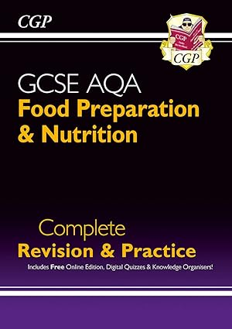
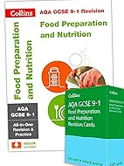
Microsoft Teams:
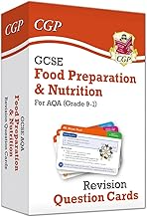
- GCSEpods – Bitesize videos
- Past Papers and Mark Schemes
- Flashcards
- Mind maps
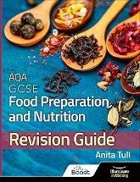
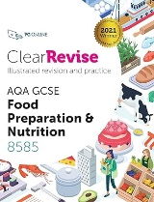
- Year 10 PowerPoints
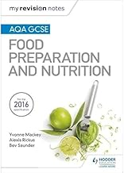
- *NEW* Revision Song Album “Food Beats”
- *Pending* Revision Podcasts
- EXAM SPECIFICATION

Online learning:
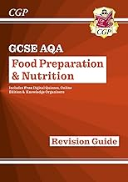
SENECA
Quizlet – Flashcards
Brainscape – Flashcards

Revision Guides & Cards:
Anita Tull – AQA GCSE Food Preparation & Nutrition Revision Guide
CGP – AQA Food Preparation & Nutrition Complete Revision & Practice
Collins – AQA GCSE 9-1 Food Preparation & Nutrition
My Revision Notes – AQA GCSE Food Preparation and Nutrition
Clear Revise – AQA Food Preparation & Nutrition
CGP or Collins – Food Preparation and Nutrition Question Cards

