Yr 11 Food Preparation and Nutrition Mock Revision Guidance
Exam Board: AQA
March Mock Exam Paper
There are 5 topics that you will be examined on:
- Food, nutrition and health (P14 -17 of the specification)
- Food science (P18 - 21)
- Food safety (P22 - 25)
- Food choice (P26 - 28)
- Food provenance (P29 - 31)

Areas to focus on are:
- Food safety temperatures including temperature probes.
- Fortification of foods
- Macronutrients energy % recommendation
- Cooking methods
- Food poisoning bacteria
- Energy
- Rules for preparing, cooking and serving food
- Fibre
- Food science – protein, carbohydrates, fats,
- Food security

There are 64 marks available. This is a part paper.
Multiple choice questions are worth 10 marks.
Longer answer questions, worth another 54 marks.
Exam Length: 50 minutes
Exam Weighting: In the real exam it is /100 and worth 50% of overall grade – your percentage achieved will indicate the grade procured.
Useful revision resources:
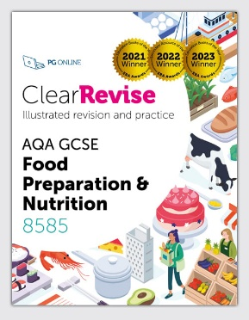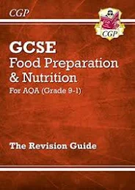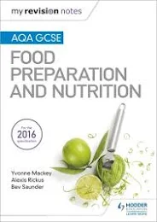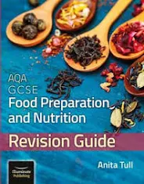

Seneca Learning is useful and has some wonderful videos to help. GCSEPod is also another great resource. All GCSEpod videos have been downloaded and uploaded onto TEAMS.

The revision booklets you are using in class are also very useful and additional resources such as mind maps, Cornell notes, flashcards. You also can access the PowerPoints from your Year10 teams.

