GCSE Geography Year 11

Topics you should revise

Paper 1
60 minutes

- Tropical Rainforests and Hot Deserts – Pages 27-44
- Resources Pages 132-136 and Energy Pages 157-164

Revision resources
● Exercise books
https://www.aqa.org.uk/subjects/geography/gcse/geography-8035/specification

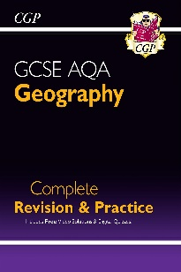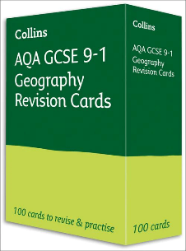

Revision Tips

Make something new - a concept map, flashcards, a quiz… anything that makes you work with the knowledge actively.

Don’t forget to practise: Practising written responses is important to get comfortable with extended pieces of writing. Use example questions provided by your class teacher.

Revise little and often: If you struggle to revise for extended periods of time, try to revise for a few minutes each day instead.

