Subject | Higher Mathematics | Exam Board | AQA | Course Code | 8300

Overview

Mock Assessments
One Non-Calculator Paper (Paper 1) 90 minutes. Two Calculator Papers (Papers 2 and 3) 90 minutes for each paper.
Full mathematics equipment required.

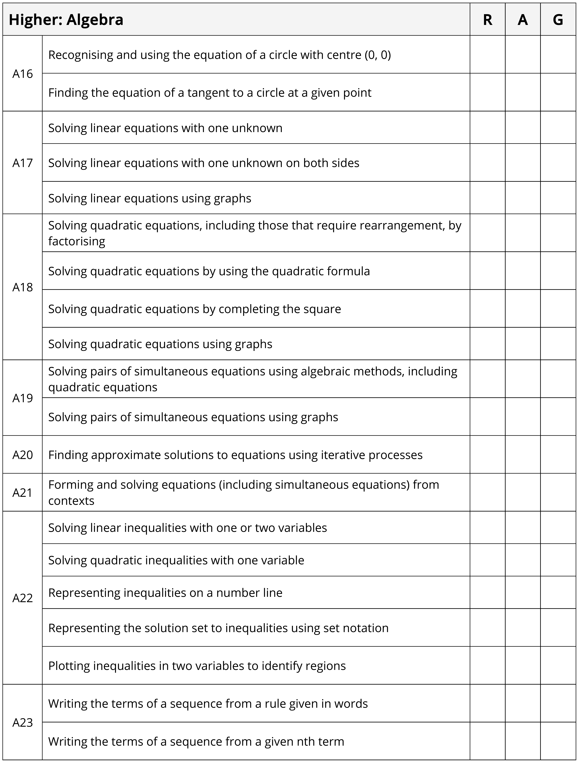

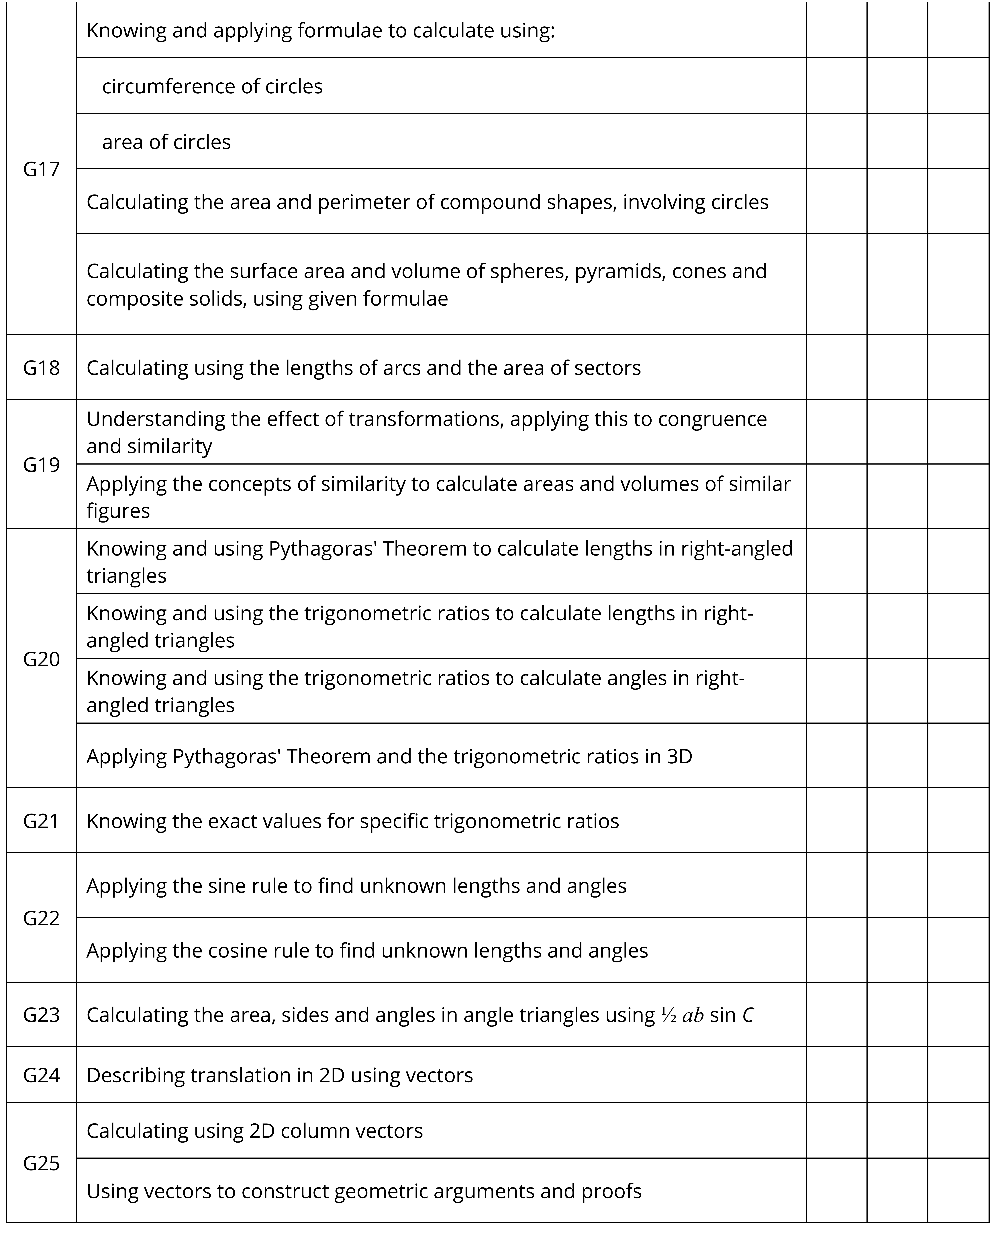

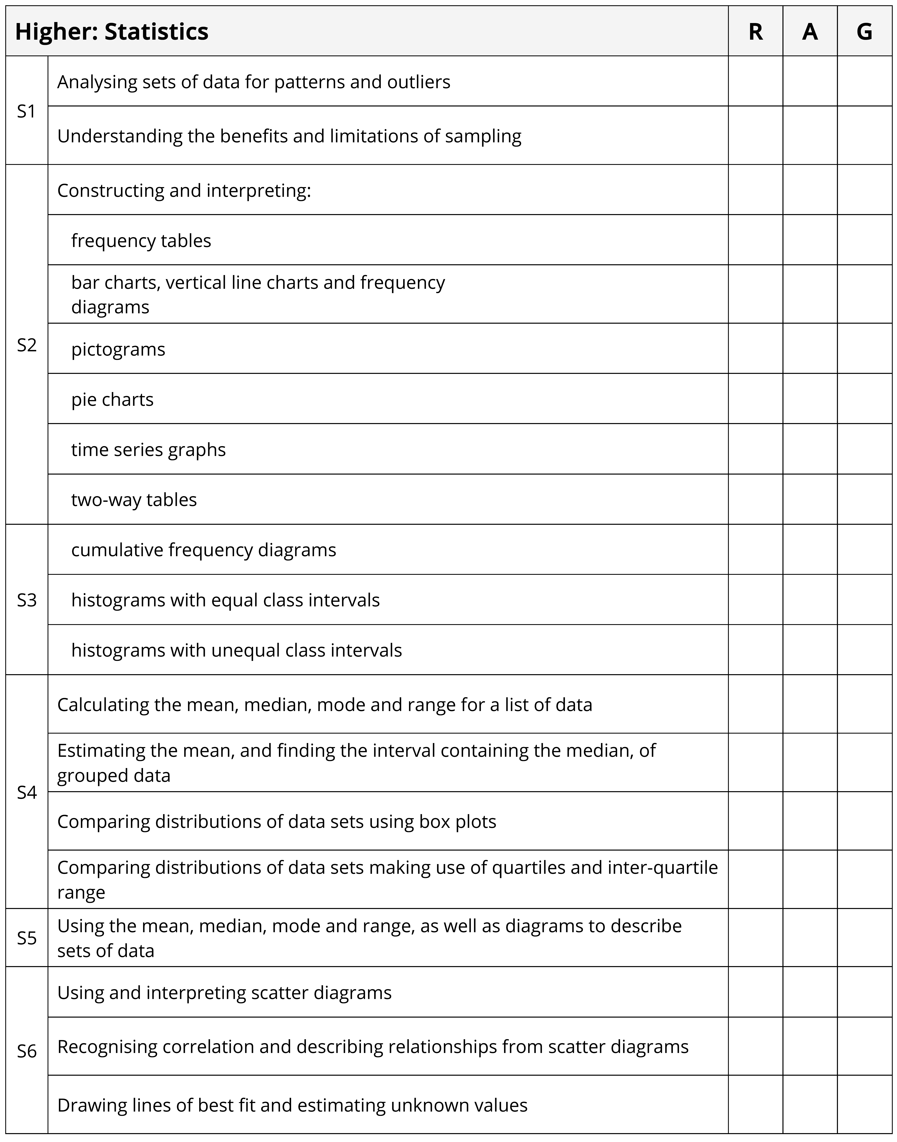
Useful revision resources

Websites

Corbett Maths – https://corbettmaths.com/
GCSEPod - https://www.gcsepod.com/
Seneca Learning - https://senecalearning.com/en-GB/
BBC Bitesize Learning - https://www.bbc.co.uk/bitesize/examspecs/z8sg6fr
Oak National Academy - https://classroom.thenational.academy/subjects-by-key-stage/key-stage-4/subjects/maths
SPARX
Recommended Revision Guides

Collins GCSE AQA revision guides
Corbett Maths revision cards

Recommended Calculators

Casio fx-83 GTX, fx-85 GTX, Casio Classwiz EX-991 (recommended if continuing onto A-Level Mathematics)
<Revision Tips

Utilise Sparx Independent Study
From your mocks, use the Green QLA sheet to use the codes to identify the areas to work on
Work through past papers and highlight questions to bring into school if you need help with them – practicing questions is important.
Remember the formulae that you will be given – are you able to apply them to the problems that involve them?
Given Formulae for Assessments – Higher

