Subject: A Level Economics
Exam Board: Edexcel
Paper 1: 2 hours (Theme 1 and 2)
Date and time:
Theme 1 Content:
- Nature of economics
- How markets work
- Market failure
- Government intervention.
- Government Failure

Theme 2:
2.1 Measures of Economic Performance
2.2 Aggregate Demand
2.3 Aggregate Supply
2.4 National Income
2.5 Economic Growth
2.6 Macroeconomic Objectives and Policy
Useful revision resources:
Physics and Maths Tutor
https://www.physicsandmathstutor.com/economics-revision/a-level-edexcel-a/theme-1/
Tutor 2 u
https://www.tutor2u.net/economics
All of these links are excellent additional ways of testing your understanding and application.
Revision Tips
Use flashcards for key theory – test yourself with the flashcards “little and often”.
Use the diagrams booklet to test knowledge and understanding of the models.
Exam question practice – test yourself as regularly as possible and compare to mark scheme answers (refer to the structure of the exams below)

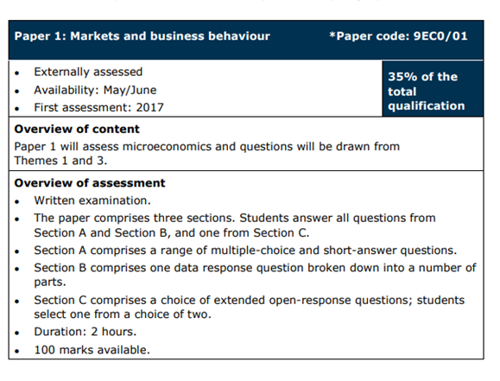

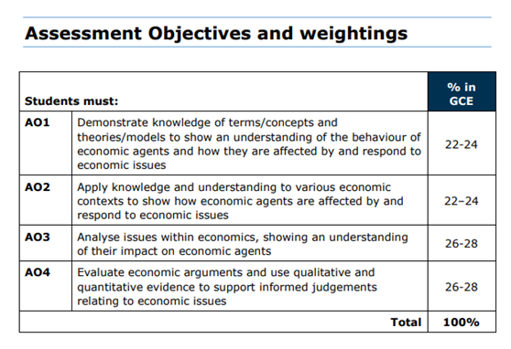

25 marker template on next page……………..

