**Returning to school after it has been closed**

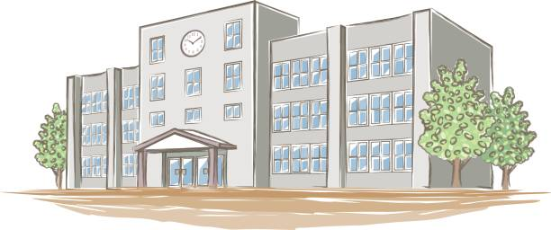

My name is _ _ _ _ _ _ _ _

I usually go to _ _ _ _ _ _ school, but recently I have been doing school work at home because my school has been closed.

On _ _ _ _ _ _ I will be going back to _________ school. This is a good thing. It means I can continue with the important learning.

I may have missed my school and my usual routines.

When I go back to school……

* I will be able to see some of my teachers and friends.
* I will be able to get help with my work from the teachers.

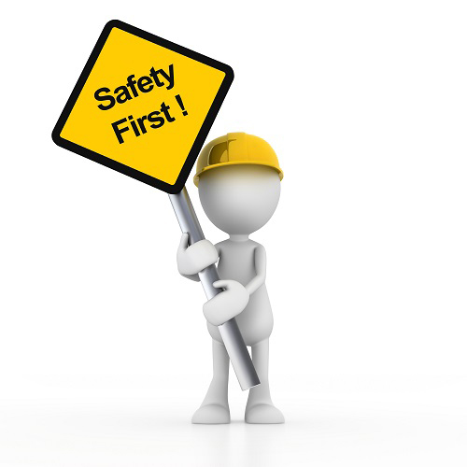

When I go back to my school, there may be things that seem a bit different. This is to keep students safe from getting and spreading illness/covid 19. This is good thing.

* I might have to follow a slightly different routine, but my teachers will tell me about this.
* I might not be allowed to see some students from other tutor groups at break-times.
* When students wait in a queue, they may have to stand a little further apart from each other.
* School may have areas taped off, where students are not allowed to go.

No Entry

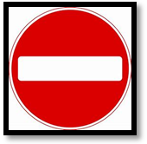

* I might have a different teacher than usual in some subjects.
* I might be in a class with different students than usual.
* There may be less students in each class. This is a good thing, as it might be quieter.
* I might not sit in my usual place in classes. Teachers will usually tell me where I should sit. If I am unhappy about this, I can raise my hand and let the teacher know by saying “please could you help me?” The teacher will try to listen and help.

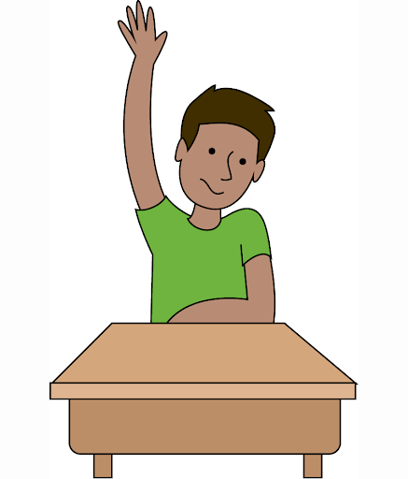

The teachers and school staff will help me to understand the new changes at school. This is great!

I may feel anxious or worried about things being different. This is ok. If I am anxious or worried, I can talk to the adults at school or home.

Soon all the students will be back at school. I will still do my learning and still do enjoyable things.

This will be ok.

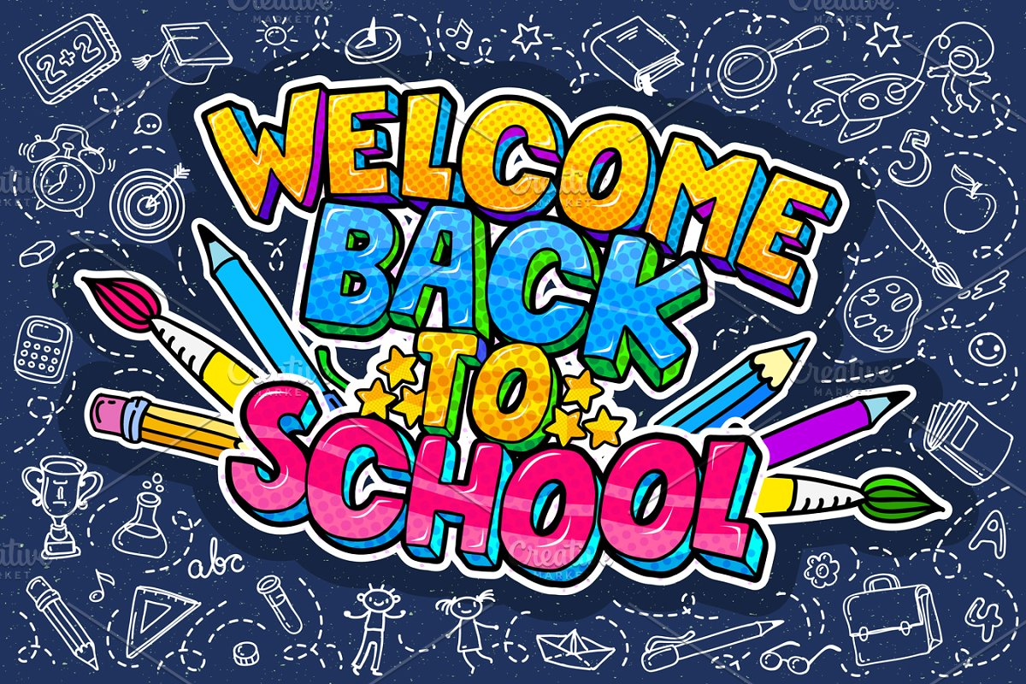

Here is a list of things that will be the same and things that may be different about school when I go back:

|  |  |
| --- | --- |
| THINGS THAT WILL BE THE SAME | THINGS THAT MAY BE DIFFERENT |
|  |  |

If I have any questions or worries about going back to school, I can write them here:

|  |
| --- |
|  |