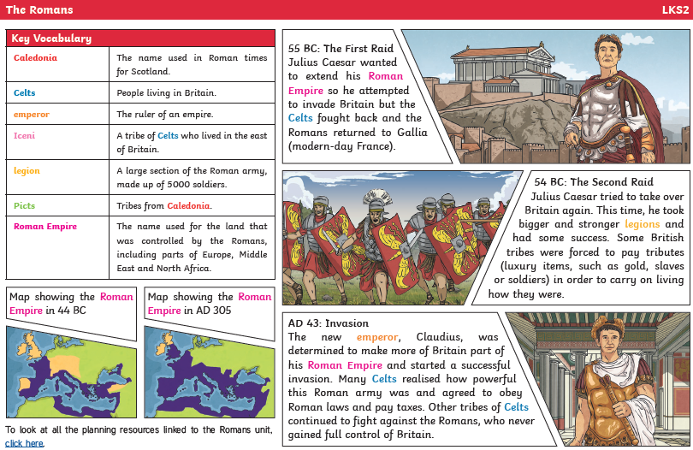

What’s the difference between an invader and settler? Which were the romans?

**Romans**

Empire

Coliseum

Emperor

Invasion

Army/soldiers

Boudicca

Celts

Iceni

When did the Romans invade Britain?

How many years did Julius Ceaser live for? How did he die?

