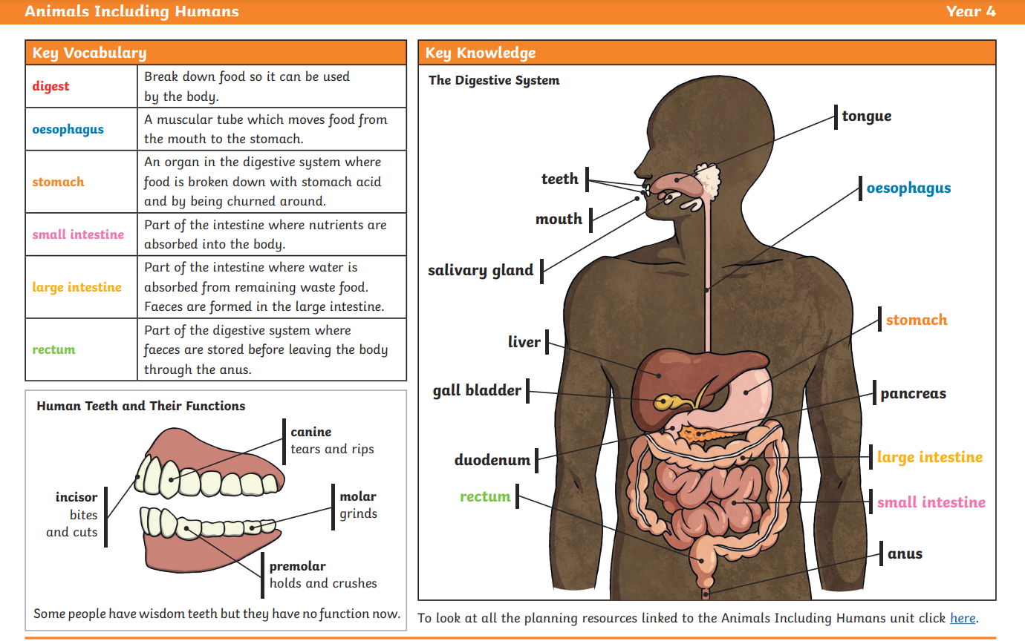

Can you tell me how food travels from our mouth to our intestines?

What does the arrow represent in a food chain?

What is the purpose of our molars?

What problems would a horse encounter if it had a lion’s teeth?

Small intestine

Vitamins

Large intestine

Colon

Incisors – cutting, slicing

Carnivore

Herbivore

Omnivore

Canines – ripping, tearing

Molars – chewing, grinding

Producers

Predators

Prey

Carnivore

Herbivore

Omnivore

Digestion

Mouth

Tongue

Saliva

Oesophagus

Transports

Stomach

Acid

Sun

Producers

Predators

Prey

Carnivore

Herbivore

Omnivore

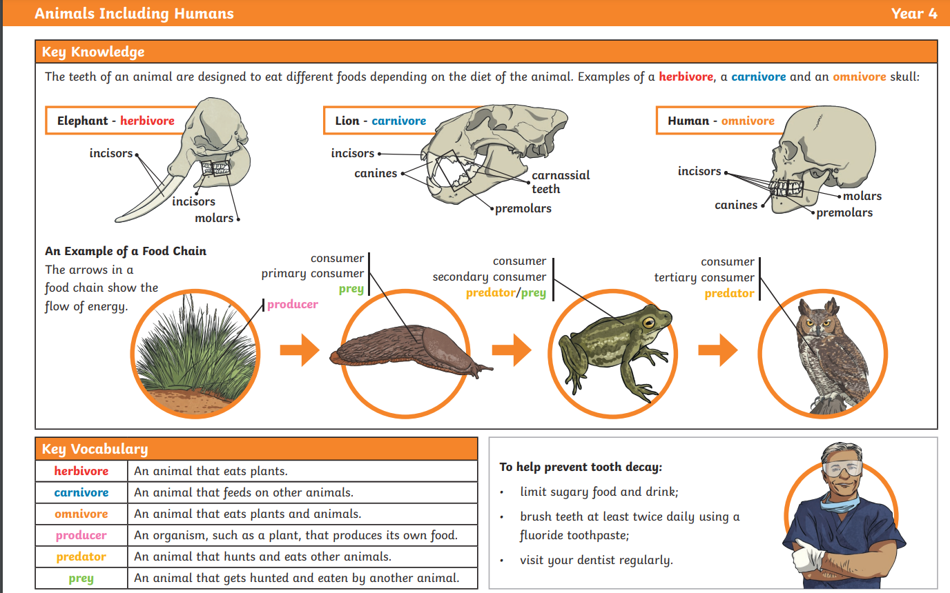

What is a herbivore and what are their teeth like?

What is the function of a canine?

What would happen to our digestive system of we had no pancreas?