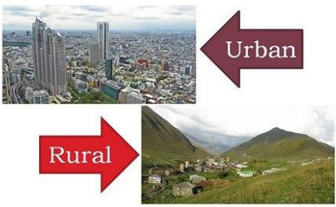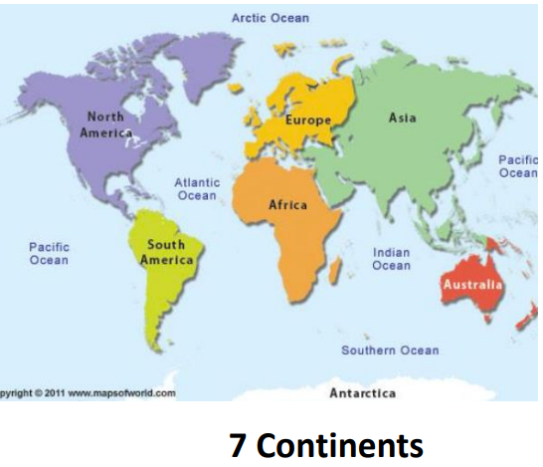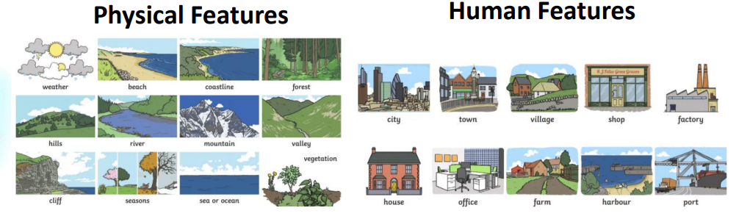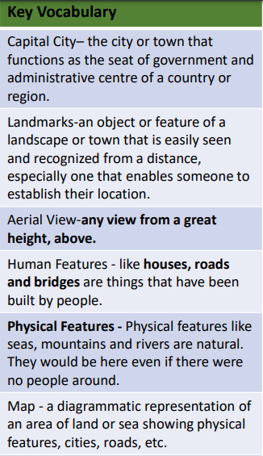

**Year 4: Globetrotters**

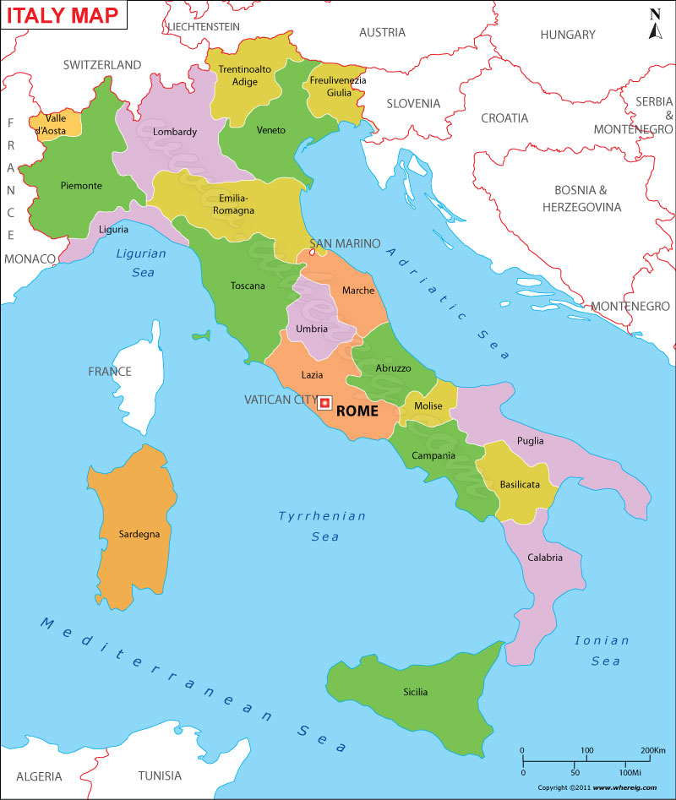

Tell me a similarity between the human geography of Rome and Rochdale.

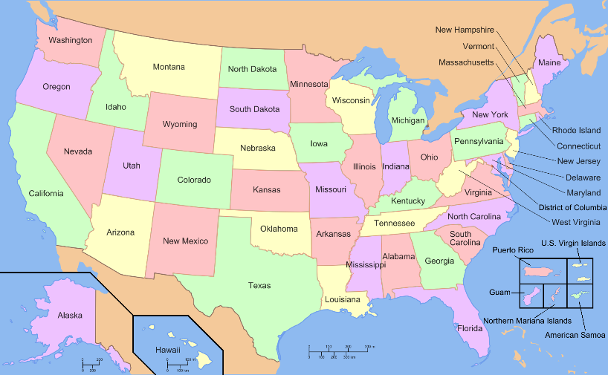

Is the colosseum a human or physical feature?

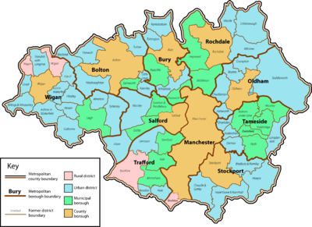

Can you compare the weather in Rome and the USA?

What would Rochdale be like if humans never existed?

What are some of the most famous human features in Rome and why?