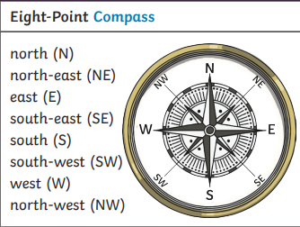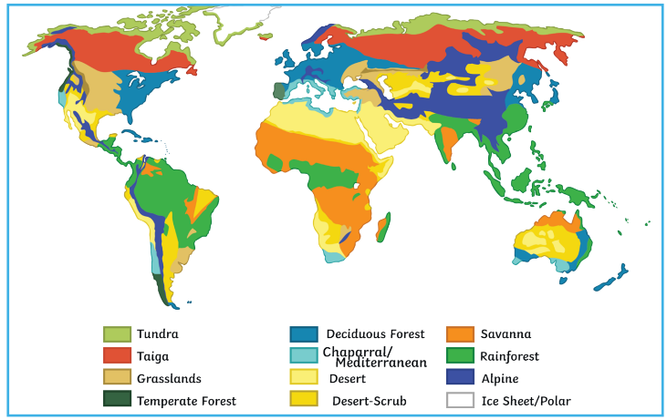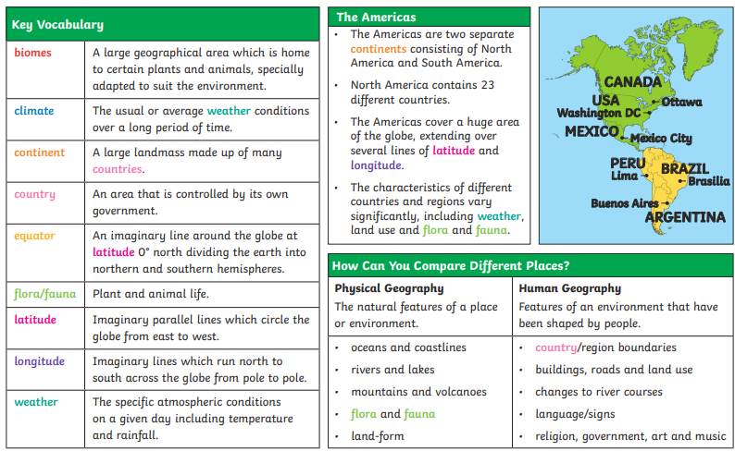

**Compass**

**Four-figure grid reference**

**Six-figure grid reference**

**Observe measure record**

**Human features**

**Physical features**

**Ordnance survey**

**Time zone**

**Desert**

**Key Questions:**

**Can you explain how to use a compass?**

**Can you explain what an OS map is?**

**Can you explain what Geographical human features are?**

**Can you explain what Geographical physical features are?**

**Can you name and identify the largets desert in the world?**

**Do you know how time zones work?**

**Olympics**

**Marathon**

**Gods/Goddesses**

**Philosopher**

**Spartan**

**War/battle**

**Vote**

