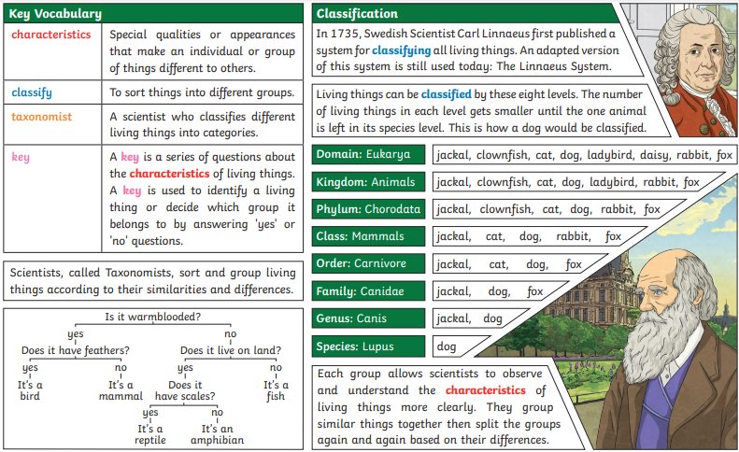

**Classify**

**Compare**

**Carl Linnaeus**

**Domain**

**Kingdom**

**Key Model**

**Species**

**Characteristics**

**Vertebrates**

**Invertebrates**

**Microorganisms**

**Organism**

**Flowering**

**Non-flowering**

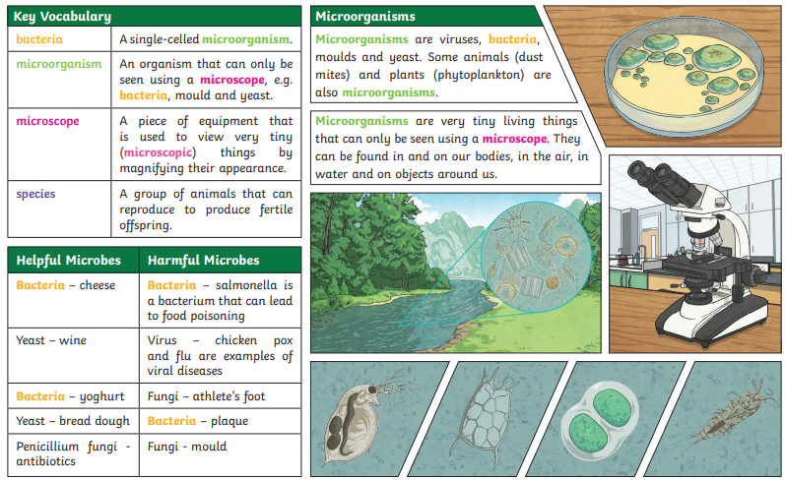

**Key Questions:**

**How can living things be classified?**

**What similarities and differences can we observe between living things?**

**What reasons can we give for how living things are classified?**

**How can microorganisms be helpful/harmful?**