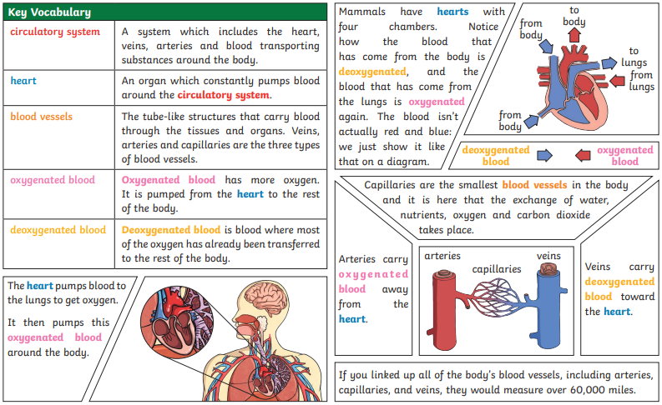

**Impact**

**Diet**

**Exercise**

**Drugs**

**Lifestyle**

**Nutrients**

**Water**

**Damage**

**Alcohol**

**Substance**

**Internal organs**

**Heart**

**Lungs**

**Liver**

**Kidney**

**Brain**

**Skeleton**

**Muscle**

**Digest**

**Circulatory system**

**Blood**

**Blood vessels**

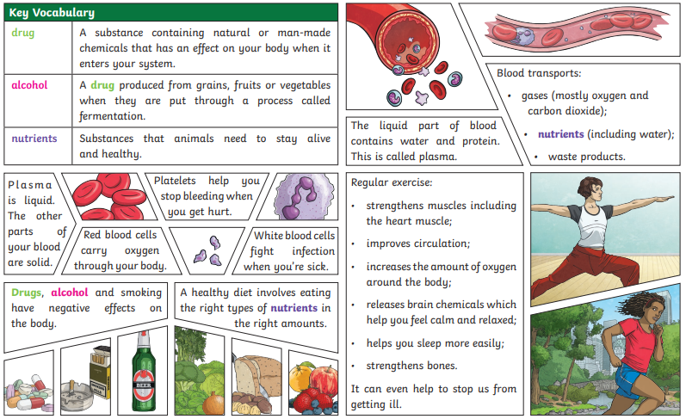

**Key Questions:**

**Can you identify and name parts of the circulatory system?**

**Can you explain the function of the heart, blood vessles and blood?**

**Can you explain the impact of a healthy/unhealthy lifestyle?**

**Can you explain how nutrients and water are transported? within animals, including humans?**