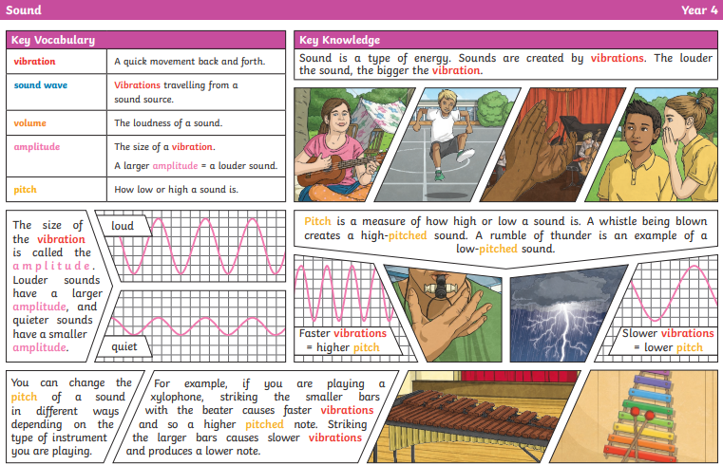

What’s another word for the volume of a sound?

What happens to vibrations when pitch gets higher?

How does sound get to our ears?

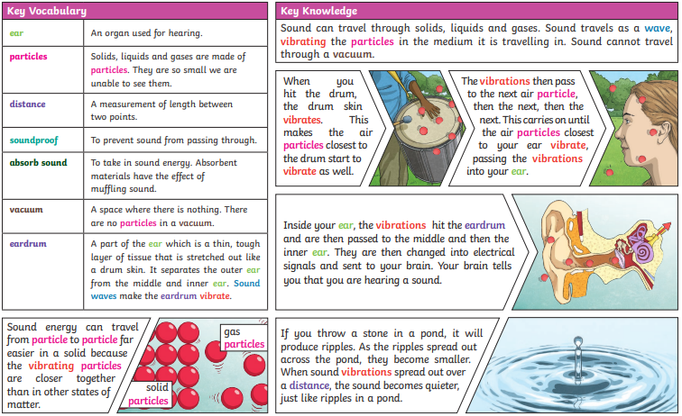

Volume

Faint

Fainter

Loud

Louder

Source

String

Percussion

Woodwind

Brass

Fair test

Sound

Vibrate

Vibration

Vibrating

Air

Medium

Ear

Hear

Sound

insulate

Pitch

High

Low