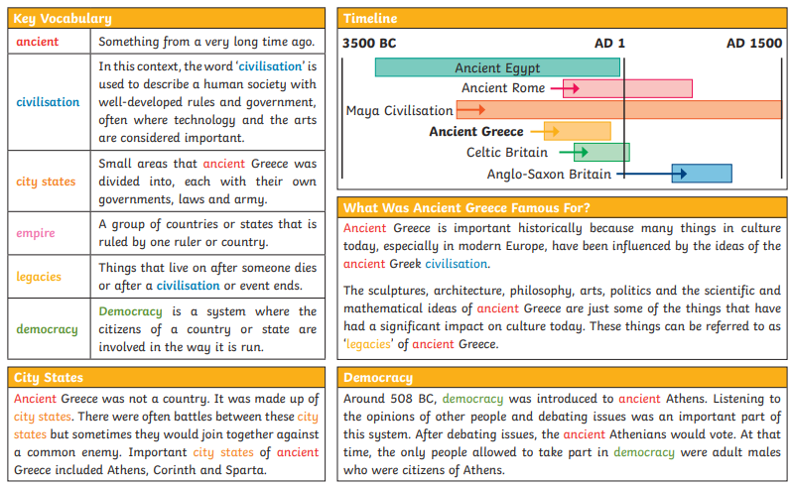

**Key Questions:**

**Can you explain who the Ancient Greeks were?**

**Can you explain the impact the Ancient Greeks had on modern day Britain?**

**Can you describe the rise and fall of Ancient Greece?**

**Can you place the Ancient Greek period on a timeline?**

**Olympics**

**Marathon**

**Gods/Goddesses**

**Philosopher**

**Spartan**

**War/battle**

**Vote**

**Athenian**

**City-state**

**Civilisation**

**Democracy**

**Empire**

**Persian**

**Olympics**

