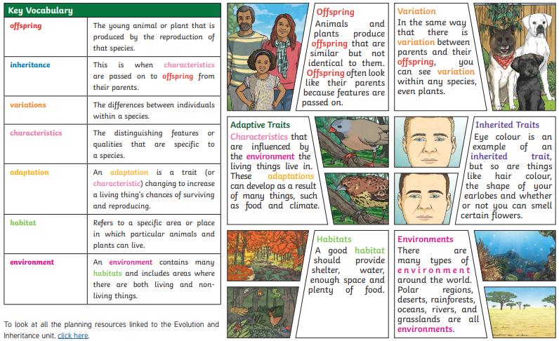

Evolution

Adaptation

Inherited traits

Adaptive traits

Natural selection

Inheritance

Charles Darwin

Alfred Wallace

DNA

Genes

Variation

Parent

Offspring

Fossil

Fossilisation

Environment

Habitat

Evidence

Argument

Refute

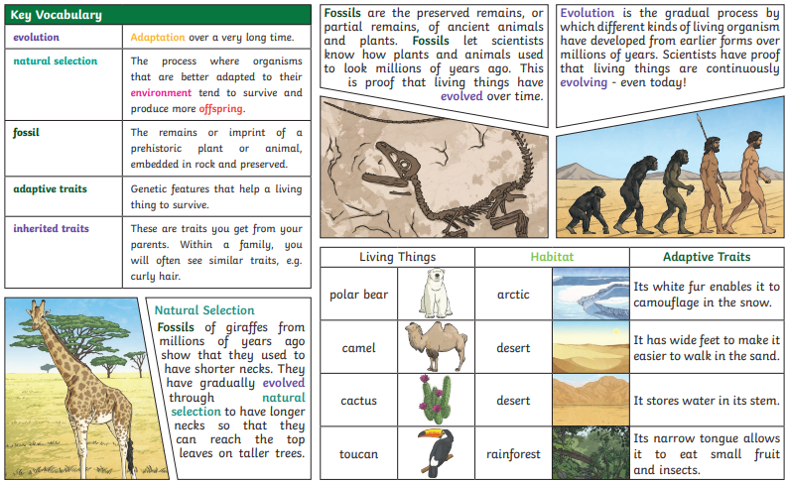

**Key Questions:**

**Can you explain how living things have changed over time?**

**Can you explain how fossils give us information about the past?**

**Can you explain that living things produce offspring?**

**Can you explain how living things are adapted to suit their environment?**